FOR IMMEDIATE RELEASE
FEBRUARY 2, 2022

22Gz IS BACK WITH “SAID IT’S LIT”

GROUNDBREAKING BROOKLYN DRILL RAPPER KICKS OFF YEAR OF THE BLIXKY
WITH EAGERLY AWAITED NEW SINGLE

THE BLIXKY TAPE 2 (DELUXE) DROPS VIA SNIPER GANG/ATLANTIC ON 2/22/22

MIXTAPE RELEASE SHOW AT NEW YORK’S GRAMERCY THEATER ON SALE NOW

LISTEN TO “SAID IT’S LIT”
WATCH OFFICIAL MUSIC VIDEO

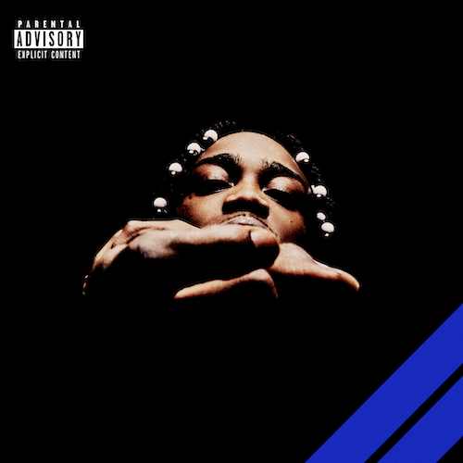
(DOWNLOAD HI-RES ARTWORK)

RIAA gold certified Brooklyn Drill pioneer 22Gz is kicking off his self-proclaimed “Year of the Blixky” by sharing his eagerly awaited new single, “Said It’s Lit,” available now via Atlantic/Sniper Gang at all DSPs and streaming services. An official music video premieres today at YouTube.

“Said It’s Lit” heralds the upcoming expanded release of 22Gz’s blockbuster 2021 mixtape, THE BLIXKY TAPE 2 (DELUXE), available February 22nd – 2/22/22 – at all DSPs and streaming services. To celebrate the mixtape release 22Gz is headlining a show at New York’s Gramercy Theater on February 21^{st.} Tickets are on sale today HERE.

Released March 2021 to wide ranging national applause, THE BLIXKY TAPE 2 is highlighted by the powerful single, “Fallen Blixkys,” available for streaming and download HERE. An emotional tribute to 22Gz’s fallen Blixky comrades, the track has earned more than 90M worldwide streams to date and is joined by an equally potent official video, now with more than 3.5M views via YouTube HERE. In addition, THE BLIXKY TAPE 2 – which features beats created by a cadre of top domestic and international producers including Reazy Renegade, Ghosty, Young Dza, Zacky Beatz, and more – also includes such hits as “Blixky Gang Freestyle Pt. 2,” “Movie (Feat. CoachDaGhost),” “Casa,” “Never Be The Same (Feat. Jackboy),” and the hugely popular “Twirlanta,” all joined by official music videos streaming now at YouTube.

Furthermore, 22Gz kept the fire going with a pair of additional 2021 smashes, “Retaliation” and “Steppers,” both of which are joined by official visuals at YouTube.

With over 330M worldwide streams and more than 100M YouTube views thus far, 22Gz stands tall at the forefront of Brooklyn Drill, consistently rewriting the rulebook with every release, leading the pack while bringing “Blixky” to the worldwide lexicon. Beyond the metallic ironclad beats, viral dances, hundreds of millions of streams, and acclaim from such high-profile outlets as Vulture, The Source, Pitchfork, and Noisey, 22Gz has cast a long shadow over the genre with a one-of-a-kind combination of menacing melodies and razor-sharp rhymes. Toughened up by the trauma of his father’s murder, the tribulations of being raised by his older sisters, and his own trouble with the law, 22Gz first lit the match for the Brooklyn Drill movement in 2017 with “Suburban,” christened by Pitchfork as “the first Brooklyn Drill song worth a damn.” A deal with Sniper Gang in partnership with Atlantic Records kicked off with 2019’s original THE BLIXKY TAPE, followed a year later by GROWTH & DEVELOPMENT, highlighted by the RIAA gold certified breakthrough, “Suburban Pt. 2,” now boasting more than 100M global streams and over 31M YouTube views. In its aftermath, Complex cited 22Gz as “a trailblazer of Brooklyn drill music,” while HYPEBEAST simply stated, “22Gz is one of the main reasons Brooklyn’s drill scene made its way to the masses.”
CONNECT WITH 22Gz
22GZOFFICIAL.COM | INSTAGRAM | YOUTUBE | TWITTER | FACEBOOK
# # #

FOR PRESS INQUIRIES PLEASE CONTACT
ARIANA.WHITE@ATLANTICRECORDS.COM

