FOR IMMEDIATE RELEASE
MAY 6, 2022

Anna Clendening returns with “Sweatshirt”

Rising singer-songwriter’s new single available now via Atlantic Records

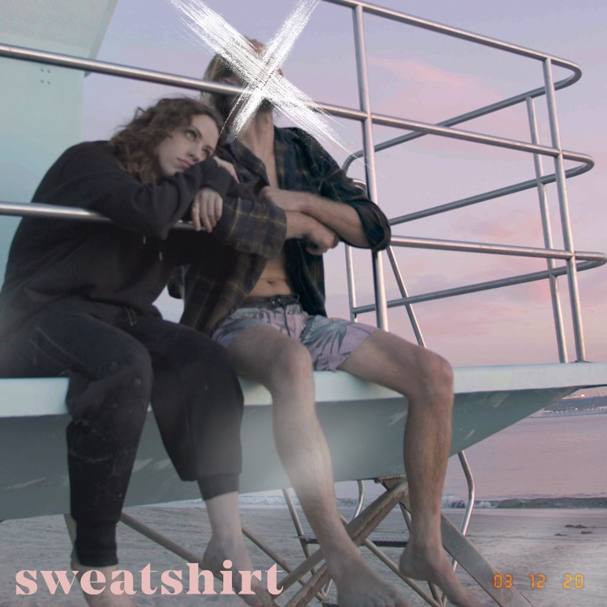
DOWNLOAD HIGH-RES IMAGES

STREAM “SWEATSHIRT”: LINK

Rising singer-songwriter Anna Clendening makes her long awaited return with new single “Sweatshirt” – available now via Atlantic Records. The track, co-penned by Dan Richards (One Direction, Anson Seabra) and produced by Colin Brittain (5 Seconds of Summer, All Time Low), marks the introduction of a new chapter for Clendening following an 18-month hiatus that found her relocated from Los Angeles to Nashville and embracing herself as both an artist and songwriter. Warm guitar, a glitchy beat, and upbeat production offset her story of a doomed relationship with “a narcissistic asshole” who quite literally stole her sweatshirt.

“I always bought oversized shirts at every tour stop,” Clendening reveals. “I let this guy I was dating borrow one. Fast forward, we break up, he ends up dating his co-worker, called me on FaceTime, and he was wearing that shirt. He knowingly put it on to call me. There was overlap. Did he cheat? I think so. It doesn’t matter at this point, but it does. I thought, ‘How funny would it be if his girlfriend ended up pulling the shirt out of his drawer and wearing it?’ I was playing out this scenario in the song.”

Clendening released her RIAA-certified Gold single “Boys Like You” in 2017, amassing over 100 million streams and critical acclaim from the likes of Billboard, Ones To Watch, Refinery29 & more. Meanwhile her debut EP, 2019’s Waves, generated over 150 million streams in under six months and led to collaborations with the likes of Illenium, Lost Kings & Matoma. Signing to Atlantic Records in 2020, her Evolve EP, featuring standout single “Love Song” with John K, arrived to applause from American Songwriter, Flaunt, Idolator & more. Now after generating nearly half-a-billion streams, Clendening perfects her very own brand of gleefully chaotic pop on her forthcoming third EP due this summer.

In tandem with her honest songwriting, Clendening has proven to be a source of universal encouragement and an incredible advocate for mental health awareness. Sharing openly with fans about her own mental health journey managing anxiety, she's continually channeled these challenges through the healing power of music.

“We’re all very similar,” Clendening observes. “Our experiences, while different, are not isolated. People are going through the same things to not feel alone. When I was first diagnosed with anxiety, I thought I was crazy. I felt like nobody else knew what was going on, and it wasn’t happening to anyone but me. With my music and platform as an artist, I want to be the person I needed when I was 13- or 14-years-old. That’s all I want to do as long as I’m alive.”

CONNECT:
OFFICIAL | FACEBOOK | TWITTER | INSTAGRAM | YOUTUBE | TIKTOK | PRESS ASSETS

CONTACT:
TED.SULLIVAN@ATLANTICRECORDS.COM

