FOR IMMEDIATE RELEASE

APRIL 8, 2022

BANKROL HAYDEN SAYS “F*CK LOVE”
WATCH HERE
STREAM HERE

RISING RAPPER ANNOUNCES FORTHCOMING PROJECT
SET TO DROP THIS SUMMER

ANNOUNCES THREE MAJOR SUMMER 2022 FESTIVAL PERFORMANCE DATES

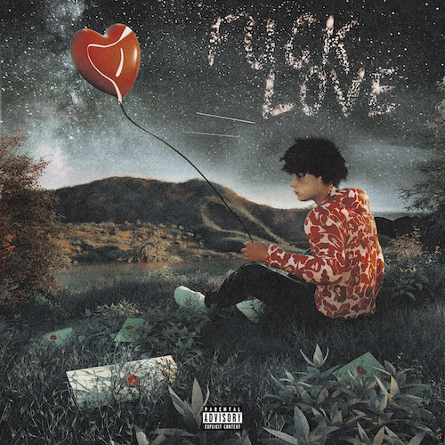
(DOWNLOAD HI-RES ARTWORK)

Modesto, CA rapper Bankrol Hayden releases outspoken new single + video, “F*ck Love”. The give-zero-f*cks break up song was produced by GRAMMY® Award-nominee Roy Lenzo (Lil Nas X, Jack Harlow, Roddy Ricch) and Adriano (Gunna, Lil Skies, Ali Gatie); while the simplistic visual directed by JakeTheShooter, has Hayden raising his middle fingers to the sky when it comes to love. He’s done with it.. Watch HERE.

“F*ck Love” is one of several tracks Bankrol Hayden is releasing prior to his eagerly awaited project, coming this Summer. The track follows a series of previously-released tracks, which include his RIAA gold certified “Costa Rica,” “Cabo,” “No Drama“ and the smash hit, “Come Through (Ft. Lil Tecca),” the latter of which boasts over 85M worldwide streams thus far, after making top playlists such as Spotify’s “Rap Caviar” and “Most Necessary,” Apple Music’s “#OnRepeat” and “The Plug,” Amazon’s “Fresh Hip-Hop,” and more.

Previously featured among YouTube’s “Artist on the Rise: Trending” series, Bankrol Hayden has proven to be an electrifying live performer, sharing stages around the world. Hayden is set to hit multiple stages this year including, Gulf Shores, AL’s Hangout Music Festival (Saturday, May 21), Grand Prairie, TX’s So What?! Music Festival (Friday, May 27), and Dover, DE’s Firefly Music Festival (Sunday, September 25). Additional dates will be announced.

Currently holding over 120M YouTube views to date, Bankrol Hayden is a true phenomenon, earning fans around the globe with his positive brand of soulful, pop-forward hip-hop. The talented young artist first broke out in 2017 with a series of popular YouTube videos and SoundCloud favorites. Viral smashes as “B.A.N.K.R.O.L.,” “29,” and the RIAA gold certified “Brothers (Feat. Luh Kel)“ followed, the latter of which scored 30M Spotify streams and 6.5M YouTube plays in under six months.

Bankrol Hayden made his Atlantic Records debut in 2020 with the RIAA gold certified “Costa Rica,” quickly following up with his powerful debut album, Pain Is Temporary, highlighted by such emotionally charged tracks as “Whatchu On Today (Ft. Polo G),,” “Drop A Tear (Ft. Lil Baby),” and “Rich Bitch,” all joined by official music videos streaming now at YouTube.

“Tupac used to write as either an observer, participant, or themselves,” Bankrol Hayden says. “That inspires me. I stay true to myself and put my life into this, but you’ll get different perspectives.”

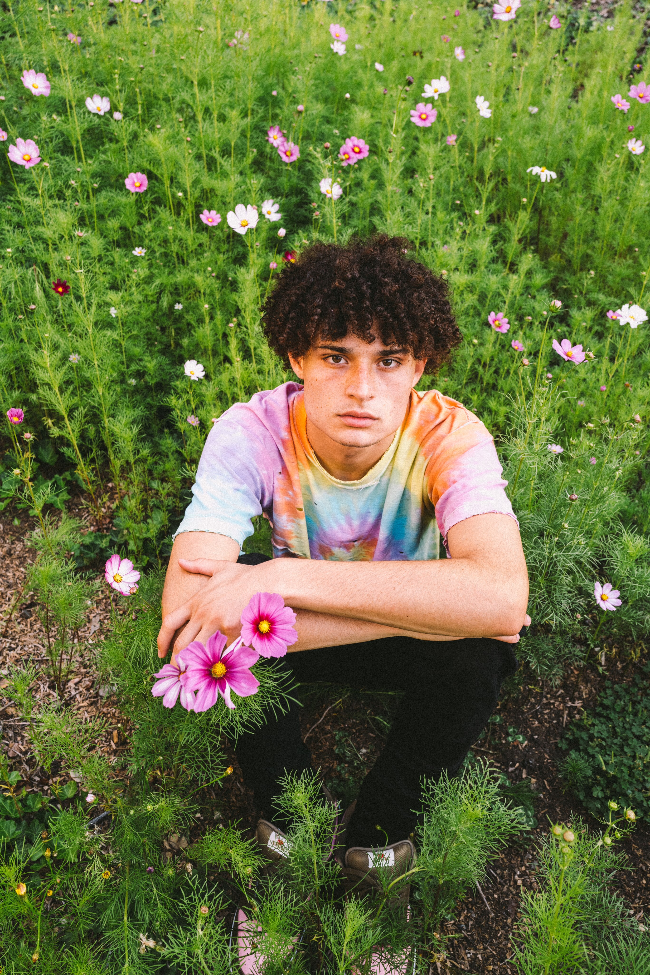
(DOWNLOAD PRESS ASSET(S) HERE )| PHOTO CRED: DAVID DICKENSON

CONNECT WITH BANKROL HAYDEN
INSTAGRAM | TIKTOK | TWITTER | YOUTUBE

PRESS CONTACT
FAIRLEY MCCASKILL | FAIRLEY.MCCASKILL@ATLANTICRECORDS.COM

# # #

