FOR IMMEDIATE RELEASE
MAY 13, 2022

BIZZY BANKS IS BACK WITH VISUAL FOR “DON’T KNOW HOW TO ACT”

ACCLAIMED NEW YORK DRILL STAR RELEASES CAPTIVATING NEW VIDEO

WATCH “DON’T KNOW HOW TO ACT” HERE

“DON’T KNOW HOW TO ACT” AVAILABLE EVERYWHERE NOW HERE

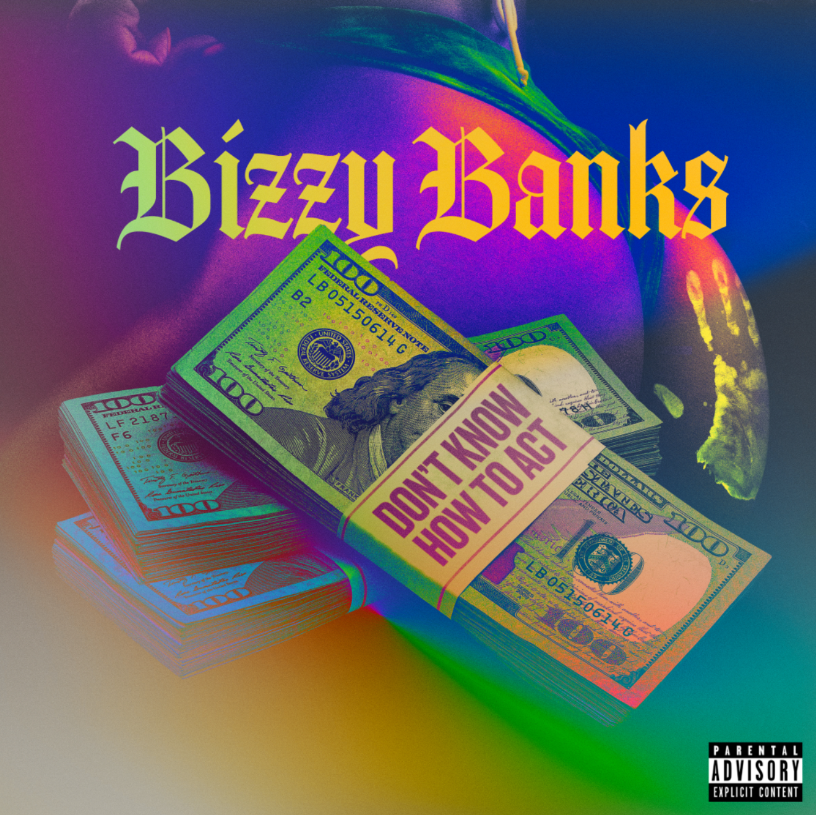

“Bizzy Banks’s music is driven less by his personality and more by his fascination with the city’s rap tradition – heavy on slick wordplay, dramatic slice-of-life stories, and a competitive spirit that’s focused on coming up with the coolest way to say a thought.” – PITCHFORK

Acclaimed New York Drill rapper Bizzy Banks is back with the follow up visual for his latest buzzing single “Don’t Know How to Act” available to stream via YouTube HERE. He recently shared his first new single of 2022, “Don’ t Know How To Act,” produced by A Lau, at all DSPs and streaming services HERE. Directed by Haitian Picasso and features sexy ladies in lingerie playing the lead roles and acting up when they get a surprise call and cameo from Bizzy. Additional new music will follow in the coming weeks.

“Don’t Know How To Act” marks the long anticipated follow-up to last year’s stand-out mixtape, SAME ENERGY, available now at all DSPs and streaming services HERE. SAME ENERGY includes such singles as “Bandemic,” “My Shit,” “Azul,” “Driftin’,” “City Hot,” and “Adore You (Feat. PnB Rock),” all accompanied by official music videos streaming now at YouTube HERE. Produced by D.A. Got That Dope (Megan Thee Stallion, Da Baby), “Adore You” was met by praise from such outlets as XXL, which raved, “Bizzy can jump from flow to flow, plus his references are clever…The slow groove puts the rhymer in a prime position to keep evolving.” “Some of the best music he's released yet,” enthused Brooklyn Vegan. “(Bizzy) seems poised to be one of New York drill's biggest breakouts since the untimely death of Pop Smoke.”

SAME ENERGY was first heralded with the acclaimed single, “Bandemic,” which currently boasts more than 7.5M global streams and received praise from a range of national publications, including LA Weekly, which wrote, “Banks holds nothing back on the new tune…it’s representative of the material he’s currently working on.” An official video – shot and edited by Useless Films – has earned over 2.2M views via YouTube alone HERE.

In the short time since Bizzy emerged on the New York drill scene, he has racked up co-signs from some of the most notable names like NY heavyweights like Lil Tjay and Pop Smoke before his passing. His feature on Pop Smoke’s FAITH album, “30”, was touted by Brooklyn Vegan as the “best collab on the album” and received critical acclaim while sitting on the OCC for its 40th week. Pitchfork named “Top 5”, a release from Bizzy’s 2020 label-debut mixtape “G.M.T.O. Vol. 1 (Get Money Take Over)” as one of “The 36 best rap songs of 2020” and is currently sitting at 5 million views. His single “Don’t Start Pt. 2” is a certified hit boasting close to 8 million views on YouTube. The finesse and astute lyricism showcased on his debut mixtape won Bizzy a nomination for the XXL 2021 Freshman class as well as the #10 spot on Rolling Stone’s “Breakthrough 25” highlighting the fastest rising artists.

# # #

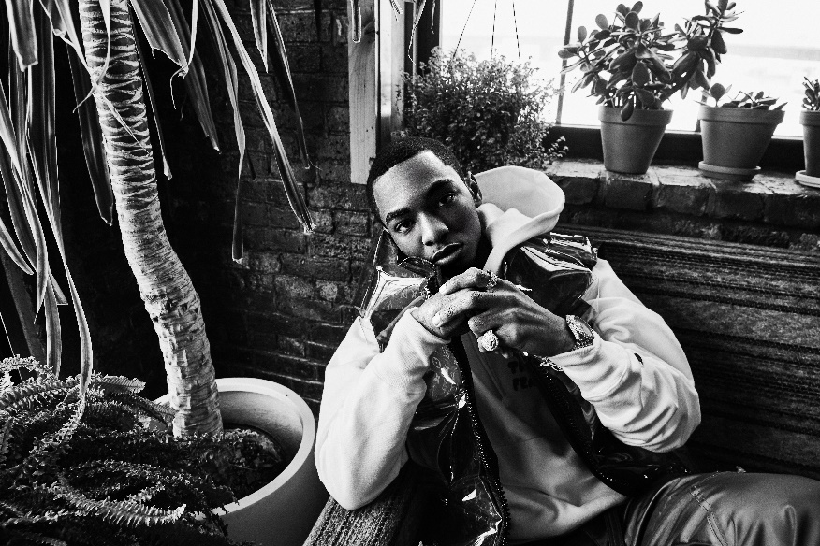

CONNECT WITH BIZZY BANKS
INSTAGRAM | TWITTER | YOUTUBE

FOR ALL INQUIRIES, CONTACT
ARIANA.WHITE@ATLANTICRECORDS.COM

