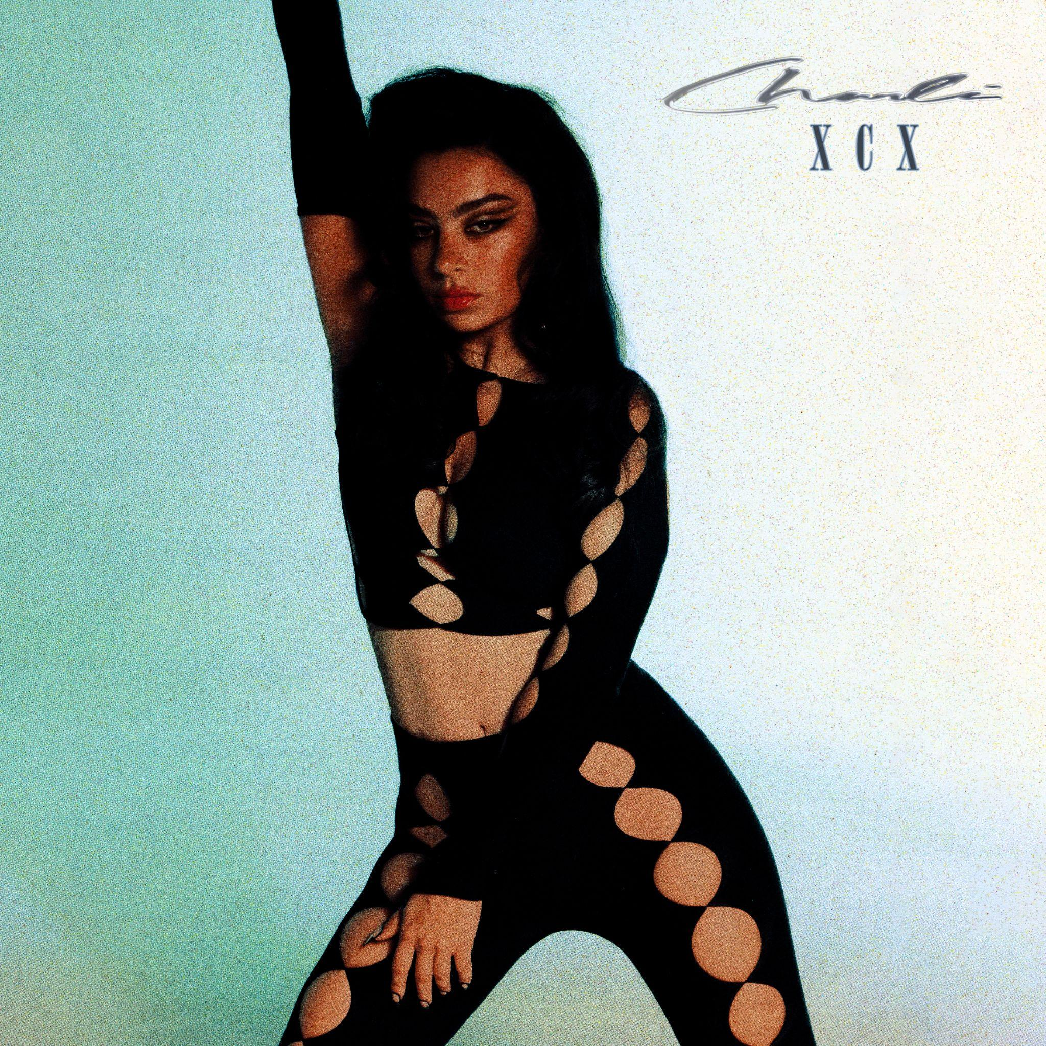
CHARLI XCX DROPS BRAND NEW TRACK + VIDEO “BABY” FOR HER FANS
AHEAD OF FORTHCOMING ALBUM
‘CRASH’
WATCH/LISTEN

CRASH: THE ALBUM - OUT 18TH MARCH
EUROPEAN AND NORTH AMERICAN TOUR STARTS IN MARCH
PRE-ORDER CRASH + BUY YOUR TOUR TICKETS HERE

(Tuesday 1st March) –– Today, Charli XCX drops track ‘Baby’, accompanied by an awe-inspiring video, directed by Imogene Strauss and Luke Orlando. Baby is one of the first songs Charli wrote for this album, and has been noted as one of the pop sensation’s personal favorites on the tracklist.

‘Baby’ is a tale of possession and self assuredness, perfectly summarizing the thought and attitude behind the record. The video comes in to illustrate Charli’s desires with an incredible routine, choreographed by Charli’s close collaborator Nathan Kim. Of the song Charli confesses, “The track is about great sex.”. ‘Baby’ will debut on Zane Lowe’s New Music Daily show today, with its debut performance on SNL to follow.

Charli’s highly-anticipated forthcoming album, CRASH, will be released on 18th March and is the fifth and final album in her record deal. Charli kicks off her 21-date North American tour in Los Angeles on 26th March followed by her 17-date UK and European tour which starts in Dublin on 13th May with support from Baby Tate, ELIO, Yeule, Magdalena and A. G. Cook, . See full tour dates below.

North American live dates:

26th March - Fox Theatre - Oakland, CA
27th March - Fox Theatre - Oakland, CA
29th March - Crystal Ballroom - Portland, OR
1st April - The Observatory North Park - San Diego, CA
3rd April - The Greek Theatre - Los Angeles, CA
6th April - Ogden Theatre - Denver, CO
8th April - ACL Live at The Moody Theater - Austin, TX
9th April - House of Blues Houston - Houston, TX (on sale TBD)
10th April - House of Blues Dallas - Dallas, TX
12th April - Orpheum Theater - New Orleans, LA
13th April - The Eastern - Atlanta, GA
15th April - The Orange Peel - Asheville, NC
16th April - The NorVa - Norfolk, VA
18th April - The Fillmore Philadelphia - Philadelphia, PA
20th April - House of Blues Boston - Boston, MA
22nd April - Hammerstein Ballroom - New York, NY
23rd April - Hammerstein Ballroom - New York, NY
25th April - Massey Hall - Toronto, ON
26th April - Royal Oak Music Theatre - Royal Oak, MI
28th April - Palace Theatre - Saint Paul, MN
29th April - Byline Bank Aragon Ballroom - Chicago, IL

European live dates:

13th May - Olympia Theatre - Dublin, Ireland
15th May - O2 Academy - Glasgow, UK
17th May - Victoria Warehouse - Manchester, UK
18th May - O2 Academy - Birmingham, UK
19th May - Alexandra Palace - London, UK
21st May - UEA - Norwich, UK
22nd May - O2 Academy - Sheffield, UK
23rd May - Rock City - Nottingham, UK
25th May - Trianon - Paris, France*
27th May - La Madeleine - Brussels, Belgium*
28th May - TivoliVredenburg (Ronda Hall) - Utrecht, Netherlands
30th May - Astra - Berlin, Germany
31st May - Carlswerk Victoria - Cologne, Germany
2nd June - Primavera - Barcelona, Spain
4th June - Fabrique - Milan, Italy
7th June - La Riviera - Madrid, Spain
9th June - Primavera - Barcelona, Spain

Follow Charli XCX here
Download press images + artworks here
Pre-order CRASH + buy your tickets here

