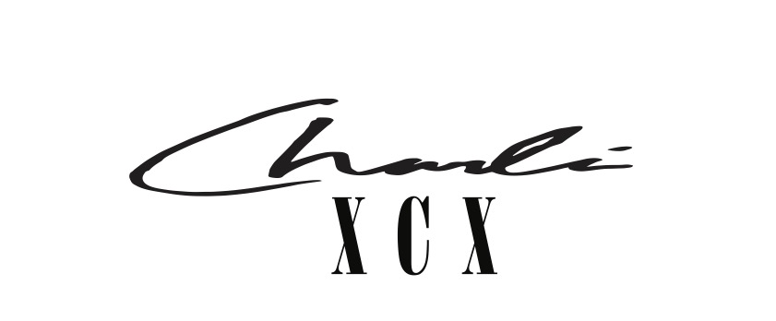

"Pop queen’s new album is a foot-down, top-down trip” - Independent - ★★★★★

"The album has the range of a greatest-hits compilation, with kinetic pop-funk and textured dream-pop.” - Pitchfork - 8/10

April 15, 2022 –– Today, Charli XCX drops the visuals to her party anthem “Used To Know Me”, directed by Alex Lill. Watch here.

‘Used To Know Me’ is the catchy story of a post-breakup revival, and borrows from the 1990 house hit “Show Me Love” by Robin S. The video comes in to further extend the impressive visuals that Charli has delivered in this era with cohesion and consistency, under the creative direction of Imogene Strauss and Choreography from Nathan Kim.

Charli’s critically acclaimed fifth studio album, CRASH, was released in March 2022 and awarded the Pop Icon her first UK #1 and in the USA her first top 10 at #7 on the charts.

Charli is eleven nights into her twenty-one-date North American tour, one night of which she performed to a sold out crowd at LA’s Greek Theatre, supported by a-list friends and a who’s who of young Hollywood. Charli will perform two nights at New York’s Hammerstein Ballroom on the 22nd and 23rd April, before moving on to her 17-date UK and European tour which starts in Dublin on 13th May and will see her perform her hit record at London’s iconic Alexandra Palace on the 19th May. Charli has just announced an extension of the tour which will stop in Vancouver's Orpheum Theater on July 21. The tour is supported by Baby Tate, ELIO, Yeule, Magdalena and A. G. Cook. See full tour dates below.

North American live dates:

April 15th - The Orange Peel - Asheville, NC
April 16th - The NorVa - Norfolk, VA
April 18th - The Fillmore Philadelphia - Philadelphia, PA
April 20th - House of Blues Boston - Boston, MA
April 22nd - Hammerstein Ballroom - New York, NY
April 23rd - Hammerstein Ballroom - New York, NY
April 25th- Massey Hall - Toronto, ON
April 26th- Royal Oak Music Theatre - Royal Oak, MI
April 28th- Palace Theatre - Saint Paul, MN
April 29th- Byline Bank Aragon Ballroom - Chicago, IL

European live dates:

May 13th- Olympia Theatre - Dublin, Ireland
May 15th - O2 Academy - Glasgow, UK
May 17th - Victoria Warehouse - Manchester, UK
May 18th - O2 Academy - Birmingham, UK
May 19th - Alexandra Palace - London, UK
May 21st- UEA - Norwich, UK
May 22nd- O2 Academy - Sheffield, UK
May 23rd - Rock City - Nottingham, UK
May 25th- Le Trianon - Paris, France*
May 27th - La Madeleine - Brussels, Belgium*
May 28th- TivoliVredenburg (Ronda Hall) - Utrecht, Netherlands
May 30th- Astra - Berlin, Germany
May 31st- Carlswerk Victoria - Cologne, Germany
June 2nd- Primavera - Barcelona, Spain
June 4th- Fabrique - Milan, Italy
June 7th- La Riviera - Madrid, Spain
June 9th - Primavera - Barcelona, Spain

North American live dates:

July 21st - The Orpheum Theatre - Vancouver, BC

Follow Charli XCX here
Download press images + artworks here
Buy + Stream CRASH + buy your tickets here

