CHARLIE PUTH AND TIËSTO TURN ON THE HIGH BEAMS WITH DANCE version of HIT NEW SONG“LIGHT SWITCH”

Track From His Forthcoming Album CHARLIE
Becomes His Most Successful Song Release Ever
Currently #13 at Top 40 and #11 at HOT AC

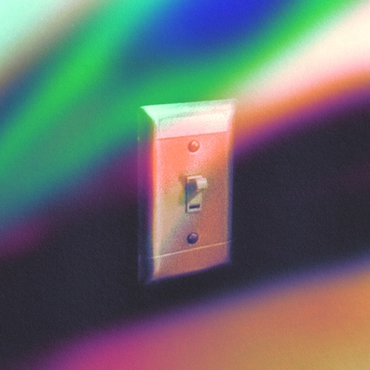
CLICK HERE TO LISTEN TO THE SONG NOW

Los Angeles, CA – March 4, 2022 – GRAMMY-nominated and multi-platinum singer/songwriter/producer Charlie Puth released the hypnotizing electronic dance version of his new song "Light Switch" today with GRAMMY Award-winning DJ and producer Tiësto. Click HERE to listen.

Tiësto creates an energetic remix of “Light Switch,” integrating a “chainsaw” sounding drop, with a bouncy, pounding bass built for dancefloors and festivals worldwide. The pulsating electronic version of the track takes Charlie’s signature vocal stylings into the world of Dancepop and EDM.

“Light Switch” has become Charlie’s most successful song release to date where it hit #1 on the iTunes Pop Chart upon release. “Light Switch” in just over one month garnered more than 113 million worldwide streams and is currently exploding up the charts, moving up the Top 40 US charts to #13 this week and #11 at HOT AC as well.

After teasing clips of the song for months to his more than 15 million fans on TikTok, the official music video for “Light Switch” has now racked up more than 36 million views upon its release. “Light Switch” is the first new song to be released from Puth’s upcoming new album, CHARLIE, via Atlantic Records.

Tiësto is a GRAMMY® Award-winning, platinum-certified, international icon who has over 8 billion global streams across platforms, 3.5 billion TikTok Video Views, 2.3 billion YouTube Views, and 20 million+ followers across social platforms.

At only 30 years old, Puth is a Diamond Certified, 20x Platinum, 4x GRAMMY-nominated singer, songwriter, producer, and multi-instrumentalist, who has garnered three Billboard Music Awards, a Critic’s Choice Award, and a Golden Globe nomination. Puth co-wrote and produced The Kid Laroi and Justin Bieber’s record-breaking single, “Stay,” which quickly became one of the biggest songs of 2021 and holds the title for the longest-reigning No. 1 on the Billboard Global 200 chart and the first to lead it for double-digits - spending a total of eleven weeks at the top of the chart. Puth’s 2020 collaboration with Gabby Barrett on their “I Hope” Remix earned him his fourth top 10 track on the Billboard Hot 100, hit number one on the Billboard “Adult Pop Songs” chart, and won a 2021 Billboard Music Award for “Top Collaboration.” His 2018 GRAMMY-nominated LP, Voicenotes, was RIAA Certified Gold only four days after its release and has logged over 5.6 billion streams worldwide.

Link to Hi-Res Press Images and Single Artwork HERE

Connect with Charlie Puth:
Website | Instagram | Facebook | Twitter | TikTok | YouTube | Spotify | Apple Music

# # #

Press Contacts for Charlie Puth:
ID, Rhett Usry (rusry@id-pr.com)
Atlantic Records, Sheila Richman (sheila.richman@atlanticrecords.com) and Ted Sullivan (ted.sullivan@atlanticrecords.com)

