COLDPLAY PREMIERE VIDEO
FOR PEOPLE OF THE PRIDE

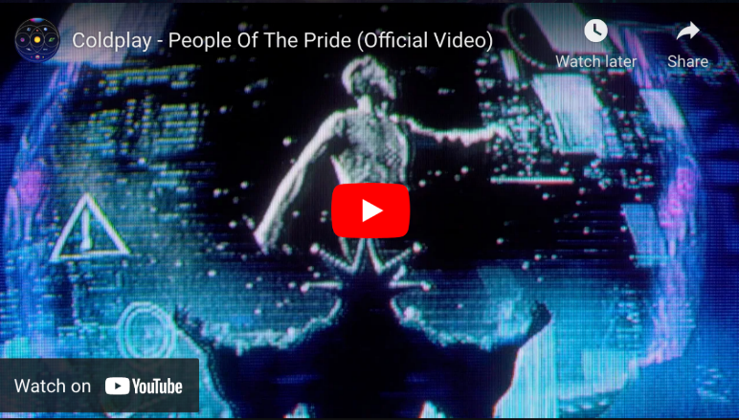

On the eve of their world tour, Coldplay have today premiered the official video for People Of The Pride from their hit album Music Of The Spheres. Watch at youtu.be/_MOmdDLQVn4 now.

Directed by Paul Dugdale, the pulsating video mixes live footage from the band’s October 2021 performance at Seattle’s Climate Pledge Arena with robot-heavy, dystopian animation.

The band’s global stadium tour begins in Costa Rica on Friday. The full list of Music Of The Spheres World Tour shows is available at coldplay.com/tour. The tour is accompanied by a comprehensive set of sustainability initiatives which can be seen at coldplay.com/sustainability.

For more information please visit Coldplay.com or contact:
Sheila Richman | sheila.richman@atlanticrecords.com
Ted Sullivan | ted.sullivan@atlanticrecords.com
Gabrielle Reese (Tour) | gabrielle.reese@atlanticrecords.com

