ENCHANTING TAPS COI LERAY FOR “FREAKY DEAKY’
NEW SONG AND MUSIC VIDEO OUT NOW
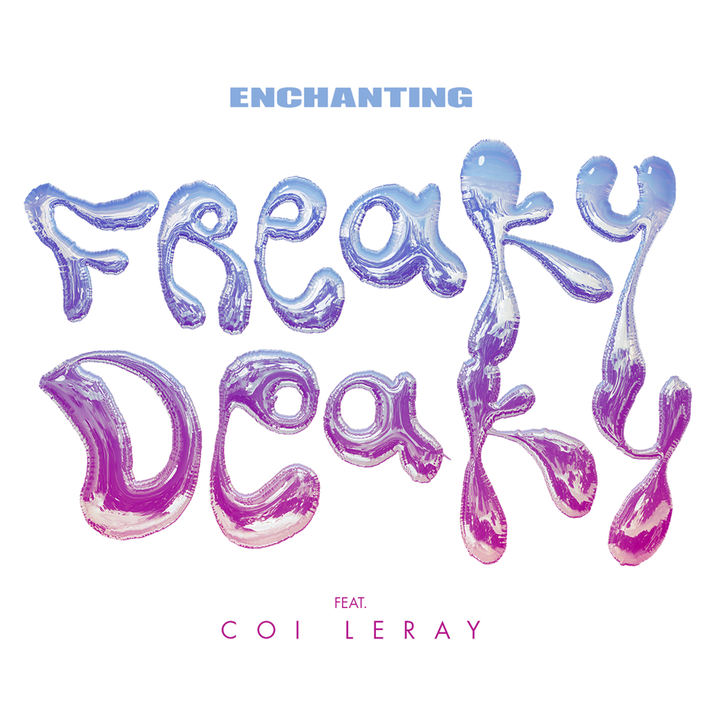
The New 1017’s rising star Enchanting has enlisted the help of hip hop sensation Coi Leray for her latest track “Freaky Deaky,” streaming now via DSPs and streaming services HERE. The new song is accompanied by an enticing music video, streaming now via YouTube HERE. Along with her signature raspy verses, Enchanting shows off her singing in the song’s infectious chorus.
STREAM “FREAKY DEAKY (FEAT. COI LERAY)”
WATCH “FREAKY DEAKY (FEAT. COI LERAY)”
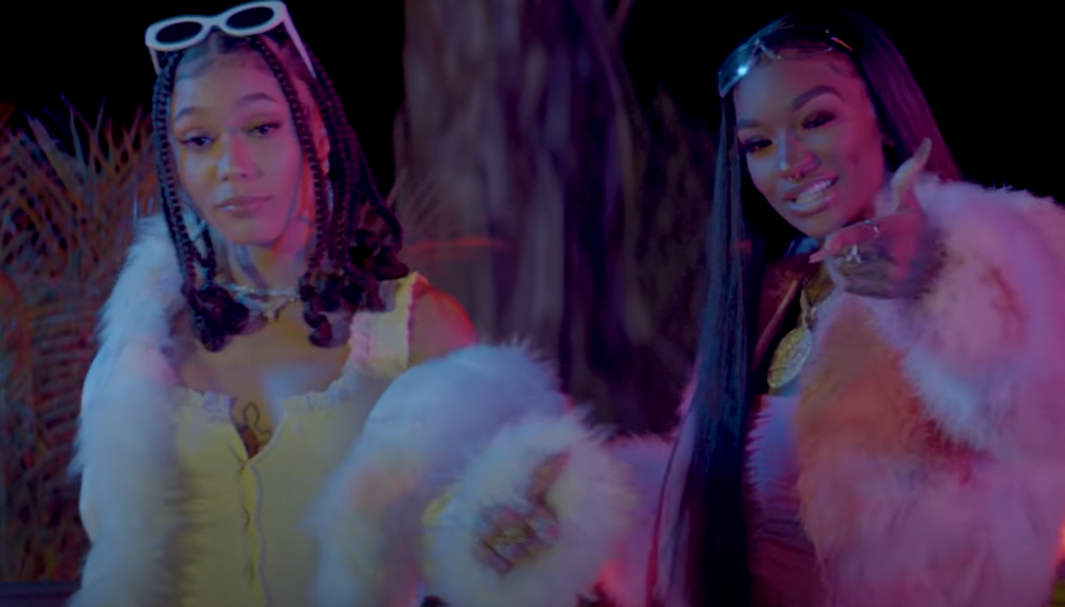
“Freaky Deaky” follows Enchanting’s release of “Want Sum,” a hard-hitting track that’s surpassed 1M streams to date. A music video for “Want Sum” is also streaming now via YouTube HERE.
Enchanting’s stage name speaks for itself. With the way her voice swirls around the beat, the name serves as a perfect descriptor of her ethereal vocals. Pressing play on an Enchanting verse, you’re instantly mesmerized by the textures the 22-year-old songstress brings to the mic. Coming out of Fort Worth, Texas, Enchanting began to pursue music around the age of 18. After graduating high school, she was quick to begin taking music seriously, taking to the studio to record “a little mixtape” that boosted both her career and her passion for music.
Recently, Enchanting appeared on Gucci Mane’s compilation tapes Gucci Mane Presents: So Icy Summer and So Icy Gang: Vol 1, highlighted by “No Luv” and its official music video with over 12M official views HERE. Enchanting credits Dallas’ superproducer, J. White Did It for making the connection between herself and Atlanta rap icon Gucci Mane. “I guess he told Gucci about me,” Enchanting explains with excitement and gratitude. “Gucci called me the next day.”

###
CONNECT WITH ENCHANTING
TWITTER
INSTAGRAM
YOUTUBE

PRESS CONTACT
Ashley Kalmanowitz | Ashley.Kalmanowitz@atlanticrecords.com

