FOR IMMEDIATE RELEASE
APRIL 8, 2022

GALANTIS ANNOUNCE RED ROCKS AMPHITHEATRE LIVESTREAM CONCERT EVENT

SOLD-OUT SHOW TO AIR LIVE APRIL 22ND EXCLUSIVELY ON VEEPS,
VIRTUAL TICKETS ON SALE NOW

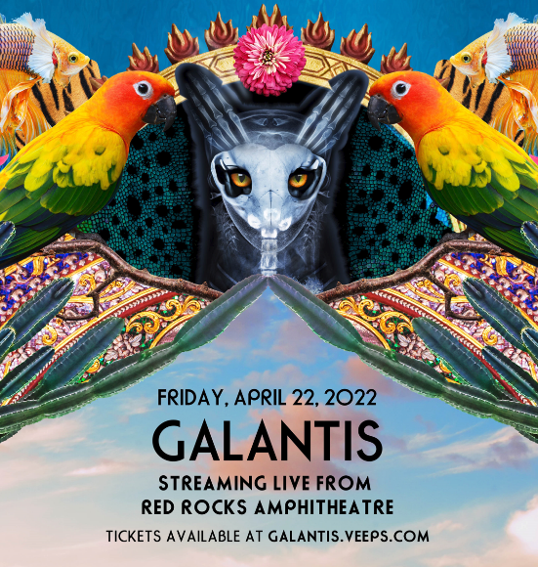
DOWNLOAD HIGH-RES IMAGES/ARTWORK

Internationally-acclaimed collaborative project Galantis has announced an exclusive livestream concert event, broadcasting live from its sold-out April 22nd show at the legendary Red Rocks Amphitheatre in Morrison, CO. Airing on VEEPS.COM, virtual tickets are available now via GALANTIS.VEEPS.COM.

One of the most dynamic live acts in dance music, Galantis boasts an innovative show that incorporates a three-tiered stage equipped with cymbals, drum pads, and 5 full-size kick drums. Since debuting in 2009, Galantis has sold out countless venues around the world on their headline tours and has thrilled crowds across the global festival circuit.

The past few months have seen a series of massive genre-bending collaborations for Galantis, most recently including “What It Feels Like” with Navos & You, “Good Luck” with Mabel & Jax Jones, “Run” with Becky Hill, “Sweet Talker” with Years & Years and a remix of Coldplay & BTS’ #1 single “My Universe.” Galantis also reunited with Little Mix for a remix of their single “No,” marking the second collaboration this year with the superstar group after their 2021 global smash hit “Heartbreak Anthem” alongside David Guetta.

***

ABOUT GALANTIS:
Setting a new standard for songwriting in dance music, Galantis is a collaborative project led by Christian Karlsson (aka Bloodshy, one-third of Miike Snow). Galantis' debut album Pharmacy reached No. 1 on the Billboard Dance album chart on the strength of RIAA gold certified single “Peanut Butter Jelly” and 2x platinum certified smash “Runaway (U & I)” – the latter of which earned GRAMMY nominations for “Best Dance Recording” and “Best Remixed Recording” – while 2017’s sophomore album The Aviary (featuring platinum certified single “No Money”) saw a top 10 debut in 23 countries. The third Galantis album, 2020’s Church, featured the chart-topping single “Faith” with country music icon Dolly Parton featuring Mr. Probz, which saw a #1 debut on Billboard’s Dance/Electronic Chart before quickly reaching #1 on the Dance/Mix Show Airplay Chart where it remained for 5 weeks. Meanwhile, 2021’s collaborative single “Heartbreak Anthem” with David Guetta & Little Mix proved a global sensation, spending 10 weeks on the Billboard Global 200 chart and reaching #1 on the overall UK Radio chart. Galantis has received over 4 billion cumulative worldwide streams, and over 1.6 billion video views to date.

The story of Galantis started back in 2009. Working as Bloodshy, Karlsson’s songwriting collaborations have included Madonna, Kylie Minogue, Katy Perry and Britney Spears (whose “Toxic” earned a GRAMMY for “Best Dance Recording”). This collaborative nature led to the birth of the Galantis project which had its live debut at 2014’s Coachella Valley Music and Arts Festival and has continued on years later as one of dance music's most dynamic and in-demand live performers.

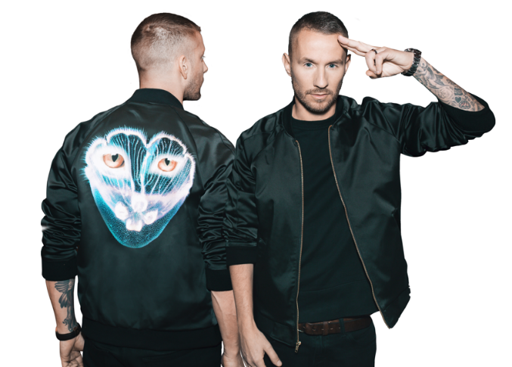
DOWNLOAD HIGH-RES IMAGES/ARTWORK

CONNECT WITH GALANTIS:
WeAreGalantis.com | Twitter | Facebook | YouTube | Instagram

CONTACT:
Ted Sullivan (Atlantic Records) | Ted.Sullivan@atlanticrecords.com

