JASIAH AND LIL DARKIE TEAM UP ON “SCORN”
PRODUCED BY WHETHAN AND DWILLY
GENRE-BENDING RECORDING ARTIST SET TO PERFORM AT LOLLAPALOOZA
CURRENTLY ON THE ROAD WITH JXDN FOR TELL ME ABOUT TOMORROW TOUR
DOWNLOAD/STREAM
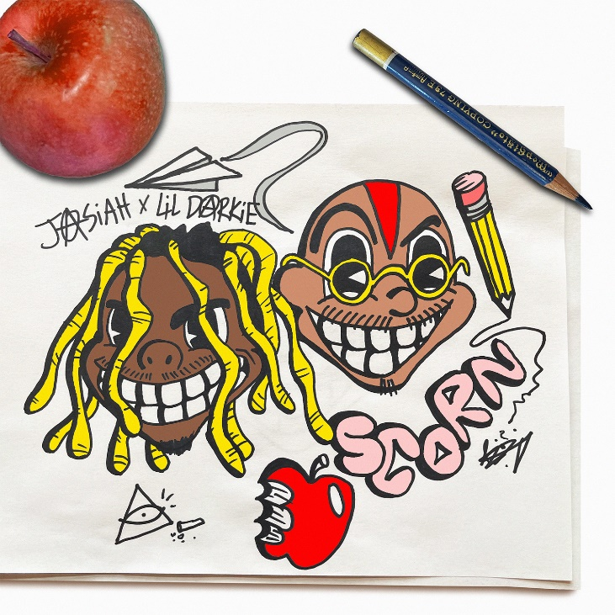
CONTACT:
JASON DAVIS | JASON.DAVIS@ATLANTICRECORDS.COM

CONNECT WITH JASIAH:
WEBSITE | FACEBOOK | TWITTER | INSTAGRAM | YOUTUBE

# # #

