FOR IMMEDIATE RELEASE
MAY 16, 2022

KEVIN GATES UNVEILS KHAZA

RAP SUPERSTAR FOLLOWS RIAA GOLD CERTIFIED VIRAL SUCCESS OF “THINKING WITH MY DICK”
WITH EAGERLY AWAITED THIRD STUDIO ALBUM

NEW TRACK, “BAD FOR ME,” PREMIERES TODAY

BIG LYFE TOUR BEGINS AUGUST 18 IN DALLAS, TX

KHAZA ARRIVES AT LAST ON FRIDAY, JUNE 17TH

PRE-ORDERS AVAILABLE NOW HERE

LISTEN TO “BAD FOR ME” HERE

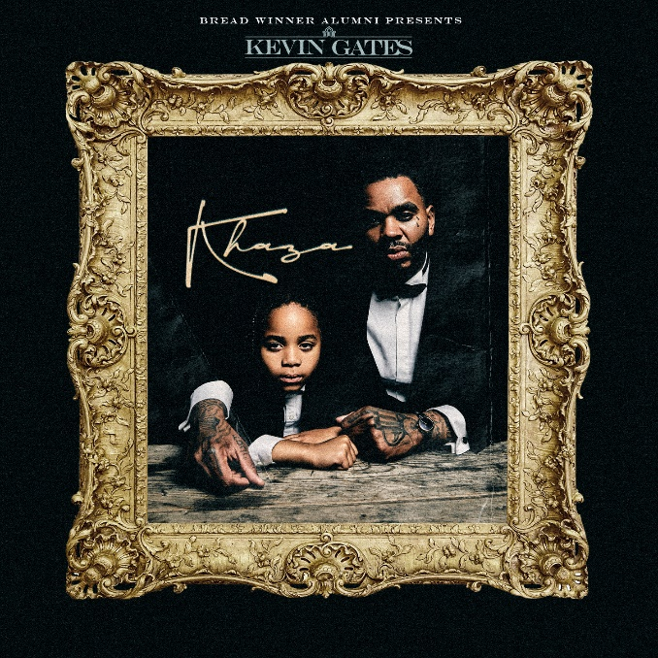

DOWNLOAD HI-RES ALBUM ARTWORK HERE
DOWNLOAD HI-RES SINGLE ARTWORK HERE

RIAA multi-platinum certified rap superstar Kevin Gates has announced the long-awaited release of his third studio album, KHAZA, due to arrive via Bread Winner Alumni/Atlantic Records on Friday, June 17th. Pre-orders are available now HERE. KHAZA is heralded by today’s premiere of the new track, “Bad For Me,” available for streaming and download HERE and produced by DJ Chose & P-Crisco.

In addition, KHAZA also includes the acclaimed new song, “Big Lyfe,” available now at all DSPs and streaming services HERE. An edgy, NYC-inspired official music video is streaming now at YouTube HERE. Produced by 3x GRAMMY® Award-nominee T-Minus (Drake, Kendrick Lamar, Young Thug), “Big Lyfe” was met by widespread media attention, with REVOLT declaring, “The brand new offering sees Kevin Gates spit some bars about appreciating the journey you’re on and life you’re living.” “The rapper's success and spirituality align over electrifying production,” wrote HotNewHipHop, “celebrating the power of positivity and purpose.”

Gates – who recently debuted “Big Lyfe” to a sold-out crowd of more than 9,500 at Morrison, CO’s world-famous Red Rocks Amphitheatre – will celebrate KHAZA with the epic “Big Lyfe Tour,” getting underway August 18 at Dallas, TX’s The Pavilion at Toyota Music Factory and then continuing into mid-October. For updates, please visit www.kvngates.com/tour.

KEVIN GATES BIG LYFE TOUR 2022

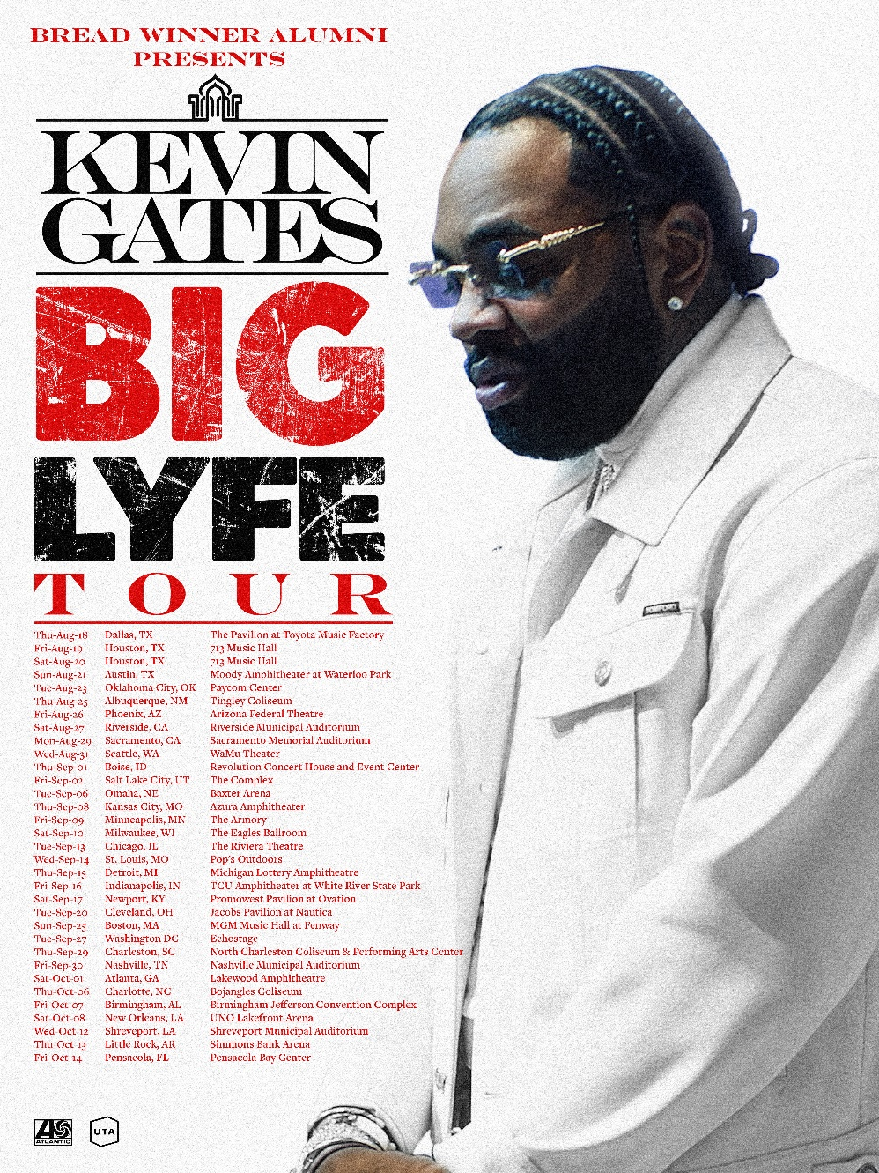

AUGUST
18 – Dallas, TX – The Pavilion at Toyota Music Factory
19 – Houston, TX – 713 Music Hall
20 – Houston, TX – 713 Music Hall
21 – Austin, TX – Moody Amphitheater at Waterloo Park
23 – Oklahoma City, OK – Paycom Center
25 – Albuquerque, NM – Tingley Coliseum
26 – Phoenix, AZ – Arizona Federal Theatre
27 – Riverside, CA – Riverside Municipal Auditorium
29 – Sacramento, CA – Sacramento Memorial Auditorium
31 – Seattle, WA – WaMu Theater

SEPTEMBER
1 – Boise, ID – Revolution Concert House and Event Center
2 – Salt Lake City, UT – The Complex
6 – Omaha, NE – Baxter Arena
8 – Kansas City, MO – Azura Amphitheater
9 – Minneapolis, MN – The Armory
10 – Milwaukee, WI – The Eagles Ballroom
13 – Chicago, IL – The Riviera Theatre
14 – St. Louis, MO – Pop’s Outdoors
15 – Detroit, MI – Michigan Lottery Amphitheater at Freedom Hill
16 – Indianapolis, IN – TCU Amphitheater at White River State Park
17 – Newport, KY - PromoWest Pavilion at Ovation
20 – Cleveland, OH – Jacobs Pavilion at Nautica
25 – Boston, MA – MGM Music Hall at Fenway
27 – Washington, DC – Echostage
29 – Charleston, SC – North Charleston Coliseum & Performing Arts Center
30 – Nashville, TN – Nashville Municipal Auditorium

OCTOBER
1 – Atlanta, GA – Lakewood Amphitheatre
6 – Charlotte, NC – Bojangles Coliseum
7 – Birmingham, AL – Birmingham Jefferson Convention Complex
8 – New Orleans, LA – UNO Lakefront Arena
12 – Shreveport, LA – Shreveport Municipal Auditorium
13 – Little Rock, AR – Simmons Bank Arena
14 – Pensacola, FL – Pensacola Bay Center

# # #

Last month saw the release of two spectacular new spins on Gates’ chart-topping viral sensation, “Thinking with My Dick (Feat. Juicy J),” both available now at all DSPs and streaming services. The exclusive reworks see the RIAA gold certified smash given brand new shapes by indie dance heavyweight TEN TONNE SKELETON (streaming HERE) and Berlin-based producer/DJ LOVRA (streaming HERE).

Originally released in 2013, “Thinking with My Dick (Feat. Juicy J)” suddenly blew up nine years later after becoming the #1 overall sound on TikTok, catapulting it to the top 5 on Apple Music’s overall US chart, #3 on the US Shazam chart, #9 on the US. SoundCloud chart, and #25 on the Global Shazam chart. Now boasting over 8.5B TikTok views, 2.7M TikTok creates, and more than 104M worldwide audio streams to date, the track soon earned RIAA gold certification while ascending to the top 40 on Billboard’s “Hot 100,” making history as Gates’ second top 40 hit thus far.

Kevin Gates is of course among the most impactful and inimitable rappers of the modern era, racking up more than 18B worldwide streams, 7B views, countless RIAA multi-platinum, platinum, and gold certifications, and a social media reach exceeding 30M followers around the globe. For 15 years, the Baton Rouge, LA-based icon’s artistry has drawn critical acclaim and unprecedented popular success, resulting in four top 5 entries on the Billboard 200 – including 2016’s 2x RIAA platinum certified classic, ISLAH, 2017’s BY ANY MEANS 2, 2018’s LUCA BRASI 3, and 2019’s I’M HIM – as well as seven debuts among the top 5 on both the “Top Rap Albums” and “Top R&B/Hip-Hop Albums” charts. An electrifying live performer, Gates has lit up countless stages around the world, spanning headline tours, show-stopping festival sets, and arena tours alongside such fellow superstars as Cardi B. Indeed, Gates has been an in-demand collaborator, with featured appearances on hit tracks from Gucci Mane, YoungBoy Never Broke Again, Da Baby, and Lil Durk, to name only a few. In addition, his inspirational online series, The Kevin Gates Helpline, is currently in its second season and streaming now via VICE. With the wind at his back, Gates is poised for the upcoming arrival of his third full-length Bread Winner Alumni/Atlantic Records LP, the hugely anticipated KHAZA, now as always doing things his own way, setting his own exceptional path towards greatness with every step.
# # #

CONNECT WITH KEVIN GATES
WEBSITE | TWITTER | TIKTOK | INSTAGRAM | FACEBOOK | SOUNDCLOUD | YOUTUBE

FOR KEVIN GATES INQUIRIES, CONTACT
SYDNEY.MARGETSON@ATLANTICRECORDS.COM

