FOR IMMEDIATE RELEASE
MARCH 4, 2022

KOJEY RADICAL RELEASES DEBUT ALBUM “REASON TO SMILE”

REASON TO SMILE OUT TODAY VIA ASYLUM/ATLANTIC RECORDS

INCLUDES THE RECENTLY RELEASED SINGLES “PAYBACK” FT KNUCKS,
“WAR OUTSIDE” FT LEX AMOR AND “GANGSTA”

ADDITIONAL APPREARANCES INCLUDE MASEGO, TIANA MAJOR9, KELIS,
SHAE UNIVERSE, WRETCH 32 & MORE

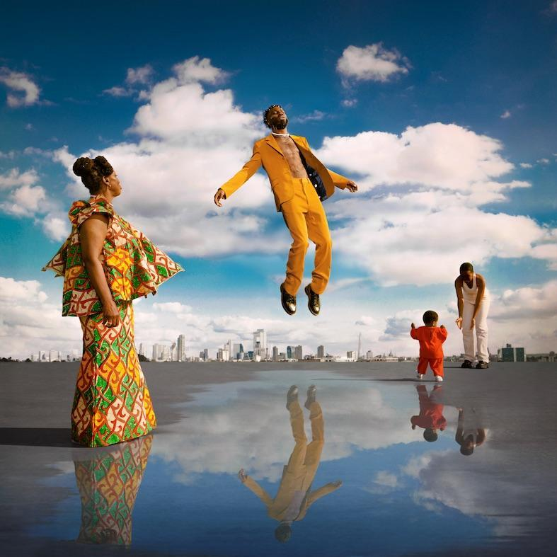
(download high res album art here)

"On the brink of rap greatness" - The Observer

"One of the most potent creative talents at work in British music" – Clash

"A potent artistic force" - Evening Standard

"Reason to Smile, a cohesive yet varied offering that makes no bones about its own ambition... His is clearly music to feel uplifted by, exploring the nuances of joy, hardship and masculinity" – The Guardian

“He tips his hat to his heroes here, but the swagger and conviction that this record oozes is no imitation job – it’s all his own” – Loud & Quiet

Kojey Radical, one of the UK's most influential musical voices, today releases his long-awaited debut album Reason To Smile via Asylum / Atlantic Records. Featuring the acclaimed singles “Payback (ft. Knucks)”, "War Outside (ft Lex Amor)" and "Gangsta", the 15 track features guest appearances from Tiana Major9, Masego, Shaé Universe, Cashh, Kelis, Lex Amor, Knucks, Shakka, Wretch 32, Ego Ella May and Rex Life Raj and his own mother (whose voice weaves throughout the record) alongside a who's-who of global production talent including KZ, Swindle, Jay Prince, iO, The FaNaTiX, Cadenza, 169, Venna, Ric & Thadeus, Blue Lab Beats, Emil Larbi, Mr Cutts and Ed Thomas.

BUY / DOWNLOAD / STREAM REASON TO SMILE HERE

To celebrate the release of Reason To Smile, Kojey Radical has also announced a week long pop up Reason To Smile store at London’s Boxpark Shoreditch, where he’ll be selling physical copies of the album. It’s a full circle moment for Kojey, who used to work in unit 12 and will take over unit 21 from today (4th March) until Friday 11th March. Fans can expect to find Kojey and friends behind the counter and in store at various points over the week and should check socials for announcements.

2022 will also see Kojey Radical’s biggest ever live shows. Following a run of intimate UK in store and out-store performances the week of album release, Kojey will headline London’s legendary, 5000 capacity O2 Academy Brixton on 7th April 2022 and Manchester’s 2300 capacity Albert Hall on 6th April. For full details via https://kojeyradical.online/

KOJEY RADICAL LIVE 2022

“From Me To You” Tour

Friday 4th March Rough Trade East / London (Instore Performance + Signing)
Saturday 5th March Banquet Records @ Pryzm / Kingston (Out store Performance + Signing)
Monday 7th March Vinilo / Bournemouth (Performance)
Tuesday 8th March Resident / Brighton (Instore Performance + Signing)
Wednesday 9th March HMV / Manchester (Signing)
Wednesday 9th March Crash / Leeds (Performance)
Thursday 10th March HMV / Birmingham (Signing)
Thursday 10th March Rough Trade / Bristol (Performance + Signing)

“Reason To Smile” Tour

Wednesday 6th April The Albert Hall, Manchester
Thursday 7th April O2 Academy Brixton, London

REASON TO SMILE OFFICIAL TRACKLIST

1. Reason to Smile ft. Tiana Major9
2. Together
3. Nappy
4. Silk ft. Masego
5. Pressure ft. Shaé Universe
6. Born Feat Cash
7. Pusher Man BWI
8. Talkin ft Kelis & Tiana Major9
9. War Outside ft Lex Amor
10. Payback ft Knucks
11. Fubu
12. Beautiful ft Shakka & Wretch 32
13. Anywhere ft Ego Ella May
14. Solo ft. Rexx Life Raj
15. Gangsta

ABOUT KOJEY RADICAL

Born and raised in East London, British Ghanaian Kwadwo Adu Genfi Amponsah aka Kojey Radical is often described as a “renaissance man”. At 28 years old, he is at the forefront of a generation of young British artists who have pushed underground Black music into the mainstream over the last few years through a series of acclaimed, ambitious EPs - Dear Daisy, 23Winters, In Gods Body and Cashmere Tears - and collaborations with the likes of Mahalia, Mereba, Ghetts, Shy FX, AJ Tracey, Swindle, Wretch32 and MJ Cole. On the eve of the release of his highly anticipated debut album Reason To Smile, Kojey Radical embodies everything that makes an artist truly exciting in 2021; he’s an authentic and uncompromising creative force, constantly evolving and blurring boundaries as he moves from rap, funk, spoken word and poetry to fashion, art and film with an almost effortless fluidity.

Connect with Kojey Radical:
INSTAGRAM // SPOTIFY // YOUTUBE

Press Contact:
Selam Belay // selam.belay@atlanticrecords.com

