FOR IMMEDIATE RELEASE
MAY 20, 2022

MAHALIA RELEASES HER HOTLY ANTICIPATED NEW EP ‘LETTER TO UR EX’

UNVEILS ACCOMPANYING VIDEO FOR UNHEARD TRACK ‘LETTER TO UR N(EX)T’

WATCH “LETTER TO UR N(EX)T” VIDEO

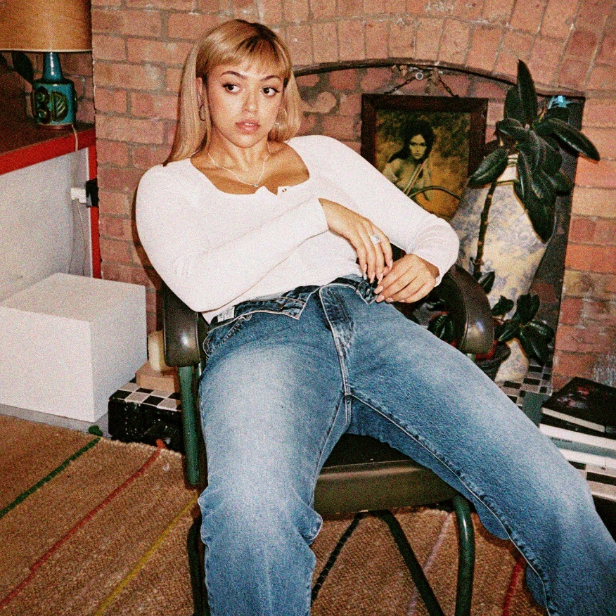

Today, GRAMMY-nominated R&B star Mahalia has released her highly anticipated new EP ‘Letter To Ur Ex’ - available now, globally via Atlantic Records. The project can be streamed on all DSPs HERE. Further to previous single releases ‘Letter To Ur Ex’, ‘Whatever Simon Says’, ‘Forever’ and ‘In The Club’, Mahalia has today unveiled her new EP in its entirety which includes the yet to be heard track ‘Letter To Ur N(ex)t’, a single which marks the concluding piece to the pentalogy and can streamed on all DSPs HERE. The accompanying visual can be streamed via YouTube HERE.

Speaking on the new track, Mahalia states; “This song will always have a bittersweet place in my heart, I think. I wrote this about my ex-partner the night before he broke up with me. Either I was completely delusional or maybe it wasn’t actually for him. I’ve always had this thought that sometimes you can write music about people who haven’t even entered your life yet. It’s almost like a sixth sense. “Forever” will always be one of my favorite love songs I’ve ever written. This song was just about finding that person that makes your senses tingle. It is a song about not being afraid to love and fall hard.”

On the EP, Mahalia states; “The idea behind ‘letter to ur ex’ was to be a tribute to all types of Exes. Whether that be an ex partner. An ex of a new partner. An ex version of oneself .. It is an EP of letters dedicated to all the different people and different stages of my life during these last two years. Real stories and real diary entries.”
The last two years have marked many achievements for the Leicester-born star. Beginning 2020 with her second BRIT nomination, Mahalia featured on up-and-coming fellow Midlands rapper Pa Salieu’s debut mixtape, ‘Send Them To Coventry’, whilst also gracing the tracklist of Headie One’s #1 album ‘Edna’. Subsequently, Mahalia also received a GRAMMY nomination for ‘All I Need’ - Jacob Collier’s single of which she features alongside US rapper, Ty Dolla $ign. Shortly after, Mahalia concluded the year with three MOBO nominations for ‘Best Female Act’, ‘Best R&B/Soul Act’ and ‘Album Of The Year’ for her debut album, ‘Love and Compromise’, winning in the first two categories. In 2021, Mahalia was also nominated for her first ever Ivor Novello award for her 2020 collaboration with UK lyricist Pa Salieu for his single ‘Energy’ and subsequently concluded the year with an incredible headline show at London’s prestigious venue, O2 Brixton Academy.
Besides the awards and nominations, it’s also been a time of deep personal growth, one that Mahalia describes as a real rollercoaster in her personal and professional life. Reflection has been the thread running through Mahalia’s writing and while the current global situation offers little more than uncertainty, the singer hopes that her music will encourage her listeners to carve out time to also look back and re-evaluate: “We’re all fixated on how we can make ourselves better during and after this period of time but I want people to also reminisce on lovely or painful situations they’ve lived through and how they’ve helped shape the people they are now.”

# # #

CONNECT WITH MAHALIA
OFFICIAL WEBSITE | TWITTER | FACEBOOK | INSTAGRAM
FOR PRESS INQUIRIES PLEASE CONTACT
ARIANA.WHITE@ATLANTICRECORDS.COM

