FOR IMMEDIATE RELEASE
MAY 2, 2022

MAHALIA UNVEILS NORTH AMERICAN TOUR

GRAMMY® AWARD-NOMINATED R&B STAR CELEBRATES UPCOMING EP
WITH THE “LETTER TO UR EX TOUR”

DATES BEGIN SEPTEMBER 3 IN SAN DIEGO, CA

BUSY LIVE SCHEDULE ALSO INCLUDES FESTIVAL APPEARANCES AT
LOLLAPALOOZA AND MONTREAL’S OSHEAGA PASSES 2022

LETTER TO UR EX EP DUE MAY 20TH

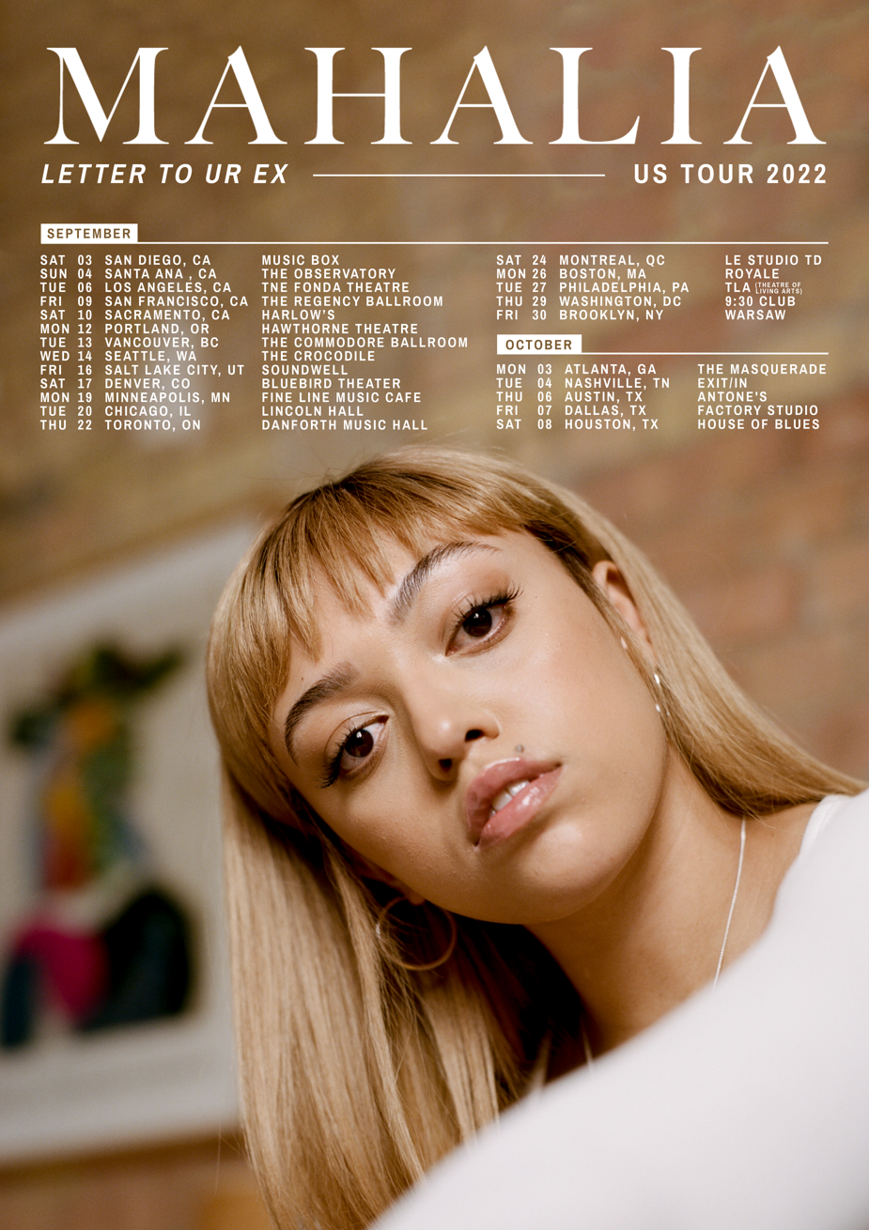

GRAMMY® Award-nominated R&B star Mahalia has announced plans for a major North American tour. “The Letter To Ur Ex Tour” begins September 3 at San Diego, CA’s Music Box and then travels through early October. In addition, Mahalia will follow her upcoming UK/Ireland tour with a number of eagerly awaited North American festival dates, including Chicago, IL’s Lollapalooza (July 28-31) and Montreal, QC’s Osheaga Passes 2022 (Friday, July 29). For complete details and ticket information, please visit www.mahaliamusic.com.
“The Letter To Ur Ex Tour” heralds Mahalia’s upcoming new EP, LETTER TO UR EX, due via Atlantic Records on May 20th. The eagerly awaited project includes the recently released singles, “Letter To Ur Ex,” “Whatever Simon Says” and “In The Club,” all available now at all DSPs and streaming services. The three tracks are joined by official music videos – directed by Mahalia in collaboration with Oliver Kane – streaming now at her official YouTube channel HERE.

The past two years have seen Mahalia rising towards the highest ranks of R&B royalty, including a 2021 GRAMMY® Award nomination for “Best R&B Performance” honoring Jacob Collier’s “All I Need (with Mahalia & Ty Dolla $ign),” an NAACP Image Award nomination as “Best New Artist,” a trio of Brit Award nominations, and prestigious MOBO Awards for both “Best Female Act” and “Best R&B/Soul Act.” She was also featured on Lucky Daye’s latest album, “Table For Two,” which recently won “Best Progressive R&B Album” at the 2022 GRAMMY Awards. Last year saw the Leicester, UK-based singer-songwriter following up her breakthrough 2019 sophomore album, Love and Compromise, with a series of new singles including the top 20 Adult R&B hit, “Whenever You’re Ready,” “Roadside (Feat. AJ Tracey),” and “Jealous (Feat. Rico Nasty),” the latter hailed by Stereogum as “an excellent piece of work — lithe, breezy, confident.”

Along with the many honors and creative efforts, it’s also been a time of deep personal growth, one Mahalia describes as a real rollercoaster in both her personal and professional life. With the impending arrival of LETTER TO UR EX, Mahalia hopes her music will encourage her listeners around the world to carve out time to also look back and revaluate.

“We’re all fixated on how we can make ourselves better during and after this period of time,” Mahalia says, “but I want people to also reminisce on lovely or painful situations they’ve lived through and how they’ve helped shape the people they are now.”

# # #

MAHALIA
LETTER TO UR EX NORTH AMERICAN TOUR

JULY
28-31 – Chicago, IL – Lollapalooza *
29 – Montreal, QC - Osheaga*

SEPTEMBER
3 – San Diego, CA – Music Box
4 – Santa Ana, CA – The Observatory – Constellation Room
6 – Los Angeles, CA – The Fonda Theatre
9 – San Francisco, CA – The Regency Ballroom
10 – Sacramento, CA – Harlow’s
12 – Portland, OR – Hawthorne Theatre
13 – Vancouver, BC – The Commodore Ballroom
14 – Seattle, WA – The Crocodile
16 – Salt Lake City, UT – Soundwell
17 – Denver, CO – Bluebird Theater
19 – Minneapolis, MN – Fine Line Music Cafe
20 – Chicago, IL – Lincoln Hall
22 – Toronto, ON – Danforth Music Hall
24 – Montreal, QC – L’Astral
26 – Boston, MA – Royale
27 – Philadelphia, PA – Theatre of Living Arts
29 – Washington, DC – 9:30 Club
30 – Brooklyn, NY – Warsaw

OCTOBER
3 – Atlanta, GA – The Masquerade -- Purgatory
4 – Nashville, TN – Exit/In
6 – Austin, TX – Antone’s
7 – Dallas, TX – Factory Studio
8 – Houston, TX – House of Blues – Bronze Peacock

* FESTIVAL APPEARANCE

# # #

CONNECT WITH MAHALIA:
OFFICIAL | TWITTER | FACEBOOK | INSTAGRAM | YOUTUBE

PRESS CONTACT:
ARIANA.WHITE@ATLANTICRECORDS.COM

