FOR IMMEDIATE RELEASE
APRIL 21, 2022

NOCAP AND KODAK BLACK “SAVE THE DAY”

ACCLAIMED MOBILE, AL RAPPER HERALDS EAGERLY ANTICIPATED DEBUT ALBUM
WITH EXCEPTIONAL NEW SINGLE

THE MR.CRAWFORD TOUR BEGINS APRIL 24 IN DALLAS, TX

MR. CRAWFORD ARRIVES VIA NEVER BROKE AGAIN LLC/ATLANTIC ON FRIDAY, APRIL 29

PRE-SAVES AVAILABLE NOW HERE

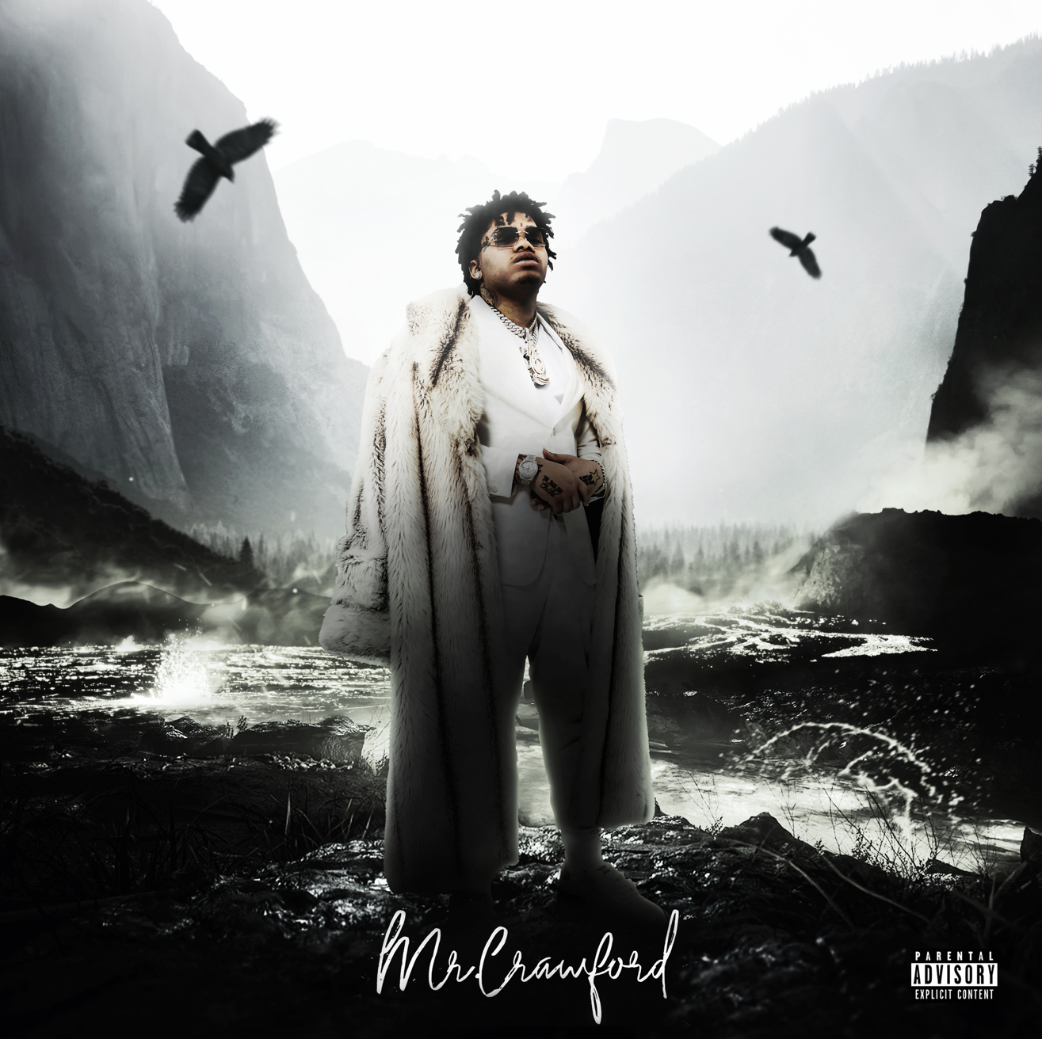
LISTEN TO “SAVE THE DAY” HERE

RIAA gold certified Mobile, AL rapper NoCap has shared his latest single, “Save The Day (feat. Kodak Black),” available now via Never Broke Again LLC/Atlantic at all DSPs and streaming services HERE. The track premiered earlier this afternoon on The Zane Lowe show, as New Music Daily. An official music video will be available in the coming weeks.

“Save The Day” comes on the heels of last week’s newly released single/video “Very Special” – both heralding the long-anticipated arrival of NoCap’s forthcoming debut album, MR. CRAWFORD, due at last on Friday, April 29. Pre-saves are available now HERE. Additional highlights include such recent singles as “Shackles To Diamonds,” “I’ll Be Here,” and “Fortune Teller,” all accompanied by official music videos streaming now at YouTube HERE.

“This is my first album,” NoCap says, “so I chose to use my real last name as the title. It deals with my perspectives on everything. It’s meant to open my world up.”

Hailed by Pitchfork as “a standout voice in the Deep South,” NoCap will celebrate MR. CRAWFORD with his biggest U.S. headline tour to date. The Mr. Crawford Tour gets underway April 24 at Dallas, TX’s House of Blues and then travels through late May. For complete details and ticket availability, please visit www.nocap.com.

By embracing the art of storytelling, NoCap narrates his life out loud. With over 100M global streams, an increasingly rapt fan following, and ecstatic praise from such outlets as Rolling Stone, Hypebeast, The FADER, Pitchfork, and more, the Mobile, AL-based rapper and singer dips in and out of turbulent and triumphant memories, all with the same careful attention to detail. 2019 saw the breakthrough release of such mixtapes as The Hood Dictionary and Steel Human, the latter highlighted by the RIAA gold certified anthem, “Ghetto Angels,” a YouTube favorite with views now exceeding 83M HERE. An array of high profile projects followed, from collaborations with Lil Baby, DaBaby, YFN Lucci, and YoungBoy Never Broke Again to “Family (Feat. Quando Rondo),” featured on 2020’s smash Road To Fast 9 Mixtape. After spending half of 2021 behind bars, he unleashed his second RIAA gold certified single, “Vaccine,” named by Pitchfork as one of “The 38 Best Rap Songs of 2021” and joined by an official music video currently boasting more than 60M views via YouTube HERE. Now, with the long awaited release of MR. CRAWFORD, NoCap’s true story comes into focus like never before.

“This will put me in different lane,” NoCap says. “It has club vibes, sad vibes, and different vibes. The production is different. Everything is different though. That was the point. I’m coming with a new sound.”

# # #

NOCAP
MR. CRAWFORD TOUR 2022

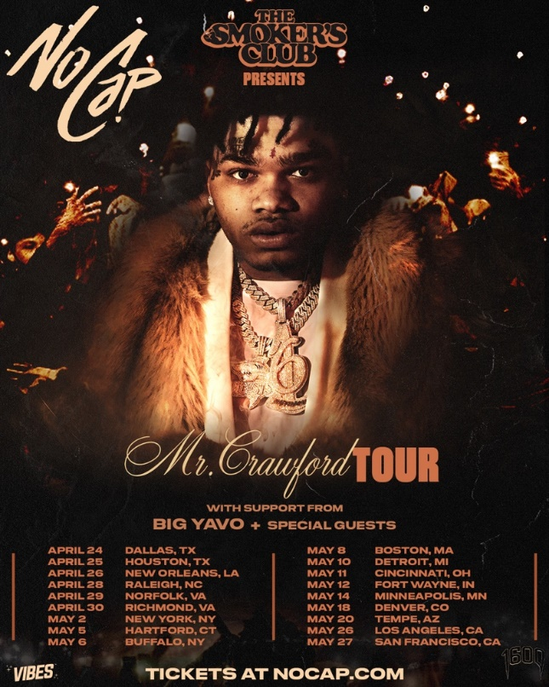

APRIL 24: DALLAS, TX - HOUSE OF BLUES
APRIL 25: HOUSTON, TX - HOUSE OF BLUES
APRIL 26: NEW ORLEANS, LA - HOUSE OF BLUES
APRIL 28: RALEIGH, NC - THE RITZ
APRIL 29: NORFOLK, VA - NORVA
APRIL 30: RICHMOND, VA - CLASSIC AMPHITHEATER
MAY 2: NEW YORK, NY - GRAMERCY THEATRE
MAY 5: HARTFORD, CT - WEBSTER THEATRE
MAY 6: BUFFALO, NY - SHOWPLACE THEATER
MAY 8: BOSTON, MA - BIG NIGHT LIVE
MAY 10: DETROIT, MI - THE MAJESTIC
MAY 11: CINCINNATI, OH - BOGARTS
MAY 12: FORT WAYNE, IN - PIERE'S ENTERTAINMENT CENTER
MAY 14: MINNEAPOLIS, MN - SKYWAY THEATRE
MAY 18: DENVER, CO - CERVANTE'S MASTERPIECE BALLROOM
MAY 20: TEMPE, AZ - AURA
MAY 26: LOS ANGELES, CA - THE NOVO
MAY 27: SAN FRANCISCO, CA - THE REGENCY BALLROOM

# # #

CONNECT WITH NOCAP
WEBSITE | FACEBOOK | TWITTER | INSTAGRAM | YOUTUBE

FOR ALL PRESS INQUIRIES, PLEASE CONTACT
ARIANA.WHITE@ATLANTICRECORDS.COM

