FOR IMMEDIATE RELEASE
MARCH 17, 2021

NOCAP SHARES “SHACKLES TO DIAMONDS”

THE LATEST SINGLE FROM HIS EAGERLY ANTICIPATED DEBUT ALBUM “MR. CRAWFORD”

PRE-ORDER “MR. CRAWFORD” HERE

WATCH THE OFFICIAL MUSIC VIDEO HERE

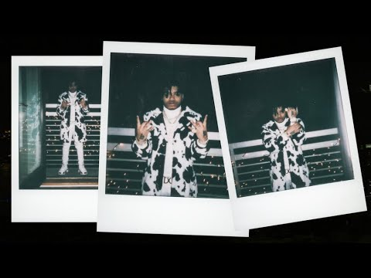

“NoCap continues to create his own sound and climb as a talent in the rap game.” – COMPLEX

Acclaimed Mobile, AL-based rapper NoCap has announced the release of a major new single. “Shackles to Diamonds” is available now via Never Broke Again LLC/Atlantic at all DSPs and streaming services. The official music video is available to stream on YouTube HERE.

Hailed by Pitchfork as “a standout voice in the Deep South”, NoCap will celebrate the long-awaited release of his debut album by headlining his biggest U.S. tour schedule to date. Tickets for the Mr. Crawford Tour are on sale this Friday, March 18th with the tour set to begin in Dallas on April 24th. For complete details and availability, please visit NoCap.com.

Born and raised in the projects of Mobile, AL, NoCap channels struggle into a melodic hip-hop carried by his airtight control of melody, pitch, range, and rhymes. 2019 saw the breakthrough release of such mixtapes as THE HOOD DICTIONARY and THE BACKEND CHILD, the latter of which is highlighted by the RIAA gold certified anthem, “Ghetto Angels,” a YouTube favorite with views now exceeding 82M HERE.

Along the way, NoCap – who followed STEEL HUMAN with yet another 2020 banger in “Drown In My Styrofoam,” joined by an official music visual streaming HERE – has racked up more than 11M video views and national acclaim from such high profile publications as Pitchfork, Complex, and more. Hailed by Rolling Stone as “a master of gloom,” NoCap connects by pulling no punches and holding nothing back.

“At the end, I feel like I just tell the truth,” NoCap says. “That’s what I believe I’m here to do. I’m here to let you know what I think and what I’ve been through. If I did this, anybody can do it. There is real pain in my music. I hope you can visualize where I’m coming from. I’m bringing my own style. It ain’t what anybody else is doing. It’s NoCap.”

NOCAP
MR. CRAWFORD TOUR 2022

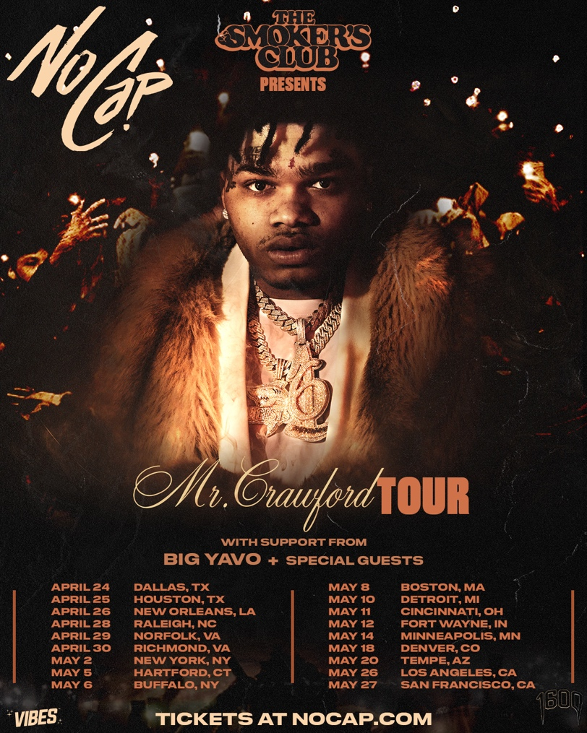
APRIL 24: DALLAS, TX - HOUSE OF BLUES
APRIL 25: HOUSTON, TX - HOUSE OF BLUES
APRIL 26: NEW ORLEANS, LA - HOUSE OF BLUES
APRIL 28: RALEIGH, NC - THE RITZ
APRIL 29: NORFOLK, VA - NORVA
APRIL 30: RICHMOND, VA - CLASSIC AMPHITHEATER
MAY 2: NEW YORK, NY - GRAMERCY THEATRE
MAY 5: HARTFORD, CT - WEBSTER THEATRE
MAY 6: BUFFALO, NY - SHOWPLACE THEATER
MAY 8: BOSTON, MA - BIG NIGHT LIVE
MAY 10: DETROIT, MI - THE MAJESTIC
MAY 11: CINCINNATI, OH - BOGARTS
MAY 12: FORT WAYNE, IN - PIERE'S ENTERTAINMENT CENTER
MAY 14: MINNEAPOLIS, MN - SKYWAY THEATRE
MAY 18: DENVER, CO - CERVANTE'S MASTERPIECE BALLROOM
MAY 20: TEMPE, AZ - AURA
MAY 26: LOS ANGELES, CA - THE NOVO
MAY 27: SAN FRANCISCO, CA - THE REGENCY BALLROOM

# # #

CONNECT WITH NOCAP
WEBSITE | FACEBOOK | TWITTER | INSTAGRAM | YOUTUBE

# # #

FOR ALL PRESS INQUIRIES, PLEASE CONTACT
ARIANA.WHITE@ATLANTICRECORDS.COM

