FOR IMMEDIATE RELEASE
APRIL 13, 2022

QUANDO RONDO LOOKS TOWARDS THE FUTURE ON “24”

MULTI-PLATINUM RAPPER CONTINUES LANDMARK YEAR WITH NEW SINGLE

LISTEN TO “24” HERE | WATCH OFFICIAL MUSIC VIDEO HERE

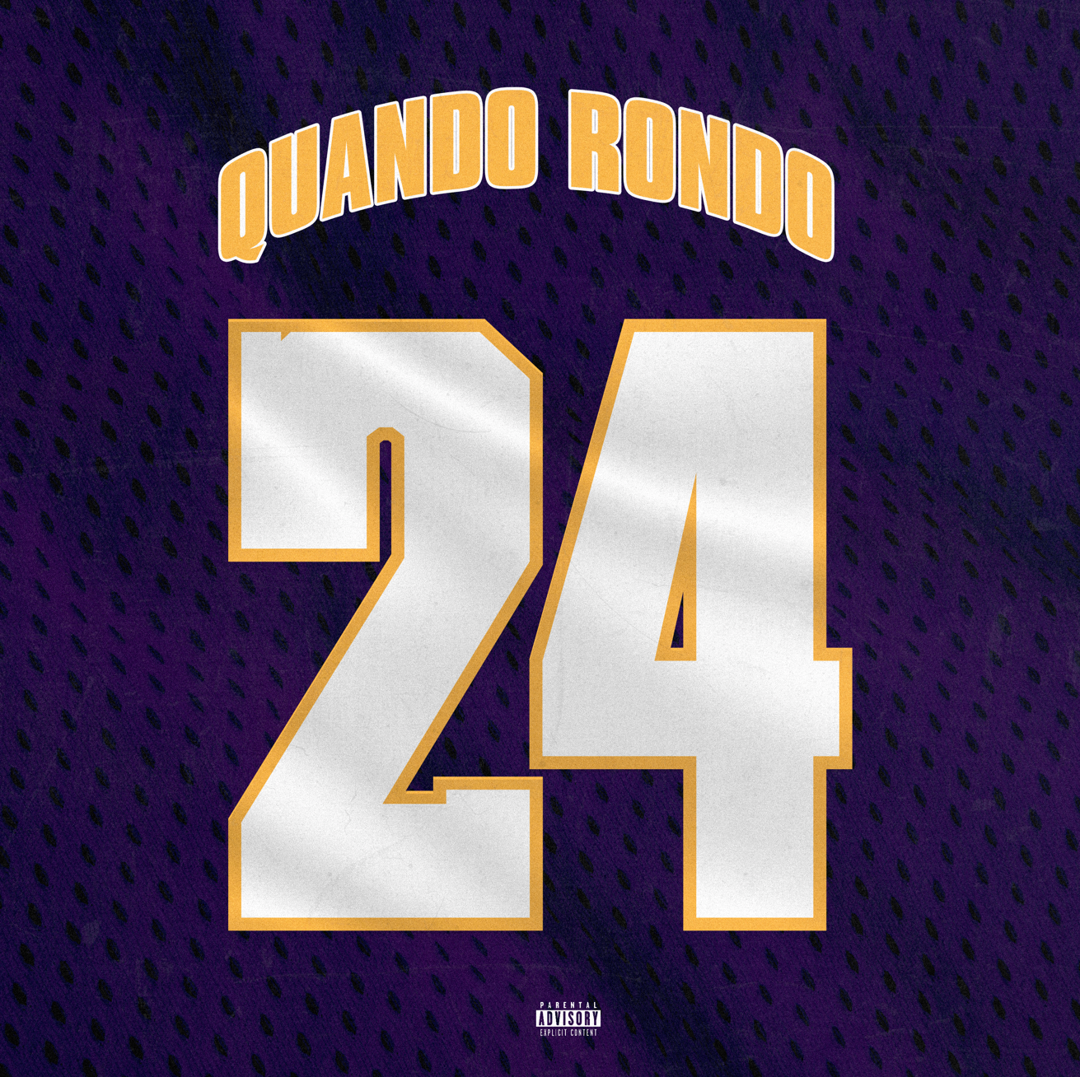

Multi-platinum rapper Quando Rondo is continuing his wildly prolific year with today’s release of his latest single, “24,” available now at all DSPs and streaming services HERE. The track premiered earlier this afternoon on The Zane Lowe show, as New Music Daily and is joined by an official music video, available now at YouTube HERE.

“24” continues what is fast shaping up as another landmark year for the Savannah, GA-based rapper, following such recently released tracks as “10.27,” “Six-0 Business,” “Jakiyah” and his recent guest verse on YoungBoy Never Broke Again’s “Gangsta (Ft. Quando Rondo)” – the only feature on YoungBoy’s chart-topping 2022 mixtape, COLORS. What’s more, YoungBoy shouts out Quando on two of the mixtape’s standout tracks, “Bring It On” and “No Switch.”

“10.27” is joined by an official music video, streaming now via YouTube following its premiere last month celebrating Quando’s 23rd birthday. In addition, a special contest is currently underway now at Tunespeak offering exclusive Quando Rondo T-shirts to 23 of his biggest fans. Entries will be accepted through April 15 HERE.

Quando officially kicked off his busy 2022 with the recently released single, “Dead Wrong,” available for streaming and download HERE; an official music video is streaming HERE. The creative hot streak commenced with last year’s release of the critically acclaimed album, Still Taking Risks, and was swiftly followed by guest verses on the explosive Never Broke Again: The Compilation Vol. 1. A stunning series of singles also dropped, including “Blueprint,” “The Realest,” “Time Spent,” “What I’m On (Ft. Jo Dirt),” and “Shine,” all available now with official music videos streaming via YouTube.

# # #

CONNECT WITH QUANDO RONDO
OFFICIAL | INSTAGRAM | TWITTER | FACEBOOK | YOUTUBE

FOR ALL PRESS INQUIRIES, PLEASE CONTACT:
ARIANA.WHITE@ATLANTICRECORDS.COM

