RICO NASTY MAKES HER TINY DESK (HOME) DEBUT WITH A SETLIST OF FAN FAVORITES

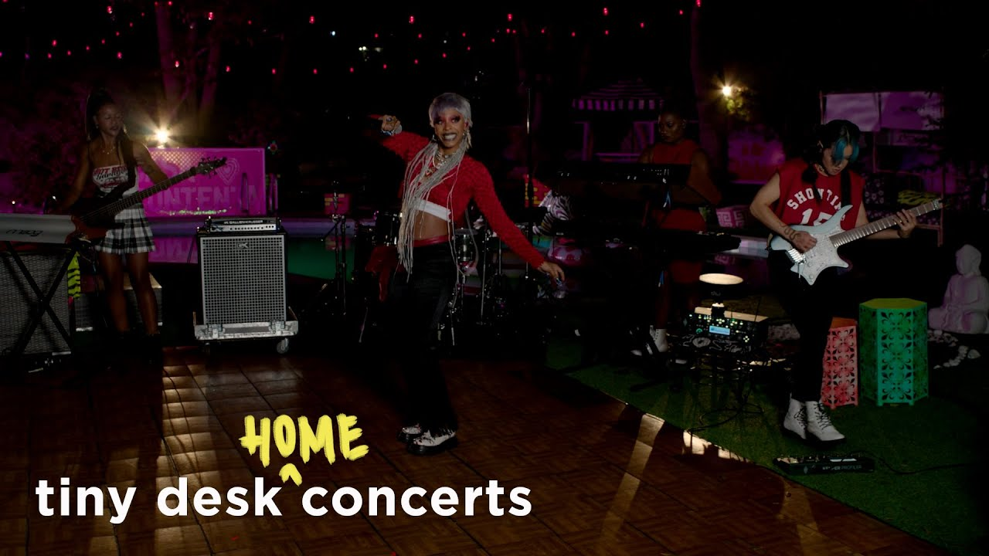

WATCH HERE

Trailblazing DMV rapper Rico Nasty break new ground today with her first ever NPR Tiny Desk (Home) performance. In true Rico fashion she is backed by an all-female band made up of solely women of color. Rico packs a powerful punch into her 13-minute set re-imagining new and old hits “Magic”, “Rage”, “OHFR?”, “Trust Issues”, and “Smack a Bitch”. Stream the fantastically Tim Burton-esque performances on the NPR Music official YouTube channel HERE.

“As one of the DMV's most formidable forces, Rico always compels her fans to jump up, take charge and never apologize for what they feel.”
- NPR

CONNECT WITH RICO NASTY:
WEBSITE | INSTAGRAM | TWITTER | FACEBOOK | YOUTUBE

FOR ALL INQUIRIES, CONTACT:
ARIANA.WHITE@ATLANTICRECORDS.COM

