FOR IMMEDIATE RELEASE
APRIL 20, 2022

RICO NASTY IS BACK WITH “VADERZ (FEAT. BKTHERULA)”

GROUNDBREAKING ICON TEAMS WITH ATL RAPPER
ON EAGERLY AWAITED NEW BANGER

OFFICIAL MUSIC VIDEO CO-DIRECTED BY RICO PREMIERES TODAY

“VADERZ (FEAT. BKTHERULA)” DROPS TODAY AT ALL DSPS AND STREAMING SERVICES

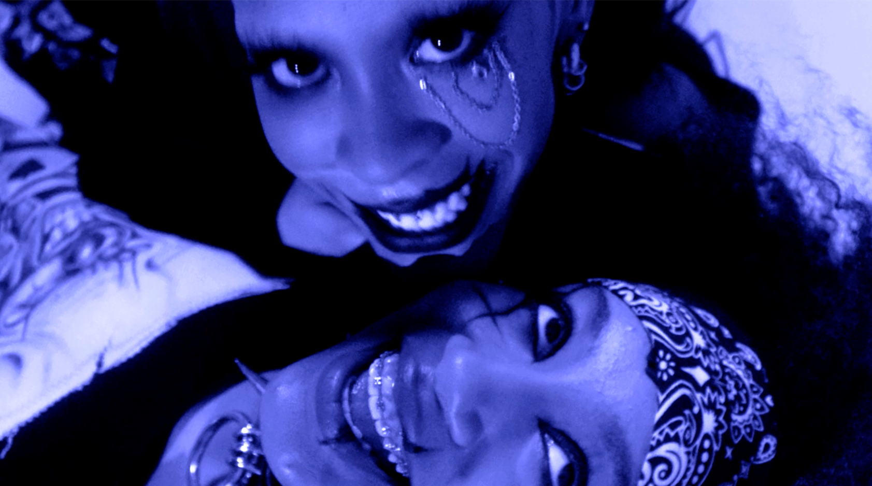
LISTEN TO “VADERZ (FEAT. BKTHERULA)” | WATCH OFFICIAL MUSIC VIDEO

Rico Nasty returns today with a brand new single, “Vaderz (Feat. Bktherula),” available now at all DSPs and streaming services; an official music video – co-directed alongside Marco Alexander and conceptualized by Rico herself – premieres today as well via YouTube HERE.

Rico – who recently appeared alongside Avril Lavigne on the cover of Alternative Press’ “Modern Icons” issue – joined forces with Doja Cat at this past weekend’s Coachella Valley Music & Arts Festival for an instantly iconic live performance of their classic 2019 collaboration, "Tia Tamera.” A busy international live schedule stacked with headline dates, top-billed festival sets and more will follow in the coming weeks and months, with highlights including San Bernardino, CA’s The Smoker’s Club Fest (Saturday, April 30), Washington, DC’s Broccoli City Festival (Saturday, May 7), Chicago, IL’s Lyrical Lemonade Summer Smash (June 17-19), London, UK’s Gopuff Delivers Wireless Festival (Friday, July 1), Stockholm, SW’s Lollapalooza Stockholm (Saturday, July 2), Hilvarenbeek, NL’s WOO HAH! x Rolling Loud (Sunday, July 3), Portimão, PT’s Rolling Loud Portugal (July 6-8), and Dour, BE’s Dour Festival (Friday, July 15). For complete information, please visit www.riconastymusic.com.

“Vaderz (Feat. Bktherula)” marks Rico’s first new song of 2022 and follows last year’s “Money (Feat. Flo Milli),” available now at all DSPs and streaming services; Produced by legendary German electronic dance music DJ/producer Boys Noize (Frank Ocean, Skrillex, Snoop Dogg), the track is joined by an official music video streaming now via YouTube HERE. “Money” – which sees Rico teaming with feisty Mobile, AL rapper Flo Milli – was met by ecstatic critical applause, with VIBE declaring, “Both ladies bring their bold attitudes to their verses declaring their desire for cash on their own terms.” “It’s got a big, bouncy beat with Miami bass 808s and chopped-up guitar riffs,” raved Stereogum. “On the hook, Rico adapts 2 Live Crew’s self-explanatory 1986 chant ‘We Want Some Pussy.’ On the verses, Rico and Flo Milli snarl hard and demand whatever’s in your pockets.”

# # #

CONNECT WITH RICO NASTY:
WEBSITE | INSTAGRAM | TWITTER | FACEBOOK | YOUTUBE

FOR PRESS INQUIRIES, PLEASE CONTACT:
Ariana White | Ariana.White@atlanticrecords.com

