FOR IMMEDIATE RELEASE
APRIL 15, 2022

REILEY RETURNS WITH “BLAH BLAH BLAH”

Euphoric new single from emerging pop star & TikTok icon available now

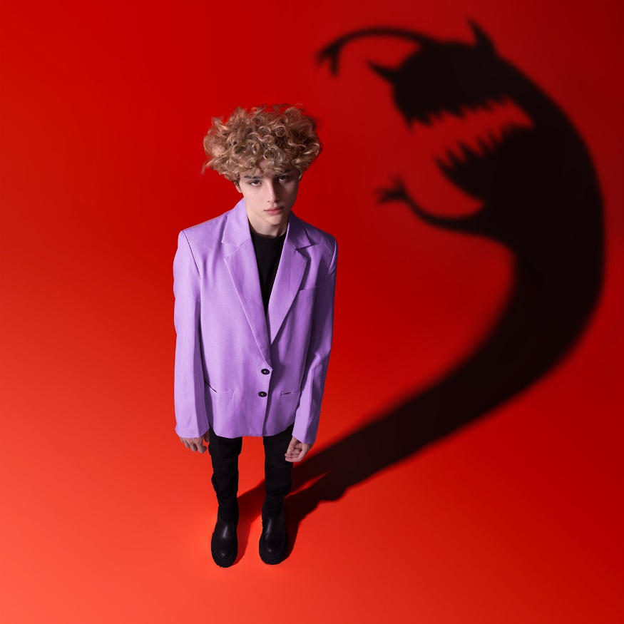
DOWNLOAD HIGH-RES IMAGES

WATCH/STREAM “BLAH BLAH BLAH”: LINK

Emerging pop sensation Reiley has returned with his euphoric new single “blah blah blah” – available now via Atlantic Records. The instantly iconic track – featuring a mesmerizing sample of the Kylie Minogue classic “Can’t Get You Out of My Head,” finds the TikTok luminary calling for a release of inhibitions and sacrifice to the spotlight.

Produced by Serm Style (J Balvin, Jason Derulo) and co-written with Rollo (Ava Max, BTS) and JHart (Justin Bieber, Tate McRae), “blah blah blah” marks Reiley’s first release of 2022 following his explosive debut EP brb, having an identity crisis. The 3-track collection, featuring standout single “YOU,” arrived last year and saw the artist team up with an all-star roster of co-writers and producers, including Noonie Bao (Charli XCX, Carly Rae Jepsen), Patrik Berger (Robyn, Lana Del Rey), Mike Sabath (Lizzo, Camila Cabello), Lostboy (Zedd, Bebe Rexha), The Nocturns (James Bay, Jonas Blue), Dreamlab (Selena Gomez, Katy Perry) & more.

Born to remote origins in the Faroe Islands (about 200 miles north of the UK with a population of just over 50,000 people), Reiley quietly made a global impact with an exuberant presence as loud as his traffic-stopping voice and as colorful as his runway-ready aesthetic. During 2020, he embraced TikTok (@reiley) as a way to connect with listeners far and wide. Against a colorful backdrop, he belted hits into a silver mic practically floating in front of him, ultimately generating over 1 billion views, inciting 132 million likes, and attracting over 11 million followers.

Reiley’s infectious debut single “Let It Ring” was deemed “already historic” by PAPER upon release in early 2021, in addition to receiving praise from the likes of Billboard, Cosmopolitan, Flaunt & more. Featuring the first-ever licensed sample of the instantly recognizable official iPhone ringtone, the track has generated over 40k creates on TikTok, picked up an incredible 16 million plus streams and saw incredible official chart placement in South Korea.

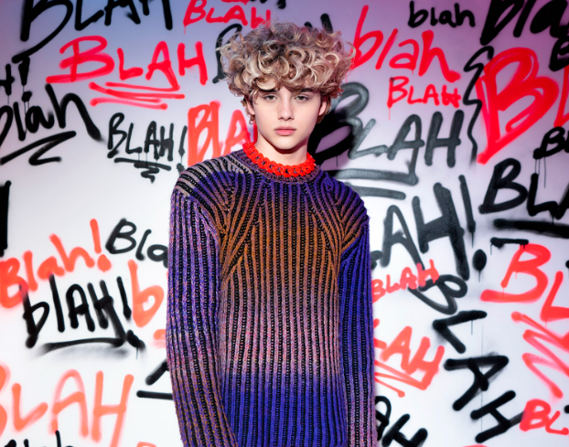
DOWNLOAD HIGH-RES IMAGES

CONNECT:
Official | TikTok | Instagram | Twitter | Facebook | YouTube | Press Assets

CONNECT:
Ted Sullivan | ted.sullivan@atlanticrecords.com

