FOR IMMEDIATE RELEASE
MARCH 11, 2022

ROZEI RETURNS WITH “CRASHING & BURNING”

GENRE-BUSTING ALT-POP HITMAKER SHARES FIERY NEW SINGLE

LISTEN TO “CRASHING & BURNING” HERE
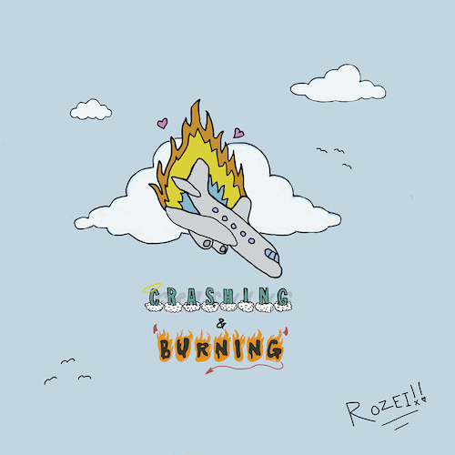
(DOWNLOAD HI-RES ARTWORK)

Genre-blurring singer-songwriter-producer Rozei continues to showcase his creative alt-pop approach with his energetic and angsty new single. Produced by Camp and Perish Beats “Crashing & Burning” is available now HERE.

Named by Alternative Press as one of “40 New Artists You Need To Hear,” Rozei recently drew applause for his most recent single, “Fever Dreams.” Produced by Colin “DOC” Brittain (5 Seconds of Summer, All Time Low, Papa Roach), the track was met by praise from Out Now, which hailed it as simply “fantastic.”

“Fever Dreams” was preceded by “The World Is Over.” Produced by Brittain, “The World Is Over” “sees the 22-year-old showcasing his skillsets once again,” declared FLAUNT, “this time singing about love and a certain female who can’t fathom leaving his life.” “Pulsing with alternative rock energy, Rozei’s new song ‘The World is Over’ is meant to be a comfort to those who feel alone, specifically after a rough break-up,” wrote Glasse Factory. “Drawing from a range of genres and experiences, the 21 year old artist is crafting a unique sound that embodies a musical style all his own that evolves with definition with each release.”

ABOUT ROZEI
Rozei first made waves with 2020’s viral smash, “Ooo La La,” which topped the Spotify Viral Charts in multiple countries and currently boasts over 40M worldwide streams and counting. “Ooo La La” is joined by an official music video – directed by FaZe Clan’s Youssef Ali and co-starring famed gamer FaZe Nikan – now with close to 1.7M views.

Known for melding powerful alternative energy with tantalizing pop zeal his own trademark brand of hip-hop bounce, Rozei draws from a range of genres to create a unique and unforgettable musical style all his own. The Erie, PA-based artist has earned high profile media attention from such national outlets as Billboard, HipHopDX, LA Weekly, and more. Rozei is currently hard at work crafting more innovative, emotionally resonant music, with additional new releases due later this year.

# # #

FOLLOW ROZEI
OFFICIAL SITE | INSTAGRAM|TWITTER|SOUNDCLOUD|YOUTUBE

PRESS CONTACT:
Jessica Nall // Jessica.Nall@atlanticrecords.com

