SABRINA CLAUDIO RELEASES NEW ALBUM BASED ON A FEELING

LISTEN HERE

MUSIC VIDEO FOR “DON’T MAKE ME WAIT” OUT NOW

WATCH HERE



CLICK HERE TO DOWNLOAD ARTWORK

Los Angeles, CA – May 6, 2022 – Critically-acclaimed, gold-selling Puerto Rican and Cuban songstress Sabrina Claudio has today released her highly-anticipated new album Based On A Feeling via Atlantic Records.

Click HERE to buy/stream.

Sabrina confidently projects sensuality, spirit and soul beyond her barriers in Based On A Feeling. The album features production by Stint (Gallant) and Blue Rondo (Young Thug) on “Better Version,” Jonah Christian (Lil Wayne, Nicki Minaj, 6LACK, Burna Boy, Normani, Anderson. Paak) and Sad Money (Khalid, Pink Sweat$, Chloe & Halle) on “Put On Repeat” as well as Jeff Gitty (J. Cole, H.E.R., Mac Miller, Anderson .Paak), Roy Lenzo (Lil Nas X) and German (Julia Michaels, Justin Bieber, Lil Wayne, Katy Perry) to name a few. It also sees Sabrina take the reins as the sole writer and present the clearest picture of herself as an artist and woman.

Of the new album, Sabrina said:

“I’m so beyond proud of this evolution that is ‘Based On A Feeling.’ The intention behind creating the album and the energy that was exuded in every session can be felt throughout each song. After a two year unanticipated break from writing, caused by various discouraging experiences that halted my desire to create, I managed to find the motivation to get back in after having a conversation with someone on my team. Not only did this conversation spark my ambition, but it also titled the album. ‘Based On A Feeling’ stems from the promise I made of only making decisions based on a feeling of love and pure intentions. I took this idea and allowed it to guide me through the creative process of this album in every single aspect and I could not be more fulfilled with the final result.”

The 11-song LP was revealed alongside a stunning and alluring music video for new track “Don’t Make Me Wait.” Airy piano twinkles out of the darkness as Sabrina’s voice barely registers above a whisper with a command, “Kiss me, I’m in need of assurance,” before harp glistens.

Click HERE to watch the music video.



Based On A Feeling is the first dose of new music from Sabrina since her 2020 holiday album Christmas Blues, an eight-song collection highlighted by her favorite holiday tracks with features from The Weeknd and Alicia Keys.

Ahead of Based On A Feeling’s release, Sabrina hosted a listening event in Los Angeles where fans got a sneak peak of the album in Dolby Atmos sound. It sold out in less than 10 minutes.

Based On A Feeling tracklisting:
1. Subtle Things
2. Don’t Make Me Wait
3. IOU
4. Impersonator
5. Sunset Eyes
6. Better Version
7. Put On Repeat
8. Basic Needs
9. Favorite Part
10. Still Strangers
11. Protect Her

Stay tuned for more news from Sabrina soon.

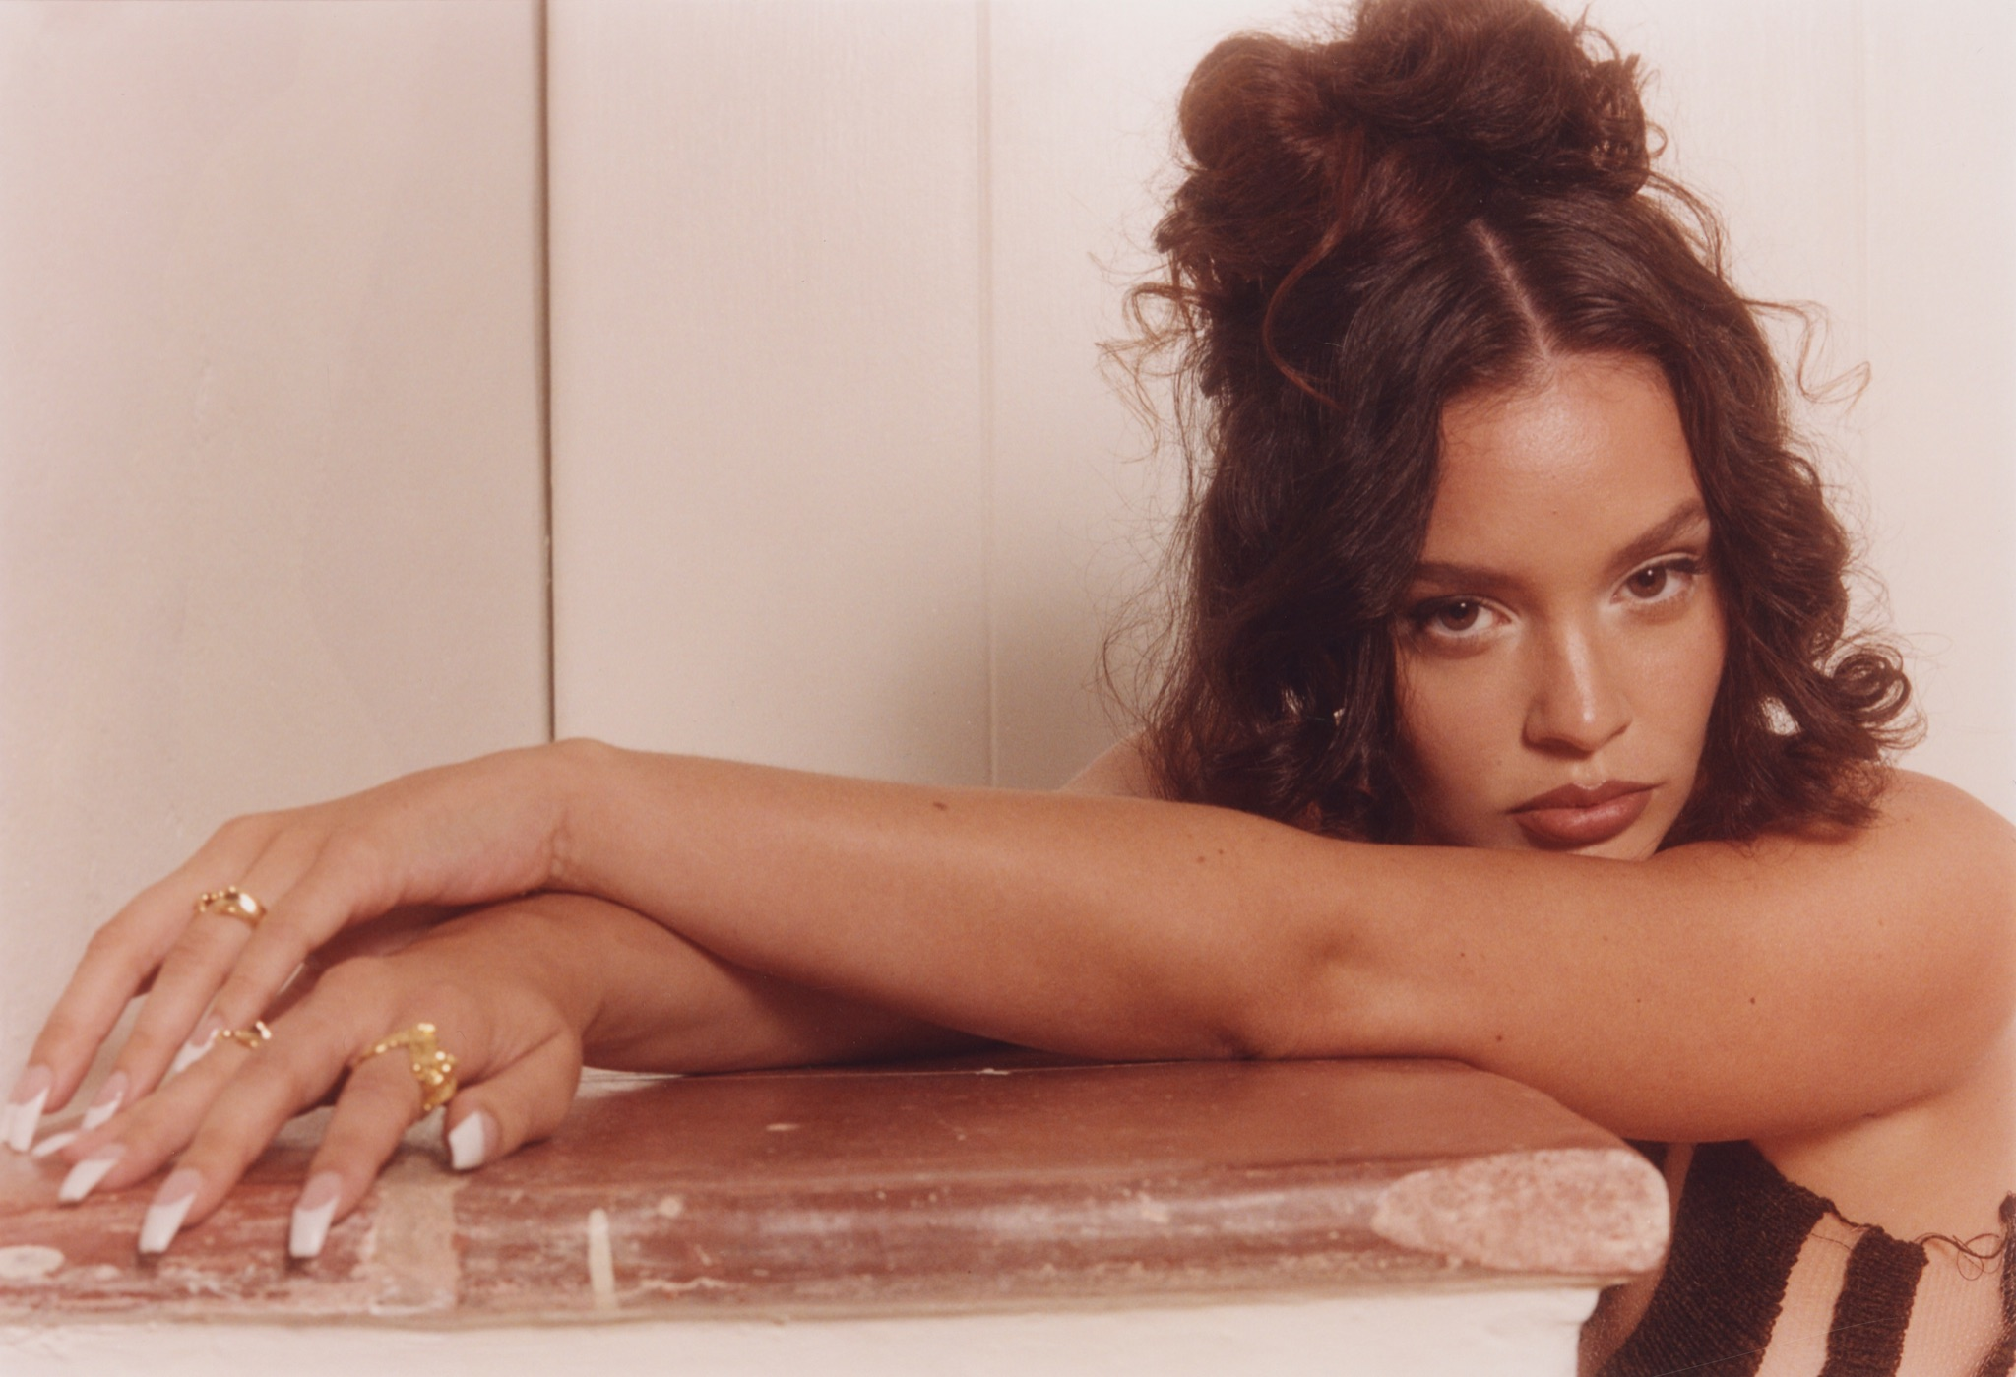

Photo credit: Ricky Alvarez | Click HERE to download artwork

Follow Sabrina Claudio:
Instagram | Twitter | Facebook | TikTok | YouTube | Spotify | Apple Music | Website

About Sabrina Claudio:
Sabrina Claudio knows exactly what she wants. To a degree, the gold-selling Puerto Rican/Cuban songstress coyly attributes these keen instincts to her Zodiac sign (she’s a Virgo), but truthfully, she quietly hustled to define her vision. After a series of critically acclaimed projects, sold out headline tours, and 2 billion streams, she confidently projects sensuality, spirit, and soul beyond barriers in her music. She’s always followed her own path though. Materializing with a D.I.Y. take on alternative R&B, Sabrina started to enrapture audiences with her 2016 debut EP, Confidently Lost. On its heels, the full-length About Time yielded the gold-certified “Belong to You” (feat. 6LACK), while 2018’s No Rain, No Flowers maintained her momentum as she sold out its accompanying headline tour. In 2019, Sabrina reached new heights with Truth Is. Inciting tastemaker applause, Complex described it as “grandiose,” while Variety christened it “one of last year’s top albums of the genre.” Closing out 2020, Sabrina unwrapped Christmas Blues, reimagining the holidays through a sexy prism with a little help from The Weeknd on the title track and Alicia Keys on “Winter Time.” 2021 saw Sabrina instantly sell out an extended vinyl reissue of her debut album About Time, twice. She’s performed on Jimmy Kimmel Live! and The Late Late Show with James Corden in addition to gracing the bills of Coachella, Lollapalooza, Outside Lands, and Life Is Beautiful. Taking the reins as the sole writer, she presents the clearest picture of herself as an artist and as a woman on her 2022 project, Based On A Feeling (Atlantic Records).

Press Contacts:
Andrew George
andrew.george@atlanticrecords.com
Megan Rasmussen
Megan.Rasmussen@atlanticrecords.com

