FOR IMMEDIATE RELEASE
MAY 9, 2022

SABRINA CLAUDIO ANNOUNCES ‘BASED ON A FEELING’ 2022 GLOBAL TOUR

Tickets On Sale Starting Friday, May 13th at 10AM Local on SabrinaClaudio.com

New album Based On A Feeling out now

Watch the stunning and alluring music video for “Don’t Make Me Wait” HERE

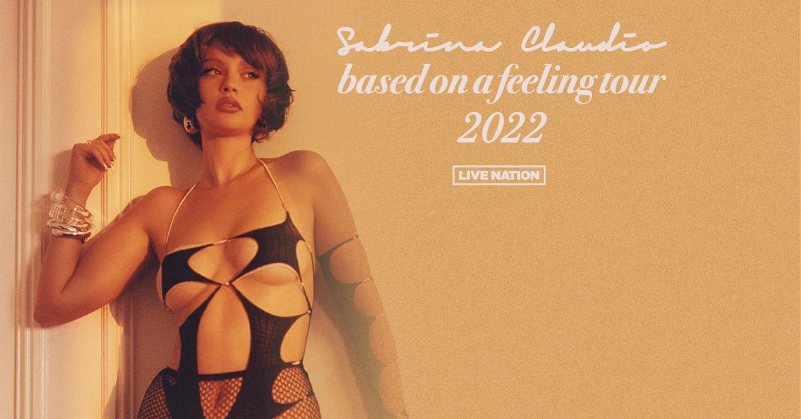

For approved artist images and hi-res tour art, please download HERE.
Following the release of her highly-anticipated new album, Based On A Feeling (via Atlantic Records), and the stunning and alluring music video for new track “Don’t Make Me Wait,” critically-acclaimed, platinum-selling Puerto Rican and Cuban songstress Sabrina Claudio has announced her Based On A Feeling global tour – a massive 38 show run across North America and Europe. Produced by Live Nation, the North American leg of the tour kicks off on August 25th at Crystal Ballroom in Portland making stops across the U.S. in New York, Los Angeles, Atlanta, and more before wrapping up in Orlando at the House of Blues on October 21st. The 13-date European leg kicks off on November 12th at the Debaser Strand in Stockholm, making stops in Berlin, Paris, Manchester, and more before wrapping up in Dublin at The Academy on November 30th.

Sabrina confidently projects sensuality, spirit and soul beyond her barriers in Based On A Feeling. The album features production by Stint (Gallant) and Blue Rondo (Young Thug) on “Better Version,” Jonah Christian (Lil Wayne, Nicki Minaj, 6LACK, Burna Boy, Normani, Anderson. Paak) and Sad Money (Khalid, Pink Sweat$, Chloe & Halle) on “Put On Repeat” as well as Jeff Gitty (J. Cole, H.E.R., Mac Miller, Anderson .Paak), Roy Lenzo (Lil Nas X) and German (Julia Michaels, Justin Bieber, Lil Wayne, Katy Perry) to name a few. It also sees Sabrina take the reins as the sole writer and present the clearest picture of herself as an artist and woman.

Based On A Feeling is the first dose of new music from Sabrina since her 2020 holiday album Christmas Blues, an eight-song collection highlighted by her favorite holiday tracks with features from The Weeknd and Alicia Keys.

TICKETS: Tickets go on sale starting Friday, May 13th at 10am local time on sabrinaclaudio.com

BASED ON A FEELING TOUR DATES:
Thu Aug 25 – Portland, OR – Crystal Ballroom
Fri Aug 26 – Seattle, WA – Moore Theatre
Sat Aug 27 – Vancouver, BC – Commodore Ballroom
Tue Sep 06 – Silver Spring, MD – The Fillmore
Wed Sep 07 – New York, NY – Radio City Music Hall
Thu Sep 08 – Boston, MA – House of Blues
Sat Sep 10 – Montreal, QC – Mtelus
Mon Sep 12 – Philadelphia, PA – The Fillmore
Thu Sep 15 – Detroit, MI – St. Andrews Hall
Fri Sep 16 – Chicago, IL – Riviera Theater
Sat Sep 17 – Toronto, ON – HISTORY
Mon Sep 19 – Minneapolis, MN – Varsity Theater
Thu Sep 22 – Denver, CO – Summit Music Hall
Sat Sep 24 – Anaheim, CA – House of Blues
Mon Sep 26 – San Francisco, CA – The Masonic
Wed Sep 28 – Los Angeles, CA – Hollywood Palladium
Fri Sep 30 – San Diego, CA – SOMA
Sat Oct 01 – Phoenix, AZ – The Marquee Theatre
Tue Oct 11 – Nashville, TN – Marathon Music Works
Wed Oct 12 – Charlotte, NC – The Fillmore
Thu Oct 13 – Atlanta, GA – Tabernacle
Thu Oct 20 – St. Petersburg, FL – Jannus Landing
Fri Oct 21 – Orlando, FL – House of Blues
Sat Nov 12 – Stockholm, SE – Debaser Strand
Sun Nov 13 – Copenhagen, DK – Pumpehuset
Mon Nov 14 – Hamburg, DE – Mojo Club
Wed Nov 16 – Berlin, DE – Metropol
Thu Nov 17 – Cologne, DE – Kantine
Sat Nov 19 – Paris, FR – Le Trianon
Sun Nov 20 – Brussels, BE – La Madeleine
Mon Nov 21 – Utrecht, NL – Tivoli Vredenburg
Wed Nov 23 – Manchester, UK – O2 Ritz
Thu Nov 24 – Bristol, UK – O2 Academy 2 Bristol
Fri Nov 25 – Birmingham, UK – O2 Institute
Sun Nov 27 – London, UK – O2 Forum Kentish Town
Wed Nov 30 – Dublin, IE – The Academy

ABOUT SABRINA CLAUDIO:
Sabrina Claudio knows exactly what she wants. To a degree, the platinum-selling Puerto Rican/Cuban songstress coyly attributes these keen instincts to her Zodiac sign (she’s a Virgo), but truthfully, she quietly hustled to define her vision. After a series of critically acclaimed projects, sold out headline tours, and 2 billion streams, she confidently projects sensuality, spirit, and soul beyond barriers in her music. She’s always followed her own path though. Materializing with a D.I.Y. take on alternative R&B, Sabrina started to enrapture audiences with her 2016 debut EP, Confidently Lost. On its heels, the full-length About Time yielded the gold-certified “Belong to You” (feat. 6LACK), while 2018’s No Rain, No Flowers maintained her momentum as she sold out its accompanying headline tour. In 2019, Sabrina reached new heights with Truth Is. Inciting tastemaker applause, Complex described it as “grandiose,” while Variety christened it “one of last year’s top albums of the genre.” Closing out 2020, Sabrina unwrapped Christmas Blues, reimagining the holidays through a sexy prism with a little help from The Weeknd on the title track and Alicia Keys on “Winter Time.” 2021 saw Sabrina instantly sell out an extended vinyl reissue of her debut album About Time, twice. She’s performed on Jimmy Kimmel Live! and The Late Late Show with James Corden in addition to gracing the bills of Coachella, Lollapalooza, Outside Lands, and Life Is Beautiful. Taking the reins as the sole writer, she presents the clearest picture of herself as an artist and as a woman on her 2022 project, Based On A Feeling (Atlantic Records).

About Live Nation Entertainment
Live Nation Entertainment (NYSE: LYV) is the world’s leading live entertainment company comprised of global market leaders: Ticketmaster, Live Nation Concerts, and Live Nation Sponsorship. For additional information, visit www.livenationentertainment.com.

MEDIA CONTACTS:

Sabrina Claudio
Atlantic Records
Andrew George | andrew.george@atlanticrecords.com

Live Nation Concerts
Monique Sowinski | moniquesowinski@livenation.com

To apply for media credentials for show coverage:
livenation.com/pressrequests

