FOR IMMEDIATE RELEASE
MAY 6, 2022

SIR CHLOE SHARE “COMPANY”

RISING ALT-ROCK BAND UNVEIL EVOCATIVE NEW SINGLE + KINKY COMPANION VIDEO

FIRST-EVER NORTH AMERICAN HEADLINE TOUR KICKS OFF TONIGHT
AT NEW YORK CITY’S’S LEGENDARY BOWERY BALLROOM

LISTEN TO “COMPANY” HERE
WATCH OFFICIAL VIDEO HERE
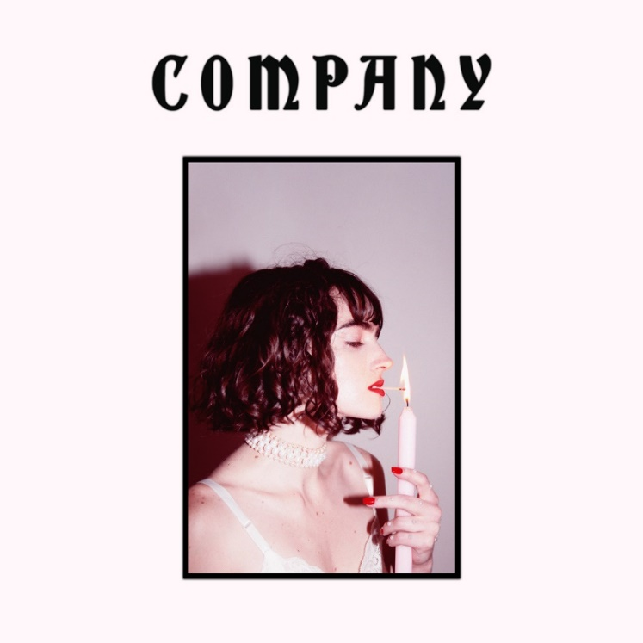
DOWNLOAD ARTWORK HERE

“Worthy of playing on repeat…”
– CONSEQUENCE

“Sir Chloe’s music exists in the nebulous void of haunting dark pop and heart-rending alternative garage rock…”
– ONES TO WATCH

“The listening experience is hypnotic…”
-UPROXX

Acclaimed alt-rock band Sir Chloe has shared their evocative new single, “Company,” available now HERE. According to Sir Chloe, the new track is, “a song to flex one’s muscles in the mirror to.” The emotionally charged, garage rock single was produced by GRAMMY® Award-winner John Congelton (St. Vincent, Sharon Van Etten) and is joined by a seductive official video streaming now HERE. Starring lead singer, guitarist, songwriter, and multi-instrumentalist Dana Foote and a lot of latex and leather, the Powered By Wind-directed video was featured on PAPER, which praised the release in saying, “"Company," consummates camp and kink, latex and leather.”

“Company” follows last month’s release of “Mercy,” a spooky rock anthem about grief that kicks off with Foote alone on vocals and guitar before exploding into an eruption of desperate catharsis. Consequence of Sound praised the single stating, “The harmonies in the first chorus are salivating enough, but the juxtaposition with the following chorus, distorted and grungy, cement ‘Mercy’ as a song worthy of playing on repeat.” Upon release, the track also saw praise from UPROXX, Entertainment Tonight, Ones to Watch and more.

Sir Chloe – who recently wrapped a series of dates supporting alt-J and Portugal. The Man on their North American co-headline tour – will celebrate their new music on their first-ever North American headline tour, beginning tonight, May 6 at New York City’s legendary Bowery Ballroom with the tour finale at Los Angeles, CA’s Regent Theater on May 28. Special guests include Moon Kissed and Luke Wild. For updates and tickets, please see www.sirchloemusic.com.

“Company” and “Mercy” follow Sir Chloe’s acclaimed EP, Party Favors, still boasting over 1.5M weekly streams more than one year after its initial 2020 release. The EP is highlighted by the breakthrough hit single, “Michelle,” which has proven an undisputed smash with more than 350K TikTok video creates and over 151M streams thus far in the US alone.

ABOUT SIR CHLOE
Sir Chloe was born and raised in a yellow house. Formerly a knife salesman, she learned to play guitar by eating one of her father’s guitar picks. She began to write songs after repeatedly dreaming of choirs of dogs. Sir Chloe debuted on Atlantic Records in early 2022 with “Mercy,” a song about grief, disrespectful in tone but inquisitive in lyrics. Sir Chloe’s debut full-length record is due the moment it comes out.

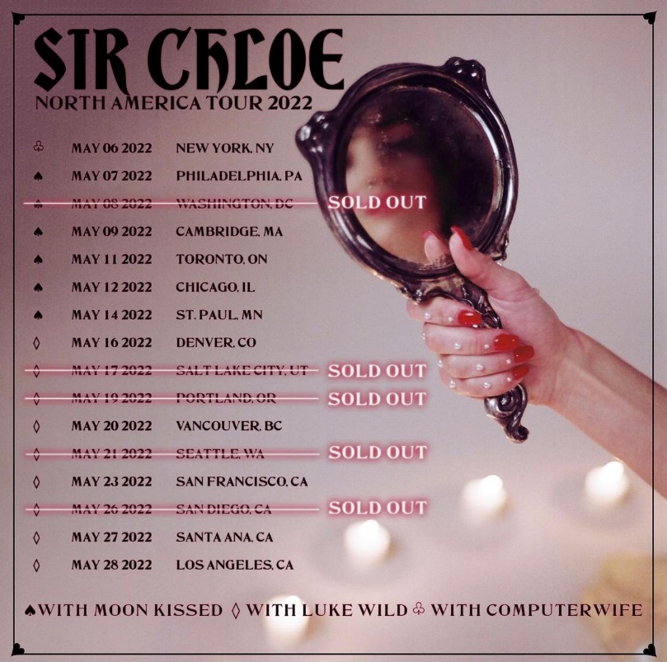

SIR CHLOE
NORTH AMERICAN TOUR 2022

MAY 2022
6 – New York, NY – The Bowery Ballroom
7 – Philadelphia, PA – Johnny Brenda's *
8 – Washington, DC – Songbyrd Music House & Record Café *
9 – Cambridge, MA – The Sinclair *
11 – Toronto, Ontario – The Garrison *
12 – Chicago, IL – Subterranean *
14 – Saint Paul, MN – Turf Club *
16 – Denver, CO – Meow Wolf *
17 – Salt Lake City, UT – Kilby Court *
19 – Portland, OR – Polaris Hall †
20 – Vancouver, BC – Fox Cabaret †
21 – Seattle, WA – Barboza †
23 – San Francisco, CA – August Hall †
26 – San Diego, CA – Quartyard †
27 – Santa Ana, CA – Constellation Room †
28 – Los Angeles, CA – The Regent Theater †

* w/Special Guests Moon Kissed
† w/Special Guest Luke Wild

# # #

CONNECT WITH SIR CHLOE
OFFICIAL | FACEBOOK | INSTAGRAM | TWITTER | SPOTIFY | YOUTUBE

For press inquiries, please contact:
Jessica Nall / Jessica.Nall@atlanticrecords.com
Libby Kober / Libby.Kober@atlanticrecords.com

