FOR IMMEDIATE RELEASE
MARCH 4, 2022

SUECO UNVEILS DEBUT ALBUM IT WAS FUN WHILE IT LASTED

RIAA CERTIFIED VIRAL STAR’S EAGERLY AWAITED DEBUT ALBUM
HIGHLIGHTED BY RISING HIT “LOSER” AND #1 BREAKTHROUGH “PARALYZED”

CURRENTLY ON TOUR WITH OLIVER TREE AND 347AIDAN

WEB3-NATIVE SUECO MAKES SANDBOX DEBUT AS FIRST-EVER WARNER MUSIC GROUP ARTIST WITH AN EXPERIENCE LAUNCHING IN SEASON 3

LISTEN TO IT WAS FUN WHILE IT LASTED HERE
WATCH “DRUNK DIAL” HERE
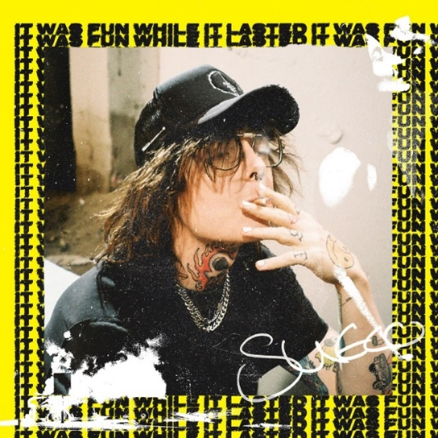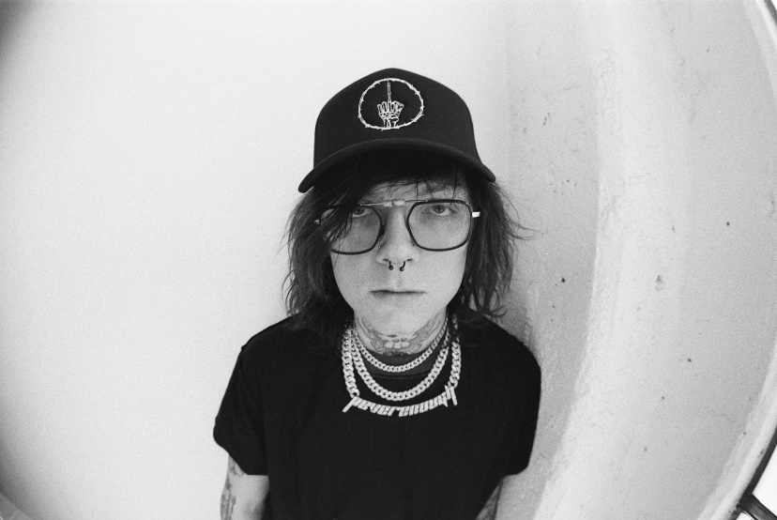
(DOWNLOAD HI-RES IMAGES)

“Sueco is as on brand as ever…” - BILLBOARD

“Sueco’s discography hasn’t failed to thrill or delight…” - MTV

“Sueco is known for mixing pop, pop punk and rap with inventive beats to create something entirely unrestrained by genre.” - ALT PRESS

“Sueco is undoubtedly a product of a new generation, one whose humor and meteoric success is unexpected, unpredictable, and nothing short of enthralling.” - ONES TO WATCH

RIAA certified singer/producer Sueco has shared his long-awaited debut album, It Was Fun While It Lasted. The 12-track project includes previously released hits “Loser,” “SOS (Feat. Travis Barker),” “Sober/Hungover (Feat. Arizona Zervas),” and the breakthrough #1 hit “Paralyzed.” as well as 7 brand new tracks. The project is joined by the official video for “Drunk Dial,” streaming now HERE.

“The album is a journey from dark to light,” Sueco says, “going from a place of emptiness to everything being alright. It’s the end of one chapter, and the beginning of another. It really was fun while it lasted.”

It Was Fun While It Lasted sees Sueco channeling the spirit of 90’s pop-punk through a 21st century lens, tapping into the unpredictability of hyperpop and the catharsis of punk rock.

As an artist who’s no stranger to Web3 and is committed to bringing fans unique experiences, Sueco is teasing an upcoming experience in the metaverse to come as part of the album launch. The Sueco portal, in leading virtual world, The Sandbox, is a first look at his wide-ranging activations on the platform. The experience, built on his label’s, Atlantic Records, plot of LAND, launches in the coming months during the Sandbox’s next wave, Alpha Season 3.

Sueco’s debut full length effort arrives on the heels of his runaway smash single “Paralyzed.” Last night, Sueco was awarded with his RIAA certified gold plaque for the track which exploded onto the scene last summer with a hugely popular TikTok teaser and has since gone on to earn more than 125M worldwide streams, reaching #1 on Spotify’s “Viral 50 US” while proving the Los Angeles-based singer, producer, and multi-instrumentalist’s first ever Billboard “Hot 100” and Rolling Stone “Top 100” hit. “Paralyzed” further saw Sueco make his Rolling Stone “Top 500 Popular Artists” chart debut after landing at #1 on Billboard’s “Rock Digital Song Sales,” #2 on “Alternative Digital Song Sales,” and #2 on Rolling Stone’s “Top 25 Breakthrough Music Artists.”

Sueco – who recently starred on the cover of Alternative Press – is currently introducing fans everywhere to It Was Fun While It Lasted with a high profile North American live schedule, including a spot on chart-topping pop icon Oliver Tree’s Cowboy Tears Tour alongside special guest 347aidan. Dates continue through late March. In addition, Sueco has just been announced as part of the star-studded lineup for Dover, DE’s Firefly Music Festival lineup. For updates and more, please visit www.sueco.com.

SUECO
ON TOUR 2022

MARCH
4 - Chicago, IL - Radius
5 - Detroit, MI - The Fillmore Detroit
6 – Cleveland, OH – Agora Theatre & Ballroom
9 – Columbus, OH – KEMBA Live!
11 - Boston, MA - House of Blues
12 - New York, NY - Hulu Theatre at Madison Square Garden
14 - Pittsburgh, PA - Stage AE
16 - Philadelphia, PA - The Fillmore Philadelphia
17 - Silver Spring, MD - The Fillmore Silver Spring
18 - Charlotte, NC - The Fillmore Charlotte
19 - Atlanta, GA - The Tabernacle
22 - Nashville, TN - Marathon Music Works
24 - Dallas, TX - The Factory
25 - Houston, TX - 713 Music Hall
26 - Austin, TX - Stubb’s Waller Creek Amphitheater

SEPTEMBER
22-25 - Dover, DE - Firefly Music Festival *

ALL DATES W/OLIVER TREE’S COWBOY TEARS TOUR EXCEPT *

# # #
# # #

SUECO
IT WAS FUN WHILE IT LASTED

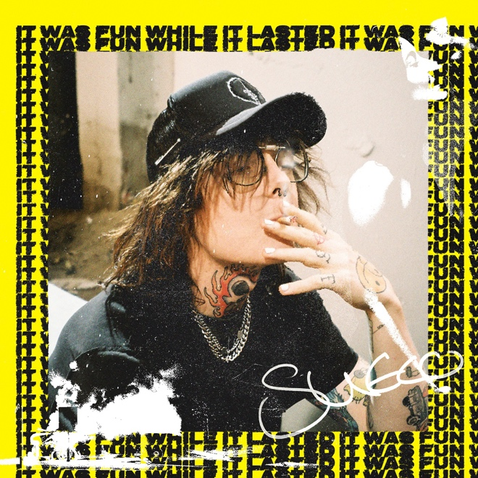

TRACKLIST
1. Today
2. Paralyzed
3. It’s Going Good!
4. Hate You Too
5. Loser
6. Drunk Dial
7. Toxic Therapy
8. SOS (feat Travis Barker)
9. Motel 666
10. Sober/Hungover (feat Arizona Zervas)
11. PRIMADONA
12. It Was Fun While It Lasted
# # #

CONNECT WITH SUECO
INSTAGRAM l TIKTOK | TWITTER l SOUNDCLOUD l YOUTUBE

For press inquiries, please contact:
Jessica Nall // Jessica.Nall@atlanticrecords.com

