FOR IMMEDIATE RELEASE
MARCH 25, 2022

SUECO DROPS “TODAY” VIDEO

RIAA CERTIFIED VIRAL STAR RELEASES NAS BOGADO-DIRECTED VIDEO

EMOTIONALLY CHARGED, CONFESSIONAL TRACK APPEARS ON SUECO’S DEBUT ALBUM
IT WAS FUN WHILE IT LASTED – OUT NOW HERE

CURRENTLY ON TOUR WITH OLIVER TREE AND 347AIDAN
+ SLATED TO PLAY FIREFLY FESTIVAL, READING AND LEEDS AND MORE

WATCH “TODAY” HERE
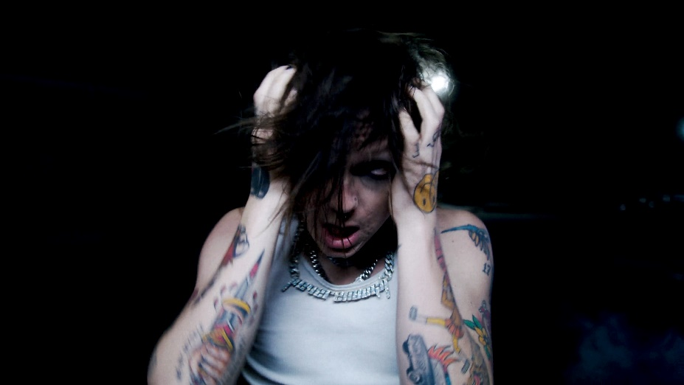

“Sueco is as on brand as ever…” - BILLBOARD

“Sueco’s discography hasn’t failed to thrill or delight…” - MTV

“Sueco is known for mixing pop, pop punk and rap with inventive beats to create something entirely unrestrained by genre.” - ALT PRESS

“Sueco is undoubtedly a product of a new generation, one whose humor and meteoric success is unexpected, unpredictable, and nothing short of enthralling.” - ONES TO WATCH

RIAA certified singer/producer Sueco has released the official visual for his personal and heavy track “Today.” From his recent debut album, It Was Fun While It Lasted, that “is a journey from dark to light,” the emotional opening track sees Sueco in his last moment before getting sober. The Nas Bogado (5SOS, Royal & the Serpent, Lauren Sanderson)-directed video is streaming now HERE.

On the song, Sueco shares: “I got sober in the summer of 2021. I was getting blacked out every day. I knew if I kept doing it, something bad would happen. My grandparents have a cabin in Mammoth, so I grabbed the keys from them and drove up there for a week. I quit cold turkey. I wrote ‘Today’ the night before I left. I really wanted people to hear it, so I put it at the beginning. The album is a journey from dark to light, going from a place of emptiness to everything being alright.”

“Today” first appeared on Sueco’s debut album, It Was Fun While It Lasted, alongside standout tracks “Loser,” “SOS (Feat. Travis Barker),” “Sober/Hungover (Feat. Arizona Zervas),” “Drunk Dial” and the breakthrough #1 hit “Paralyzed.” On the eve of his album release, Sueco was awarded with his RIAA certified gold plaque for his runaway hit “Paralyzed” which exploded onto the scene last summer with a hugely popular TikTok teaser and has since gone on to earn more than 140M worldwide streams, reaching #1 on Spotify’s “Viral 50 US” while proving the Los Angeles-based singer, producer, and multi-instrumentalist’s first ever Billboard “Hot 100” and Rolling Stone “Top 100” hit. “Paralyzed” further saw Sueco make his Rolling Stone “Top 500 Popular Artists” chart debut after landing at #1 on Billboard’s “Rock Digital Song Sales,” #2 on “Alternative Digital Song Sales,” and #2 on Rolling Stone’s “Top 25 Breakthrough Music Artists.”

Now boasting over 770M streams, Sueco – who recently starred on the cover of Alternative Press – is currently introducing fans everywhere to It Was Fun While It Lasted with a high profile North American live schedule, including a spot on chart-topping pop icon Oliver Tree’s Cowboy Tears Tour alongside special guest 347aidan. Dates continue through late March. In addition, Sueco has been announced as part of the star-studded lineup for Dover, DE’s Firefly Music Festival lineup, Texas’ Float Fest and the iconic Reading and Leeds Festival. For updates and more, please visit www.sueco.com.

(DOWNLOAD HI-RES IMAGES)

# # #

CONNECT WITH SUECO
INSTAGRAM l TIKTOK | TWITTER l SOUNDCLOUD l YOUTUBE

For press inquiries, please contact:
Jessica Nall // Jessica.Nall@atlanticrecords.com

