FOR IMMEDIATE RELEASE
MAY 4, 2022

WINONA OAK ANNOUNCES DEBUT ALBUM ISLAND OF THE SUN OUT JUNE 10
PRE-SAVE ALBUM HERE

SWEDISH SONGSTRESS HERALDS DEBUT ALBUM WITH
PERSONAL NEW TRACK “JOJO”
LISTEN TO “JOJO” HERE | WATCH VISUAL HERE

WINONA OAK JOINING OH WONDER ON NORTH AMERICAN TOUR
+ ALEC BENJAMIN ON EUROPEAN AND UK TOUR

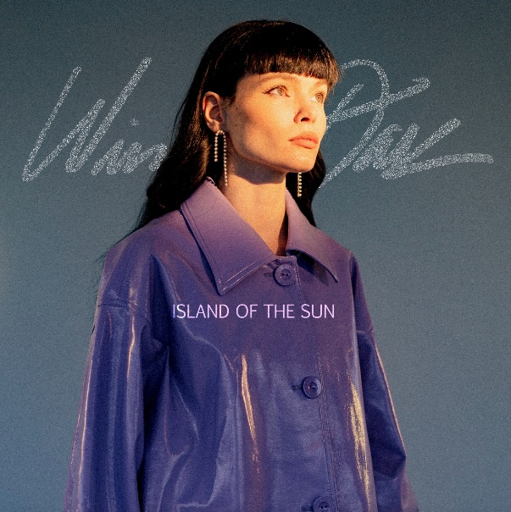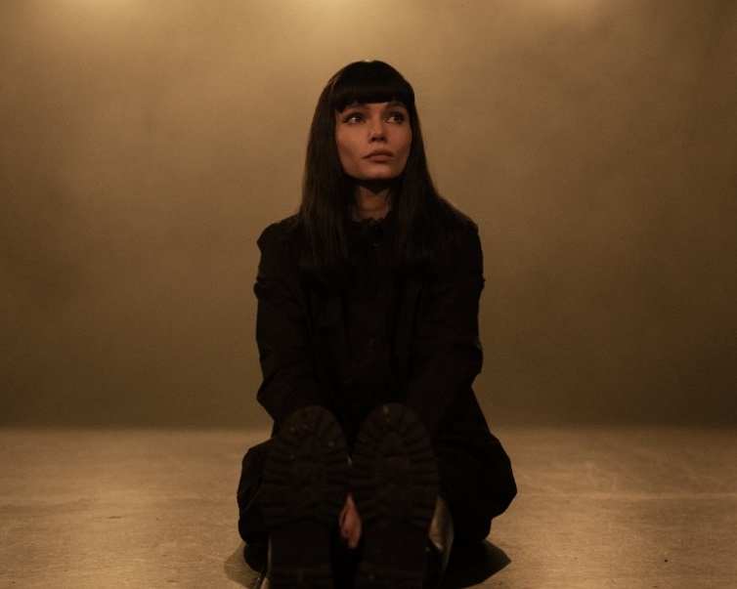
DOWNLOAD ARTWORK + PRESS PHOTOS HERE

“Winona Oak is a name you should know” – PAPER

Acclaimed singer-songwriter Winona Oak has announced that her debut album Island of the Sun will arrive Friday, June 10. The stunning body of work is available for pre-save now HERE. The highly-anticipated project will include recent singles “Baby Blue” and the album’s title track, “Island of the Sun,” fan favorites “He Don’t Love Me,” “Piano in the Sky,” and “Break My Broken Heart” as well as the new track “Jojo” out today.

The personal track “Jojo” serves as a letter from Winona to herself about what truly matters to her and the beauty that surrounds her. Born Johanna Ekmark, Jojo was Winona’s nickname while she was growing up in Sollerön, Sweden. Listen to “Jojo” HERE, watch the visual HERE.

On the song, Winona shared, "Jojo is actually my nickname, I wrote 'Jojo’ as a song to myself. Sometimes I feel helpless, frustrated and completely overwhelmed inside the frames of society. Specifically, I don’t know how to navigate inside this parallel universe of the internet and all that comes with it. It’s a world that’s getting more and more shallow and gives us endless access to everything. Polished images of “perfect” people living their ‘perfect’ lives online. I will never look like them, but the thing is that they don’t even look like themselves. On the internet we can be whoever we want to be. We can pick apart and choose the best parts of our personality, showcase our best moments, our most flattering images and even manipulate them to look less human. It’s a toxic part of social media that pushes people into doing things that ruin them. How do we know what’s real? How do we find real love and honest connections when you judge someone based on their internet persona? If money controls everything how can people without it control a change? (They can’t) And who am I in the middle of all of this? Just one out of billions of tiny little spots in the universe. I know what you’re thinking, but despite its heavy subjects I feel like writing ‘Jojo’ actually reminded me about what’s really important to me. There’s so much beauty and light surrounding me, real human connections, breathtaking nature and unconditional love. And in the end I’m made of the same particles as everyone else around me and maybe they feel just as lost as I do sometimes. I don’t know but maybe one day we’ll figure it out together.”

Winona will celebrate ISLAND OF THE SUN with her first ever North American tour thus far. The dates – which see Winona supporting British alt-pop duo Oh Wonder – begin May 8th at Toronto, ON’s History and then continue through the month. Oak will then join Alec Benjamin on his European and UK tour this summer.

DOWNLOAD PRESS PHOTOS HERE

WINONA OAK ON TOUR 2022

MAY
8 – Toronto, ON – History*
10 – Montreal, QC – Mtelus*
11 – Boston, MA – House of Blues*
13 – Washington, DC – 9:30 Club*
14 – Philadelphia, PA – Theatre of Living Arts (TLA)*
15 – Brooklyn, NY – Brooklyn Steel*
17 – Chicago, IL – The Vic Theatre*
18 – Minneapolis, MN – First Theatre*
20 – Denver, CO – Ogden Theatre*
21 – Salt Lake City, UT – The Depot*
23 – Seattle, WA – Showbox SoDo*
24 – Vancouver, BC – Vogue Theater*
25 – Portland, OR – Roseland Theater*
28 – Oakland, CA – Fox Theater*
29 – Anaheim, CA – House of Blues*
31 – Los Angeles, CA – The Wiltern*

JUNE
28 – Paris, FR – Le Trainon^
30 – Cologne, DE – Live Music Hall^

JULY
1 – Amsterdam, NL – Melkweg^
2 – Werchter, BE – Rock Werchter^
4 - Milan, IT – Fabrique^
7 – Lisbon, PT – Nos Alive^
9 – Barcelone, ES – Razzmatazz Room 2^
11 – Munich, DE – Tonhalle^
12 – Berlin, DE – Columbiahalle^
14 – Warsaw, PL – Razzmatazz Room 2^
15 – Hamburg, DE – Mojo Club^
17 – Copenhagen, DK – Vegetable^
18 – Oslo, NO – Bentrum Scene^
20 – Stockholm, SW – Arenan Fryshuset^
22 – Helsinki, FL – House of Culture^
24 – Vienna, AT – WUK^
25 – Praha 4, CZ – Zlute Lazne^
26 – Budapest, TR – Akvarium Klub^
30 – London, UK – O2 Forum Kentish Town^
31 – Manchester, UK – O2 Ritz^

AUGUST
2 – Dublin, IE – Academy^
3 – Dublin, IE – Academy^
5 – Glasgow, UK – SWG3^

* w/ Oh Wonder
^ w/ Alec Benjamin

# # #

Born and raised in the Nordic forests of Sweden on a small crop of land called Sollerön – known as the Island of the Sun and serving as the inspiration for her upcoming debut album - Winona Oak is every bit as enchanting as her origin story. With a childhood spent encountering more animals than people, she grew up a trained horse acrobat and pursued creative expression however she could, writing poetry and songs and playing violin and piano from a young age. After moving to Stockholm to pursue her passion for music, Winona honed her craft and landed a deal with Atlantic/Neon Gold Records. Soon after, the budding songstress met Australian electronic maestro What So Not and the two co-wrote his singles "Better," "Stuck In Orbit" and "Beautiful," which highlighted Winona as the track’s featured artist. She then went on to collaborate with The Chainsmokers on their RIAA-certified gold hit single, “Hope” and soon followed with her debut solo single “He Don’t Love Me”, which proved to be a runaway success. In 2020, Winona released her first EP Closure and her critically acclaimed sophomore EP, SHE, which received praise from the likes of PAPER who declared, “Winona Oak is a name you should know.” Winona celebrated SHE with a stirring live performance of the title track as part of CBS’ The Late Show with Stephen Colbert’s #PLAYATHOME series, streaming HERE. 2021 saw Winona collaborate with breakout bedroom pop star ELIO on “Nobody Loves Me,” and also saw her share the graceful and intimate track “Old Insecurities.” Most recently, Winona released “Baby Blue,” “Jojo” and “Island of the Sun,” off her forthcoming debut album. The project’s title track was praised by Consequence of Sound who said “Winona Oak’s voice is like honey — rich and oozing with elegance, she never has to do too much to leave an impression…[‘Island of the Sun’ is] jarring, exciting, and points to her impressive ability as a producer, songwriter, and arranger.” Winona Oak’s debut album, Island of the Sun, will be released June 10.

# # #

PRAISE FOR WINONA OAK
“Magnetizing...a true testament to her unprecedented singing abilities, and it’s a refreshingly authentic look into the multi-faceted vocalist’s emotional psyche”
– V MAGAZINE

“Lyrically, the electro-pop musician pays homage to strong women in every respect, delivering body and sex-positive anthems, and touching on important topics such as mental health and self-love.”
– PAPER

“From the Nordic forests of Sweden, on a small crop of land called Sollerön, known as the ‘Island of the Sun,’ emerges singer-songwriter Winona Oak. Her music, the product of her upbringing, is just as enchanting as its setting, surrounded by nature and wildlife.”
– AMERICAN SONGWRITER

“An impossible to ignore artist. Ethereal, mesmerizing…”
– ONES TO WATCH

“Staggeringly good”
– IDOLATOR

# # #

CONNECT WITH WINONA OAK
INSTAGRAM | TWITTER |SPOTIFY | APPLE MUSIC | YOUTUBE

For more on Winona Oak, please reach out to:
Kelly McWilliam - Kelly.McWilliam@atlanticrecords.com

