FOR IMMEDIATE RELEASE
APRIL 5, 2022

YOUNGBOY NEVER BROKE AGAIN ANNOUNCES ‘THE LAST SLIMETO’

WATCH ‘4KT BABY’ HERE
PRE-ORDER ‘THE LAST SLIMETO’ HERE
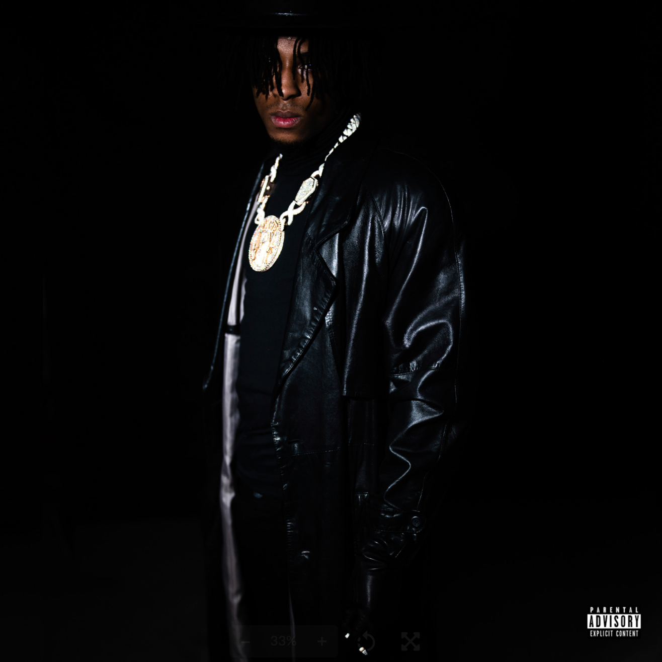

Multi-platinum certified rap superstar YoungBoy Never Broke Again has announced his upcoming album, ‘The Last Slimeto.’ The 30-track album is slated for release via Never Broke Again/Atlantic Records on August 5th. According to the partially revealed track list, no features are included on the album thus far but things can change in the months to come. You can pre-order the album HERE.

The album, that’s currently sitting at no. 1 on Apple Music’s Top Albums chart, features his most recent single ‘4KT Baby.’ The official companion visual is now streaming at YouTube. ‘Check it out here.

‘The Last Slimeto’ will join YoungBoy’s ever-burgeoning catalogue of music after his latest mixtape, ‘Colors’ – which housed recent hit tracks, including “Emo Rockstar,” “Fish Scale,” “Foolish Figure,” “Emo Love,” “Bring The Hook,” and “Know Like I know” all now available at DSPs and streaming services everywhere.
Track list
1.
2.
3.
4.
5.
6.
7.
8.
9.
10.
11.
12.
13.
14.
15.
16.
17.
18.
19.
20. 4KT Baby
21. The North Bleeding
22. Loner Life
23. Acclaimed Emotions
24. Wagwan
25. Ghost
26. Nightfall
27. Holy
28. I Got The Bag
29. Mr. Grim Reaper
30. I Hate YoungBoy

# # #

FOR MORE INFORMATION, PLEASE VISIT:
INSTAGRAM | TWITTER | FACEBOOK

FOR ALL PRESS INQUIRIES, PLEASE CONTACT:
ARIANA.WHITE@ATLANTICRECORDS.COM

