DAINE CHRONICLES HER COMING OF AGE ON DEBUT MIXTAPE
QUANTUM JUMPING

RELEASES VIDEO FOR ‘WEEKENDS’

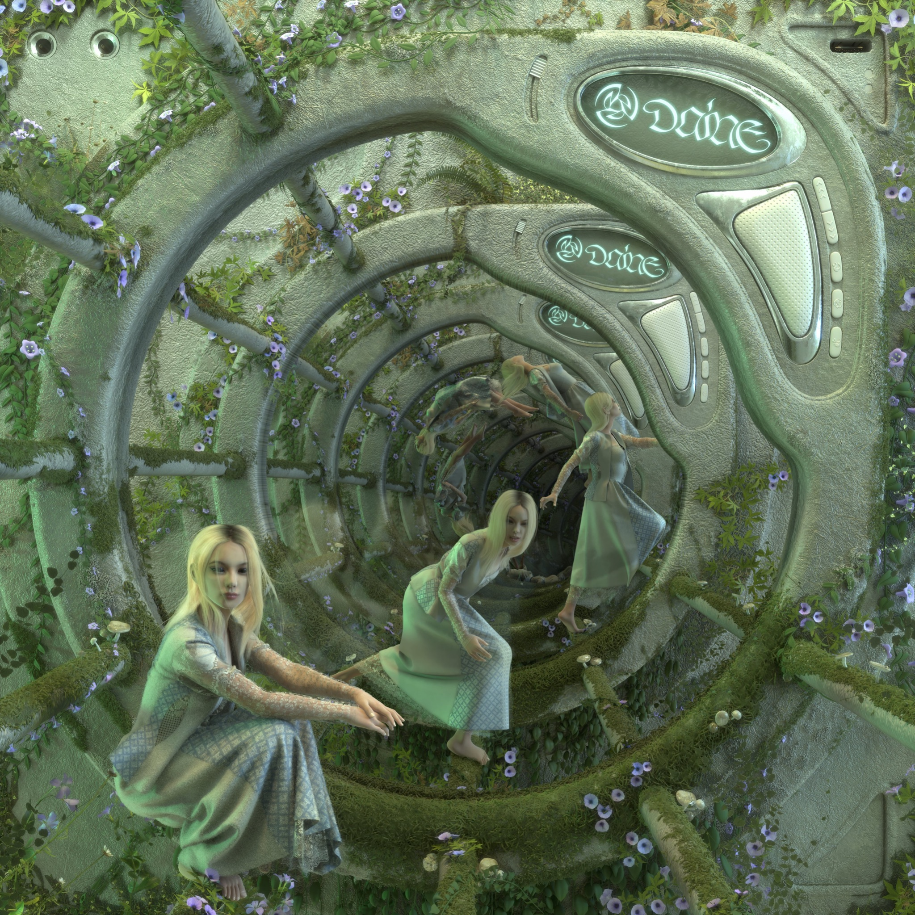

Watch the video for ‘Weekends’ HERE
Buy/Stream the mixtape HERE

“A future emo icon” – NME

“Teen angst’s freshest voice” - V Magazine

“It feels healing and painful; like looking directly at a solar flare.” - The Guardian

“A nihilistically detached voice” - The FADER

“Emo-pop melodies with otherworldly aesthetics that feel like they’ve been plucked from a faraway fantasy land” - DAZED

An artist who found her audience within the COVID-19 pandemic, daine has become a guiding voice in a hybrid scene of creatives who are splicing their diverse tastes and talents for a truly postmodern take on contemporary music. A rapidly ascending voice in the alternative and electronic pop scenes thanks to her output and Nocturne online parties which have featured the likes of Charli XCX, Oklou, Ethel Cain, umru and more, today daine finally releases her debut mixtape Quantum Jumping following 18 months of fervent anticipation from fans and press alike.

A chronological timeline of the very first songs she wrote at the age of 16, Quantum Jumping charts a burgeoning artist growing in real time, finding their own source of expression and building their own space in a world she felt ostracized within. That sense of solitude is no more apparent than in the project’s opening cut, ‘Cemetery Dreams’. A devastatingly immersive soundscape that belies the 16 years that daine had lived when they wrote the track, ‘Cemetery Dreams’ balances finely crafted emotional peaks and melodrama expertly. Formed around a lo-fi loop of daine’s own guitar playing, the track swells gradually with subtle textures and grandiose strings alongside contemporary rap production flourishes from regular collaborator Circle Pitt. Following on ‘Cemetery Dreams’’ spiritual melancholia is new single ‘Weekends’; the project’s most pop-focused moment. An almost weightless cut of emo-pop that explores daine contending with her own thoughts while alone, ‘Weekends’ signifies daine’s already hugely matured songwriting abilities with an irresistibly replayably chorus and devastatingly relatable lyrical subject matter that reckons with the often uncontrollable power of teenage emotion.

Quantum Jumping spotlights daine’s versatility as an artist even in her earliest beginnings, with fan favourite ‘IDC’ playing host to a vengeful fantasy that allows daine to visualise those who ridiculed her from a great height over a brooding soundscape that builds towards all out sonic maximalism thanks to production from Lonelyspeck. ‘Black and Blue’ takes a folk-tinged stance on daine’s midwest emo influenced sound while she reckons with her relationship insecurities and the careless abandon of new love. ‘Glitter’’s spacious yet emotional soundscape feels wholly accessible despite it’s subtle production and the deferred gratification within its composition, featuring an uplifting spoken word outro written by daine herself. ‘Comes and Goes’, a collaboration with Seattle emo stalwart Into It. Over It, gradually begins to build out her own alternative influences over glitched out percussion that splices with organic instrumentation seamlessly, tied together by daine’s own saccharine delivery. Final track ‘New Ground’ closes the first chapter of daine’s diary as the final song written for the project. The most upbeat of the collection, the song offers a redemptive end to Quantum Jumping as daine addresses those who left her behind from a new found clarity, ready to ascend to the next stage in her life. daine’s signature reverberated guitar picks are offset by an uptempo drum track that is punctuated only by daine’s disaffected yet impactful vocal and a pair of blazing guitar solos that take the track to a powerful new level.

A self-professed “tombstone to her adolescence,” daine’s debut mixtape Quantum Jumping places a sonic world of daine’s own design on full display while marking her out as one of 2022’s most exciting breakout stars. An artist who has already experimented with the boundaries of alternative music, metal, pop, electronic sounds and more, daine’s genre-eschewing compositions are a perfect encapsulation of the boundless creativity at her fingertips. With daine’s demand to subvert expectations only growing with each release, the possibilities of where she may go next are endless. Quantum Jumping is the opening chapter to what is sure to be a compelling and extremely varied diary that is set to be shared with the world in real time.

daine
Quantum Jumping

- Cemetery Dreams
- Weekends
- IDC
- Black and Blue
- Glitter
- Comes and Goes
- New Ground

daine: Website | Twitter | Instagram

