FOR IMMEDIATE RELEASE
JULY 1, 2021

FENIX FLEXIN SHARES DEBUT MIXTAPE FENIX FLEXIN VOL 1.
LISTEN

NEW VIDEO FOR "WHAT'S THE MOVE" OUT NOW
WATCH

FENIX FLEXIN VOL. 1 TOUR KICKS OFF IN SEPTEMBER
TICKETS ON SALE NOW

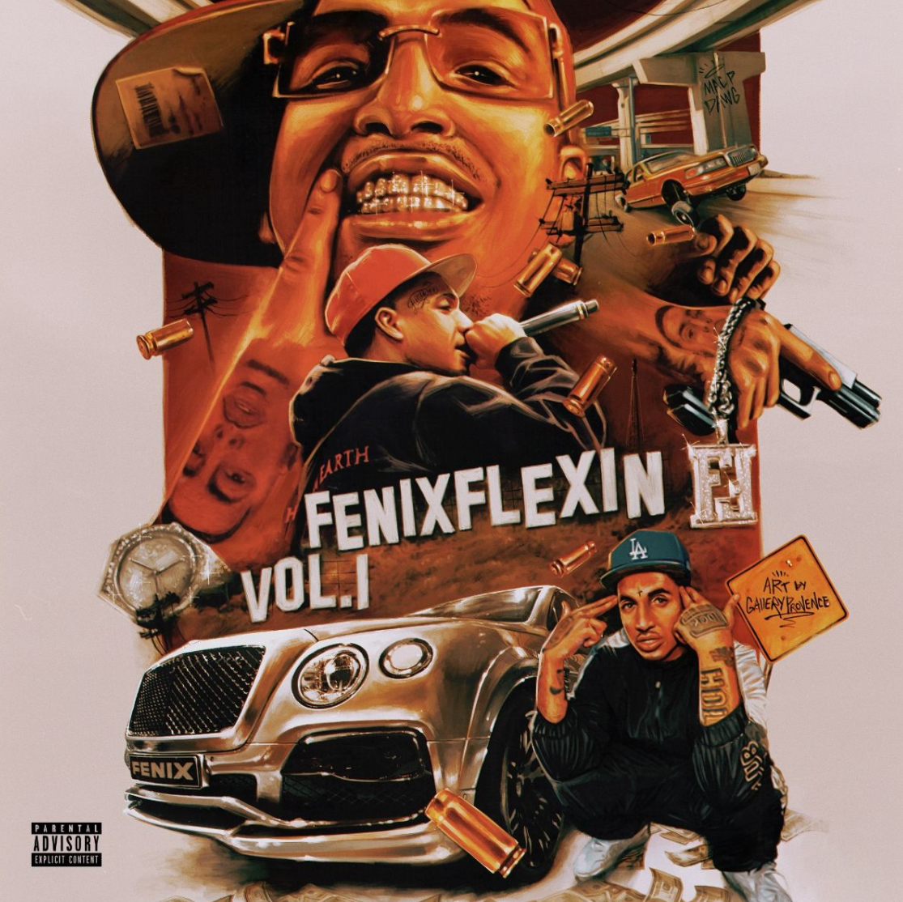

Continuing to make his mark on the sound and style of West Coast rap music, former Shoreline Mafia member, Fenix Flexin has just released his debut mixtape, Fenix Flexin Vol. 1. The new project includes Fenix's recently released singles "10 Toes," the Ron Ron and Menace produced "For Me," and "NDS" as well as twelve new tracks with features from Drakeo The Ruler, Rob Vicious, Bravo The Bagchaser, D-Block Europe, Peso Peso, and SaysoTheMac. The new mixtape arrives with a video for "What's the Move," an AfterPangea directed visual featuring Fenix and his crew cleaning up in their DTLA penthouse before a night out.
Fenix Flexin Vol. 1 sees the L.A. born and raised rapper leaning into his newfound autonomy. The project demonstrates Fenix's ability to thrive as a solo artist while staying true to himself and his supporters. For Fenix, music has always been about a sense of community. It's what motivates and inspires him. To further his involvement in the culture that's shaped him, Fenix has recently launched a new lifestyle and apparel company called Burnt Co and sponsored a team of pro skaters from in and around Los Angeles.
Having built Shoreline Mafia into a critically acclaimed arena headlining group with three platinum singles (“Bands,” “Nun Major,” and “Musty”), two gold singles (“Whuss The Deal” and “Bottle Service”), and billions of streams, Fenix Flexin is now out to show his fans that the best is yet to come. After the overwhelmingly positive response from fans to his solo songs on 2020's Mafia Bidness, including “Hoe Sh*t” and "How We Do It" (feat Wiz Khalifa), as well as his massive hit, "Fell In Love" off 2019's Party Pack Vol. 2, Fenix Flexin is ready to manifest the solo career he's always envisioned. “The group had a bunch of respect, a huge following, and a whole lot of people behind us,” affirms Fenix. “Now, I’m claiming all of those things for myself as an individual, and I’m off to a good start.” Carrying his seven-figure streaming audience and viewership with him, Fenix Flexin has shared his debut mixtape, Fenix Flexin Vol. 1 and plans to set out on tour this September – Tickets on sale now.

ABOUT FENIX FLEXIN
After a heavy hand in three platinum singles and several acclaimed full-length projects with Shoreline Mafia, Fenix Flexin has stepped away from the group to manifest the solo career he always envisioned. Being on his own is something that is not new to Fenix Rypinski, who is of Black, Mexican, and Polish heritage. While the rapper’s mother and father each battled addiction, he bounced around between his grandmother and siblings’ houses, staying in West LA, East Hollywood, Downey, and Huntington Park.
Along with skating and graffiti, rap was a creative outlet that allowed the kid on the move to make fast friends. For now, Fenix Flexin is focused on branding his individuality, “I have to reclaim that respect and attention.” The founder of the skate-inspired lifestyle company Burnt self-released “10 Toes” to kickstart his 2021 campaign. On his own, Fenix Flexin has a plan. “I’m ready to show people what I’m capable of,” he asserts. That proper introduction will take place across three mixtapes and a solo debut project. Tapping into some Bay area sounds as well as some Midwest production, he says, “It’s all about growth and expansion."

FENIX FLEXIN VOL. 1 - TRACKLISTING
01. Risky (prod. Fbeat)
02. Respectfully (feat. Drakeo The Ruler) (prod. Cypress Moreno)
03. Feds (feat. Rob Vicious) (prod. DJ Flippp & Rappa)
04. True 2 This (feat. Bravo The Bagchaser) (prod. Cypress Moreno & E Blessed)
05. From The Block (feat. D-Block Europe) (prod. Cuddie Joe)
06. NDS (prod. Fbeat)
07. Lightshow (prod. Quad)
08. For Me (prod. RonRon, LNK, Mario Petersen)
09. Wockiana (prod. Bruce24k)
10. PesoFlexin (feat. Peso Peso) (prod. Quad)
11. On Fig (feat. SaysoTheMac) (prod. Fbeat)
12. What's the Move (prod. Milo)
13. 10 Toes (prod. Fbeat & LowTheGreat)
14. Pain (prod. TerisJay)
15. RIP Mac P Dawg (prod. Milo & Tonydahittman)

FENIX FLEXIN VOL. 1 – TOUR DATES
09/14 – Hawthorne – Portland, OR
09/15 – Wow Hall – Eugene, OR
09/16 – Neumos – Seattle, WA
09/18 – Senator – Chico, CA
09/19 – The Complex – Oakland, CA
09/20 – The Catalyst – Santa Cruz
09/21 – Harlow’s – Sacramento, CA
09/23 – Music Alley – Santa Barbara, CA
09/24 – Regent Theater – Los Angeles, CA
09/25 – Aura – Phoenix, AZ

"When it comes to Fenix Flexin, he’s back and better than ever" – Lyrical Lemonade
"This is some real lifestyle music that if you get it, you really get it." – Daily Chiefers
"Lyrically, this latest single seems to effectively capture his current headspace." – HotNewHipHop
"Shoreline Mafia frontman Fenix Flexin lives up to his name" – Rap Radar
“Shoreline Mafia’s Fenix Flexin starts a new chapter” – The FADER
"Fenix Flexin is tied into the skate culture of Los Angeles" – All Hip Hop

CONNECT WITH FENIX FLEXIN
Spotify | Instagram | Twitter | Facebook

PRESS CONTACT:
BRITTANY BELL | BRITTANY.BELL@ATLANTICRECORDS.COM

