FOR IMMEDIATE RELEASE

JUNE 1, 2022

**AVA MAX ANNOUNCES NEW ALBUM** [***DIAMONDS & DANCEFLOORS***](http://avamax.lnk.to/DiamondsAndDancefloors)

**DUEOCTOBER 14TH**

**GLOBAL POP SENSATION ANNOUNCES HIGHLY-ANTICIPATED SOPHOMORE ALBUM**

**DURING APPEARANCE ON NBC’S *THE TODAY SHOW***

**DEBUT ALBUM *HEAVEN & HELL* NEWLY RIAA CERTIFIED PLATINUM**

**+ NEWLY 4X PLATINUM “SWEET BUT PSYCHO,” 2X PLATINUM “KINGS & QUEENS,” AND PLATINUM “MY HEAD & MY HEART”**

**POP SUPERSTAR HAS EARNED OVER 11 BILLION GLOBAL STREAMS**

**LEAD SINGLE “MAYBE YOU’RE THE PROBLEM” ALREADY BOASTS 35M STREAMS AND COUNTING**

**LISTEN TO “MAYBE YOU’RE THE PROBLEM”** [**HERE**](https://nam04.safelinks.protection.outlook.com/?url=https%3A%2F%2Favamax.lnk.to%2FMYTP&data=05%7C01%7CTiana.Timmerberg%40atlanticrecords.com%7C0de4796169b447ccb33308da3f3d2232%7C8367939002ec4ba1ad3d69da3fdd637e%7C0%7C0%7C637891829061897569%7CUnknown%7CTWFpbGZsb3d8eyJWIjoiMC4wLjAwMDAiLCJQIjoiV2luMzIiLCJBTiI6Ik1haWwiLCJXVCI6Mn0%3D%7C3000%7C%7C%7C&sdata=3tCiPrsjoZzOGn6HNjUYOiZssd4jIZab%2FfBy2npCNaU%3D&reserved=0) **| WATCH OFFICIAL MUSIC VIDEO** [**HERE**](https://nam04.safelinks.protection.outlook.com/?url=https%3A%2F%2Favamax.lnk.to%2FMYTPVideoPR&data=05%7C01%7CTiana.Timmerberg%40atlanticrecords.com%7C0de4796169b447ccb33308da3f3d2232%7C8367939002ec4ba1ad3d69da3fdd637e%7C0%7C0%7C637891829061897569%7CUnknown%7CTWFpbGZsb3d8eyJWIjoiMC4wLjAwMDAiLCJQIjoiV2luMzIiLCJBTiI6Ik1haWwiLCJXVCI6Mn0%3D%7C3000%7C%7C%7C&sdata=uAChQsNjz6BBecbU1HsNGTu%2FIXCjcTD3VJ8KckP2GK4%3D&reserved=0)

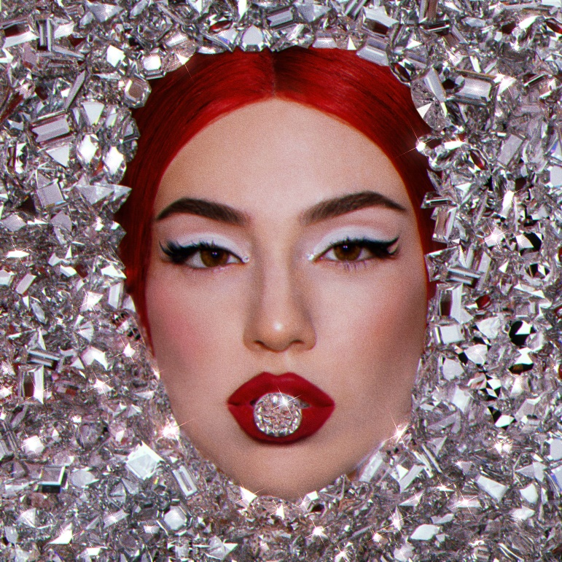

**DOWNLOAD ARTWORK** [**HERE**](https://warnermusicgroup.box.com/s/f1xb88j9adglw36s0prtkbmhjdbwi2wv)

RIAA multi-platinum certified global pop sensation **Ava Max** is celebrating her newest single “Maybe You’re The Problem” with this morning’s interview and performance on NBC’s *The TODAY Show*. Along with delivering the debut national television performance of her upbeat and confident new single, Ava gave the exclusive announcement that her sophomore album, *DIAMONDS & DANCEFLOORS*, is coming October 14th. Pre-saves and pre-orders are available across DSPs now [HERE](http://avamax.lnk.to/DiamondsAndDancefloors).

The announcement comes hot on the heels of the recent RIAA Platinum certification of her debut album *HEAVEN & HELL*,featuring smash hits such as the newly 4x Platinum “Sweet but Psycho,” 2x Platinum “Kings & Queens,” and Platinum “My Head & My Heart.” “**Maybe You’re The Problem**” offers the first preview of Ava’s fiercely personal upcoming album and is available now [HERE](https://nam04.safelinks.protection.outlook.com/?url=https%3A%2F%2Favamax.lnk.to%2FMYTP&data=05%7C01%7CTiana.Timmerberg%40atlanticrecords.com%7C0de4796169b447ccb33308da3f3d2232%7C8367939002ec4ba1ad3d69da3fdd637e%7C0%7C0%7C637891829061897569%7CUnknown%7CTWFpbGZsb3d8eyJWIjoiMC4wLjAwMDAiLCJQIjoiV2luMzIiLCJBTiI6Ik1haWwiLCJXVCI6Mn0%3D%7C3000%7C%7C%7C&sdata=3tCiPrsjoZzOGn6HNjUYOiZssd4jIZab%2FfBy2npCNaU%3D&reserved=0). The track is joined by an official music video, directed by Joseph Kahn (Britney Spears, Taylor Swift, Jennifer Lopez) streaming now via YouTube [HERE](https://nam04.safelinks.protection.outlook.com/?url=https%3A%2F%2Favamax.lnk.to%2FMYTPVideoPR&data=05%7C01%7CTiana.Timmerberg%40atlanticrecords.com%7C0de4796169b447ccb33308da3f3d2232%7C8367939002ec4ba1ad3d69da3fdd637e%7C0%7C0%7C637891829061897569%7CUnknown%7CTWFpbGZsb3d8eyJWIjoiMC4wLjAwMDAiLCJQIjoiV2luMzIiLCJBTiI6Ik1haWwiLCJXVCI6Mn0%3D%7C3000%7C%7C%7C&sdata=uAChQsNjz6BBecbU1HsNGTu%2FIXCjcTD3VJ8KckP2GK4%3D&reserved=0).

“Maybe You’re The Problem” follows Ava’s collaboration with superstar DJ Tiësto for their worldwide hit, “[The Motto](https://nam04.safelinks.protection.outlook.com/?url=https%3A%2F%2Ftiesto.lnk.to%2FthemottoID&data=05%7C01%7CTiana.Timmerberg%40atlanticrecords.com%7C0de4796169b447ccb33308da3f3d2232%7C8367939002ec4ba1ad3d69da3fdd637e%7C0%7C0%7C637891829061897569%7CUnknown%7CTWFpbGZsb3d8eyJWIjoiMC4wLjAwMDAiLCJQIjoiV2luMzIiLCJBTiI6Ik1haWwiLCJXVCI6Mn0%3D%7C3000%7C%7C%7C&sdata=gbFmfwyak%2BTXAGgPKIHKeo66ZTJxAyzfa4xqBxPtzg0%3D&reserved=0).” The track has proven an undeniable international blockbuster since its release, reaching the top 5 on *Billboard*’s “Dance/Electronic Songs” chart while earning over 500M worldwide. An official music video – directed by Christian Breslauer (The Weeknd, Lil Nas X, Doja Cat) – currently boasts over 70M views via YouTube [HERE](https://nam04.safelinks.protection.outlook.com/?url=https%3A%2F%2Fwww.youtube.com%2Fwatch%3Fv%3D1_4ELAxKrDc&data=05%7C01%7CTiana.Timmerberg%40atlanticrecords.com%7C0de4796169b447ccb33308da3f3d2232%7C8367939002ec4ba1ad3d69da3fdd637e%7C0%7C0%7C637891829061897569%7CUnknown%7CTWFpbGZsb3d8eyJWIjoiMC4wLjAwMDAiLCJQIjoiV2luMzIiLCJBTiI6Ik1haWwiLCJXVCI6Mn0%3D%7C3000%7C%7C%7C&sdata=j1gq4xKpeVyrmKATWNyOqQ7irGmACQe2%2BU31ppkY31c%3D&reserved=0).

“Maybe You’re The Problem” marks Max’s first solo release since last year’s “[EveryTime I Cry](https://nam04.safelinks.protection.outlook.com/?url=https%3A%2F%2Favamax.lnk.to%2FEveryTimeICryID&data=05%7C01%7CTiana.Timmerberg%40atlanticrecords.com%7C0de4796169b447ccb33308da3f3d2232%7C8367939002ec4ba1ad3d69da3fdd637e%7C0%7C0%7C637891829061897569%7CUnknown%7CTWFpbGZsb3d8eyJWIjoiMC4wLjAwMDAiLCJQIjoiV2luMzIiLCJBTiI6Ik1haWwiLCJXVCI6Mn0%3D%7C3000%7C%7C%7C&sdata=io1o0%2BwtzEUVibUzuY6ZZMQyHp4oHK1v3yjGGm%2BWWu4%3D&reserved=0),” declared by *PAPER* as “*an undeniably uplifting banger.*”

**ABOUT AVA MAX:**

Ava Max is ready to take her already extraordinary rise to the pinnacle of pop success to even greater heights with her first new single of 2022, “Maybe You’re The Problem.” With over 11B worldwide streams, an array of smash collaborations, and multiple RIAA gold and platinum certifications in the US alone, the first-generation Albanian American artist has fast proven a true pop superstar, hailed for her seismic voice, idiosyncratic high fashion mindset, and undeniable knack for cinematic, theatrical popcraft. 2018 saw Max make her explosive arrival with the blockbuster success of the RIAA 4x-platinum certified hit, “Sweet but Psycho.” Currently boasting more than 3.5B global streams, the track took the world by storm, spending three weeks in the top 10 on *Billboard*’s “Hot 100” while reaching #1 in more than 20 countries around the world and earning diamond certification in Brazil, France, Poland, as well as multi-platinum certification in Australia (5x), Austria (3x), Belgium (2x), Canada (6x), Denmark (3x), Germany (2x), Italy (3x), the Netherlands (2x), New Zealand, Norway (9x), Portugal (2x), Spain, Switzerland (4x), and the United Kingdom (3x). Joined by an official video that has now garnered over 780M views, “Sweet But Psycho” further earned Max a long string of international honors, including the 2019 MTV Europe Music Awards’ coveted “Best Push Artist” award, “Best New Artist” nominations at both the 2019 MTV Video Music Awards and the 2019 MTV Europe Music Awards, and an iHeartRadio Titanium Award marking over 1B spins in 2020 alone. Max kept up the pace with a series of smash singles, including the RIAA gold certified “So Am I,” “Salt,” and the Platinum “My Head & My Heart,” as well as the platinum certified title track to her acclaimed full-length debut, *Heaven & Hell*. The newly RIAA Platinum certified album made spectacular chart debuts around the globe, earning over 11B worldwide streams and gold, platinum, and multi-platinum certifications in over a dozen countries. 2021 saw Max unveil “EveryTime I Cry,” declared by *PAPER* as “*an undeniably uplifting banger*” and joined by an official music video, co-directed by Max and Charlotte Rutherford, currently boasting over 23M views via YouTube. What’s more, Tiësto & Ava Max’s worldwide hit anthem, “The Motto,” has proven an undeniable international blockbuster since its November 2021 release, reaching the top 5 on *Billboard*’s “Dance/Electronic Songs” chart while earning over 500M worldwide streams thus far.

Named to *Forbes*’ prestigious “30 Under 30” list in 2021, Ava has been feted with a wide range of media attention from such high profile outlets as *VOGUE*, *Rolling Stone*, *Vanity Fair*, *Billboard*, *PAPER*, to name but a few, while also delivering a long run of show-stopping performances on CBS’s *The Late Late Show with James Corden*, NBC’s *TODAY*, ABC’s *Jimmy Kimmel Live!*, *Good Morning America*, and *Dick Clark’s New Year’s Rockin’ Eve with Ryan Seacrest 2020,* the MTV Europe Video Music Awards, and more. A truly international artist, Max has teamed up with a stunning assortment of diverse musicians around the world, spanning Norwegian DJ/producer Alan Walker and Spanish superstar Pablo Alborán to David Guetta, Jason Derulo, AJ Mitchell (for the RIAA gold certified “Slow Dance”), and country stars Thomas Rhett & Kane Brown (the RIAA gold certified “On Me”). Now, with “Maybe You’re The Problem” – and more exhilarating new music to come – Ava Max is poised to push pop even further, setting a direct course toward the top and beyond.

**CONNECT WITH AVA MAX:**

[OFFICIAL](https://nam04.safelinks.protection.outlook.com/?url=https%3A%2F%2Fwww.avamax.com%2F&data=05%7C01%7CTiana.Timmerberg%40atlanticrecords.com%7C0de4796169b447ccb33308da3f3d2232%7C8367939002ec4ba1ad3d69da3fdd637e%7C0%7C0%7C637891829061897569%7CUnknown%7CTWFpbGZsb3d8eyJWIjoiMC4wLjAwMDAiLCJQIjoiV2luMzIiLCJBTiI6Ik1haWwiLCJXVCI6Mn0%3D%7C3000%7C%7C%7C&sdata=Z2Cx38hgnqjrNJY%2Fuv4o5TE4ziEXRMmqa1wyfQ8vnn8%3D&reserved=0) I [INSTAGRAM](https://nam04.safelinks.protection.outlook.com/?url=https%3A%2F%2Fwww.instagram.com%2Favamax%2F&data=05%7C01%7CTiana.Timmerberg%40atlanticrecords.com%7C0de4796169b447ccb33308da3f3d2232%7C8367939002ec4ba1ad3d69da3fdd637e%7C0%7C0%7C637891829061897569%7CUnknown%7CTWFpbGZsb3d8eyJWIjoiMC4wLjAwMDAiLCJQIjoiV2luMzIiLCJBTiI6Ik1haWwiLCJXVCI6Mn0%3D%7C3000%7C%7C%7C&sdata=1F%2FSRGtJ80iVS87x0KqKsYRW9xHsQr6ozW69EZx12XE%3D&reserved=0) I [TIKTOK](https://nam04.safelinks.protection.outlook.com/?url=https%3A%2F%2Fwww.tiktok.com%2F%40avamax%3Flang%3Den&data=05%7C01%7CTiana.Timmerberg%40atlanticrecords.com%7C0de4796169b447ccb33308da3f3d2232%7C8367939002ec4ba1ad3d69da3fdd637e%7C0%7C0%7C637891829061897569%7CUnknown%7CTWFpbGZsb3d8eyJWIjoiMC4wLjAwMDAiLCJQIjoiV2luMzIiLCJBTiI6Ik1haWwiLCJXVCI6Mn0%3D%7C3000%7C%7C%7C&sdata=TM2rQfA6SFpapEyR3qVT8YsBWRX4X11PYEaKMoQs7t0%3D&reserved=0) | [TWITTER](https://nam04.safelinks.protection.outlook.com/?url=https%3A%2F%2Ftwitter.com%2Favamax&data=05%7C01%7CTiana.Timmerberg%40atlanticrecords.com%7C0de4796169b447ccb33308da3f3d2232%7C8367939002ec4ba1ad3d69da3fdd637e%7C0%7C0%7C637891829061897569%7CUnknown%7CTWFpbGZsb3d8eyJWIjoiMC4wLjAwMDAiLCJQIjoiV2luMzIiLCJBTiI6Ik1haWwiLCJXVCI6Mn0%3D%7C3000%7C%7C%7C&sdata=FGaTzk2ztywJz6gFvM4kDZ2qdmgvMi3RWvrAHXsczhY%3D&reserved=0) I [FACEBOOK](https://nam04.safelinks.protection.outlook.com/?url=https%3A%2F%2Fwww.facebook.com%2FAvaMax&data=05%7C01%7CTiana.Timmerberg%40atlanticrecords.com%7C0de4796169b447ccb33308da3f3d2232%7C8367939002ec4ba1ad3d69da3fdd637e%7C0%7C0%7C637891829061897569%7CUnknown%7CTWFpbGZsb3d8eyJWIjoiMC4wLjAwMDAiLCJQIjoiV2luMzIiLCJBTiI6Ik1haWwiLCJXVCI6Mn0%3D%7C3000%7C%7C%7C&sdata=al5SGgHXCLs5n7tz1irN92onXbzKHNlezaMhDA6%2B5%2Fg%3D&reserved=0) | [YOUTUBE](https://nam04.safelinks.protection.outlook.com/?url=https%3A%2F%2Fwww.youtube.com%2Fchannel%2FUCOwgc8DswjoBMuuUU2ScPvQ&data=05%7C01%7CTiana.Timmerberg%40atlanticrecords.com%7C0de4796169b447ccb33308da3f3d2232%7C8367939002ec4ba1ad3d69da3fdd637e%7C0%7C0%7C637891829061897569%7CUnknown%7CTWFpbGZsb3d8eyJWIjoiMC4wLjAwMDAiLCJQIjoiV2luMzIiLCJBTiI6Ik1haWwiLCJXVCI6Mn0%3D%7C3000%7C%7C%7C&sdata=yA7z88BRLJhbHFbq1Vz4pk79rmO4zHvWHqX7PvCT02s%3D&reserved=0)

Press contacts:

Kelly McWilliam / [Kelly.McWilliam@atlanticrecords.com](mailto:Kelly.McWilliam@atlanticrecords.com)

Ashley Kalmanowitz / [Ashley.Kalmanowitz@atlanticrecords.com](mailto:Ashley.Kalmanowitz@atlanticrecords.com)