FOR IMMEDIATE RELEASE
JUNE 10, 2022

Anna Clendening trades her ex’s for “Girls Like You”

Second track off forthcoming Untitled Ex’s EP out Now

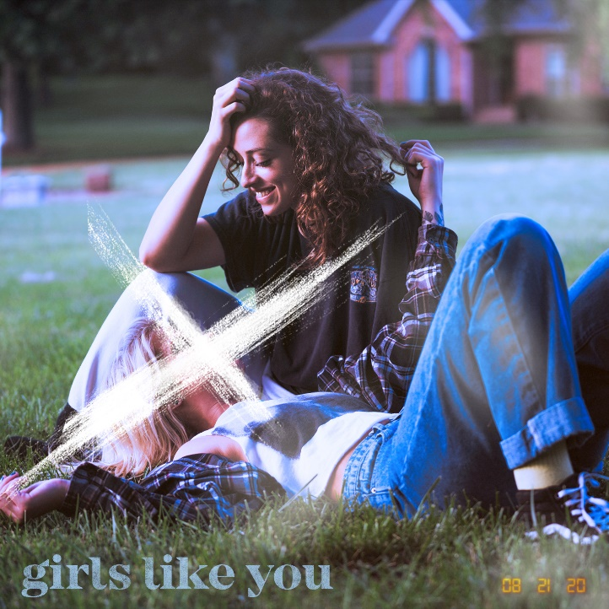
DOWNLOAD HIGH-RES IMAGES

STREAM “GIRLS LIKE YOU”: LINK

Rising singer-songwriter Anna Clendening has unveiled “Girls Like You,” the second offering off her forthcoming Untitled Ex’s EP due this summer via Atlantic Records. A spiritual successor to her RIAA-certified Gold single “Boys Like You,” the track finds Clendening exploring her sexuality from a new place as she croons “Girls like you got me questioning everything I thought I knew.”

“Everyone has a ‘coming out song,’ and I’m not trying to reinvent the wheel, but it’s a response to ‘Boys Like You’ about a girl I met from Florida who I ended up kissing,” she explains. “It was written for myself.”

“Girls Like You” follows comeback single “Sweatshirt,” which arrived last month following an 18-month hiatus that found Clendening relocated from Los Angeles to Nashville and embracing herself as both an artist and songwriter. The period of growth led to an outpouring of creativity that ultimately formed her Untitled Ex’s EP – a five track collection that perfects her very own brand of gleefully chaotic pop.

“I wanted to write about the past five relationships I’ve had just to get it all out there,” Clendening recalls. “Being a spiteful human sometimes, I thought it would be cool to name each song after a guy. My manager said it wouldn’t be cool to get sued—he was right. That’s how we came up with ‘Untitled Ex’s.’ Every song is very much about a specific person.”

Since the release of “Boys Like You” in 2017, Clendening has amassed over half-a-billion streams and critical acclaim from the likes of Billboard, Ones To Watch, Refinery29 & more. Her debut EP, 2019’s Waves, generated over 150 million streams alone in under six months and led to collaborations with the likes of Illenium, Lost Kings & Matoma. Signing to Atlantic Records in 2020, her Evolve EP, featuring standout single “Love Song” with John K, arrived to applause from American Songwriter, Flaunt, Idolator & more. In tandem with her honest songwriting, Clendening has proven to be a source of universal encouragement and an incredible advocate for mental health awareness. Sharing openly with fans about her own mental health journey managing anxiety, she's continually channeled these challenges through the healing power of music.

“We’re all very similar,” Clendening observes. “Our experiences, while different, are not isolated. People are going through the same things to not feel alone. When I was first diagnosed with anxiety, I thought I was crazy. I felt like nobody else knew what was going on, and it wasn’t happening to anyone but me. With my music and platform as an artist, I want to be the person I needed when I was 13- or 14-years-old. That’s all I want to do as long as I’m alive.”

CONNECT:
OFFICIAL | FACEBOOK | TWITTER | INSTAGRAM | YOUTUBE | TIKTOK | PRESS ASSETS

CONTACT:
TED.SULLIVAN@ATLANTICRECORDS.COM

