BENNETT IS BACK WITH HER ANTHEMIC FIRST SINGLE, “BUZZED”

ARRIVES WITH OFFICIAL VIDEO DIRECTED BY ART CAMP

RELEASE ARRIVES AHEAD OF PERFORMANCE AT LYRICAL LEMONADE’S SUMMER SMASH

“We don’t dream we live these nightmares.
Tears in Benzes, buzz like lightyears.”

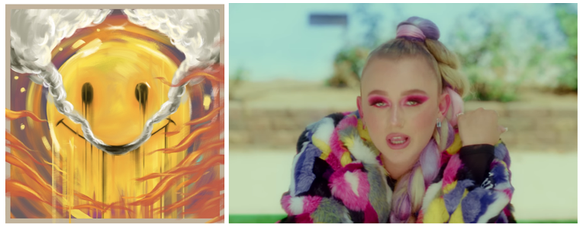
DOWNLOAD HI-RES ARTWORK HERE

Connecticut songstress, BENNETT, has released her latest track today. “Buzzed” is available now at all DSPs and streaming services. The release is accompanied by an official video directed by Art Camp available now and is the first single from Bennett’s upcoming sophomore EP.

Download/stream “Buzzed” now: https://BennettGotBops.lnk.to/Buzzed
Watch/share “Buzzed” now: https://youtu.be/7RpdowXbvzo

“Buzzed” is Bennett’s first musical offering of 2021 and the Orphanage produced anthemic party banger serves as a small taste of what’s to come for the burgeoning pop/soul singer-songwriter. With a live performance date at Lyrical Lemonade’s Summer Smash this Friday 8/20 it’s safe to say that Bennett is back and eager to heat things up.

After signing to Atlantic Records, she dropped her debut EP THINGS I NEVER SAID in 2020. The single “Give Me A Reason” eclipsed 6 million global streams and almost 1 million YouTube views. Lyrical Lemonade urged, “Give her a listen before she blows up,” while Cool Accidents posited, “‘Give Me A Reason’ might just be her strongest release yet.” Racking up millions of streams and garnering praise from OnesToWatch and Elevator, to name a few, the singer and songwriter is well on her way.

For more information please visit https://www.bennettofficial.com/.

DOWNLOAD HI-RES PRESS PHOTOS HERE

CONNECT WITH BENNETT
WEBSITE | INSTAGRAM | FACEBOOK | TWITTER

PRESS CONTACT
SELAM BELAY // SELAM.BELAY@ATLANTICRECORDS.COM

# # #

