FOR IMMEDIATE RELEASE
JULY 1, 2022

BENNETT IS BACK WITH HER NEW EP WHEN IT’S TOO GOOD
FOLLOW-UP TO TITLE TRACK STREAMING VIA YOUTUBE HERE
STREAM WHEN IT’S TOO GOOD
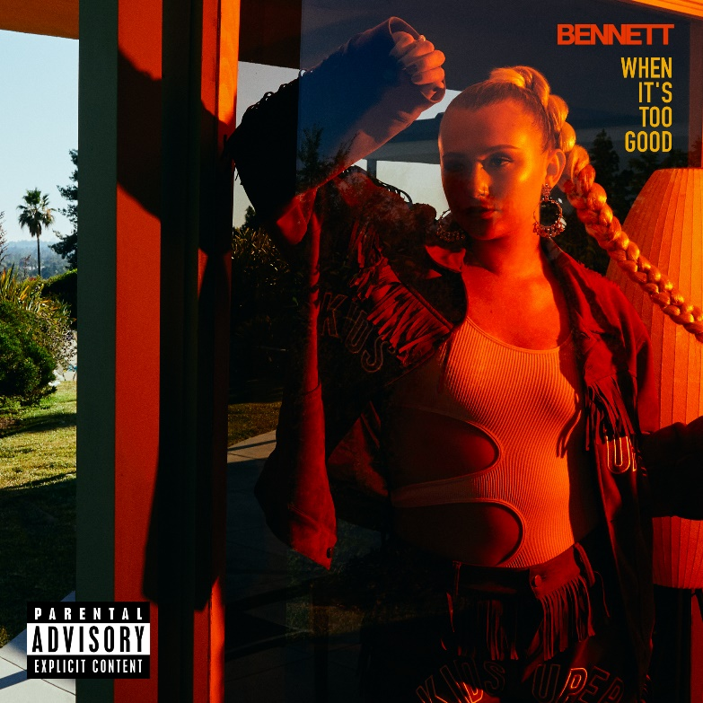
DOWNLOAD HI-RES ARTWORK HERE
“Few artists are able to perk our ears up after releasing a single, let alone are able to continue delivering again and again.” – ONES TO WATCH

“Give her a listen before she blows up.” – LYRICAL LEMONADE

Connecticut songstress, BENNETT, has released her latest EP today. When It’s Too Good is available now at all DSPs HERE. Follow up to previously released title track “When It’s Too Good” streaming via YouTube HERE.
When It’s Too Good comes as the follow up to BENNETT’S previous projects The Buzzed Mixes and Things I Never Said. After signing to Atlantic Records, she dropped her debut EP THINGS I NEVER SAID in 2020. The single “Give Me A Reason” eclipsed 6 million global streams and almost 1 million YouTube views. Lyrical Lemonade urged, “Give her a listen before she blows up,” while Cool Accidents posited, “‘Give Me A Reason’ might just be her strongest release yet.” Racking up millions of streams and garnering praise from OnesToWatch and Elevator, to name a few, the singer and songwriter is well on her way.
BENNETT came back with singles “Ain’t My Fault” “Alone” and “Buzzed” all streaming via YouTube HERE.
WHEN IT’S TOO GOOD TRACKLIST
- Hate It Here
- Depression for Now
- Buzzed
- Don't Take Drugs
- Don't Stay Too Long
- When It's Too Good
- LookWhatYouMadeMeDo

BENNETT is like the friend who always understands exactly what you’re going through and knows what to say to make you feel better. Tears, toxic relationships, heartbreak, addiction, anxiety, and anxiousness absorb into her music and bleed back out as R&B-backed bops with bite. The daughter of a single mother, she embraced music wholeheartedly as a kid. During middle school, she performed in jazz band and pep band and started to write and record original material by high school. Under the influence of Lana Del Rey, Stevie Wonder, Frank Ocean, SZA, and her “favorite artist” The Weeknd, she cut through the noise and made waves on Soundcloud with a 2018 cover of Jorja Smith’s “I Am.” Her original debut single “Never Yours” eventually generated 3 million Spotify streams followed by “Groupie” and “Gone.” Signing to Atlantic Records, she dropped her debut EP THINGS I NEVER SAID in 2020.
###
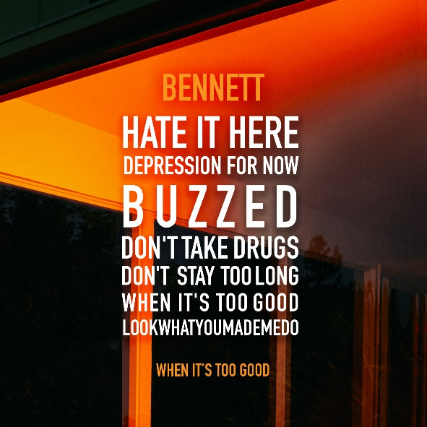
CONNECT WITH BENNETT
WEBSITE | INSTAGRAM | FACEBOOK | TWITTER
PRESS CONTACT
SELAM BELAY // SELAM.BELAY@ATLANTICRECORDS.COM

