FOR IMMEDIATE RELEASE
April 13, 2022

“PRAISE THE LORD” BRELAND BROUGHT DIERKS BENTLEY, KANE BROWN, MICKEY GUYTON, TYLER HUBBARD, CHARLES KELLEY, NELLY, SAM HUNT & MORE TO THE MOTHER CHURCH OF COUNTRY MUSIC LAST NIGHT FOR “BRELAND & FRIENDS” SOLD-OUT CONCERT TO BENEFIT OASIS CENTER

RAISING OVER $140,000 FOR NASHVILLE’S AT-RISK YOUTH,
THE A-LIST LINEUP BROUGHT THE CROWD AT RYMAN AUDITORIUM TO THEIR FEET
SHOW COMES ON THE HEELS OF DEBUT SOLO
2022 CMT MUSIC AWARDS PERFORMANCE

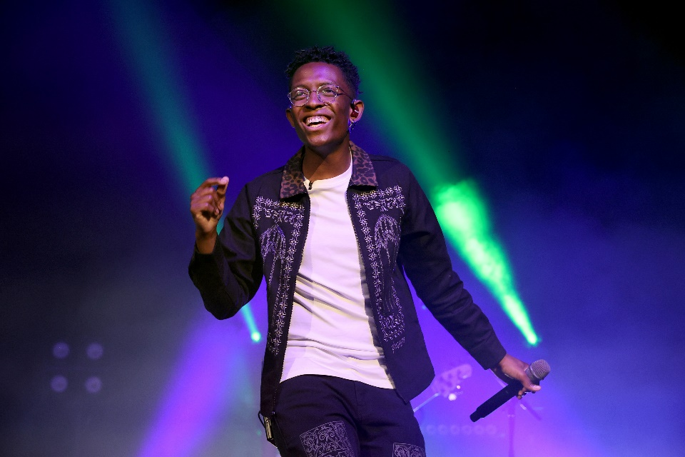

Download Assets Here | Photo Cred: Jason Kempin/Getty Images

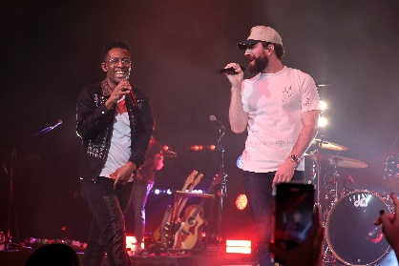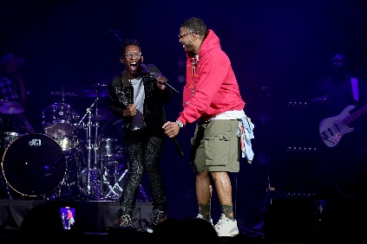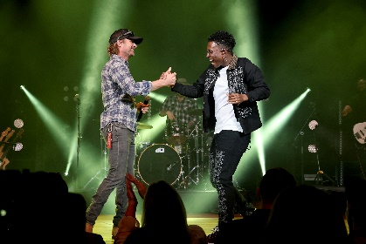

(L-R) Breland; Sam Hunt, Nelly, Dierks Bentley |Photo Cred: Jason Kempin/Getty Images

LOS ANGELES, CA. (April 13, 2022) – Bad Realm Records / Atlantic Records / Warner Music Nashville PLATINUM entertainer BRELAND lit up Nashville’s historic Ryman Auditorium with a stacked A-list lineup of 17 of his friends for the SOLD-OUT, one-night-only “BRELAND & Friends” concert to benefit the Oasis Center. The group raised over $140,000 to benefit the Oasis Center, helping local youth in need. helping local youth in need.

“I just want to thank everyone out here for coming…” shares BRELAND. “I texted everyone that I know and pretty much every single person is here tonight. And to be able to raise money and awareness for an incredible organization with so many artists that I know stand for the same values and ideals that I do is inspiring. I think Country music in general stands for the same ideals, which is helping people, bringing people together, and loving people.”

Taking Ryman Auditorium “Cross-Country,” BRELAND brought out an all-star crew to accompany him on the iconic stage while hosting the star-studded event himself. Some of the evening’s highlights include BRELAND performing “High Horse” with Nelly, “Praise The Lord” with Thomas Rhett, current single verging on #1 Country radio, “Beers On Me,” with Dierks Bentley, and wrapping the night with the certified PLATINUM track “My Truck” with Sam Hunt. Jimmie Allen, Tyler Braden, Kane Brown, Russell Dickerson, Mickey Guyton, Tyler Hubbard, Charles Kelley, RaeLynn, Restless Road, Lily Rose, Seaforth, Brittney Spencer, and Lathan Warlick also took the stage for a night chock-full of epic collaborations. Adding the heart and purpose, Mark Dunkerley, President and CEO of Oasis Center, shared touching first-hand experiences of those who benefit from the charitable organization.

Livestreamed via the Amazon Music Twitch channel, “BRELAND & Friends” was sponsored by Amazon Music with the event proceeds benefiting the Oasis Center. As one of Middle Tennessee’s most comprehensive youth development agencies, Oasis Center is at the forefront of helping young people and their families navigate the complex challenges of today with over 20 programs and services responding to the area’s diverse needs. BRELAND and Oasis Center share in the belief that the greatest impact happens when we bring people together and unite for a common purpose.

This monumental event was hot on the heels of BRELAND’s debut 2022 CMT Music Awards solo performance with his brand-new song “Praise The Lord” listen HERE. Receiving three fan-voted nominations, the rising star brought his signature vocal prowess and magnetic energy to the show in company of Country superstars such as Kenny Chesney, The Judds, Miranda Lambert, Carrie Underwood and more.

Up next, BRELAND will hit the road for high-profile festivals such as Stagecoach Country Music Festival (4/29), Hangout Music Festival (5/21), Tidalwave Music Festival (8/12) with more dates to come. For full tour details visit here, and his debut album CROSS COUNTRY (pre-save/pre-add here) is slated for release this summer.

ABOUT BRELAND
With his PLATINUM debut “My Truck,” singer/songwriter/producer BRELAND has emerged as a bold new force on today’s music landscape. The newly named Breakthrough Artist by Amazon Music first popped off when the Hip-Hop and Country hybrid hit #1 on Spotify’s Global Viral 50 in 2019, and a remix featuring Sam Hunt landed on best-of-the-year lists from NPR to The New York Times. Debuting his brand-new song “Praise The Lord (feat. Thomas Rhett)” at the 2022 ACM Awards, the “symbol of Country music’s ongoing evolution” (Rolling Stone) will be featured on his highly anticipated debut album CROSS COUNTRY slated for release this summer. Featured on Dierks Bentley’s Top 5 and rising single with HARDY, “Beers On Me,” BRELAND also teamed up with Keith Urban for the buzzy track “Throw It Back.” Since signing to Bad Realm Records / Atlantic Records / Warner Music Nashville, he has collaborated with heavy-hitters such as Gary LeVox of Rascal Flatts, Nelly, Blanco Brown, Lauren Alaina, and Chase Rice, and scored high profile looks on The Kelly Clarkson Show, ABC’s 2021 CMA Awards, ABC’s CMA Summer Jam, CMT Crossroads, ABC’s Jimmy Kimmel Live!, ABC’s Good Morning America, CBS’ New Year’s Eve Live: Nashville’s Big Bash, YouTube’s Artist on The Rise, and a Chevy campaign that launched during NFL’s season opener. Coined “1,000 percent the whole package” (Rolling Stone), he’s nominated for three fan-voted nominations for the 2022 CMT Music Awards. He’s out on the road for Russell Dickerson’s ALL YOURS, ALL NIGHT TOUR and is recognized in the Country Music Hall of Fame® and Museum’s brand-new exhibit, American Currents: State of the Music.

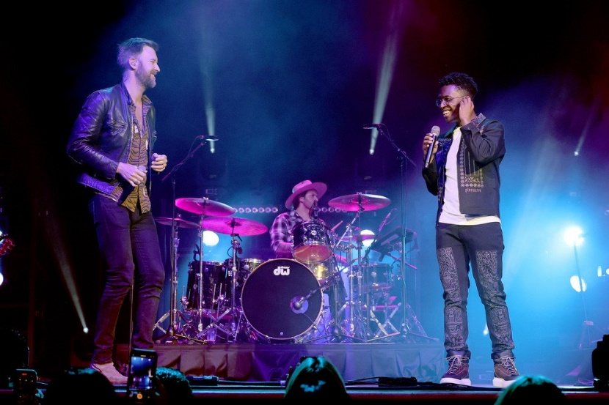
(L-R) Charles Kelley; Breland | Photo Cred: Jason Kempin/Getty Images For “Breland & Friends”

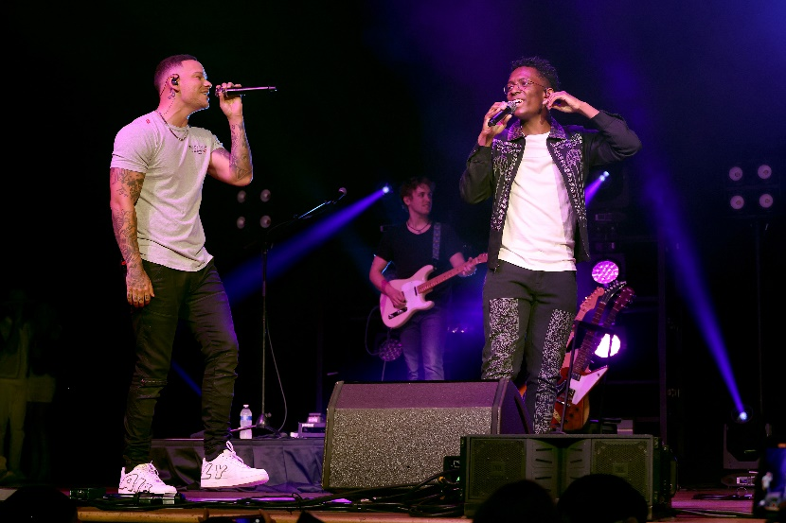
(L-R) Kane Brown; Breland | Photo Cred: Jason Kempin/Getty Images For “Breland & Friends”
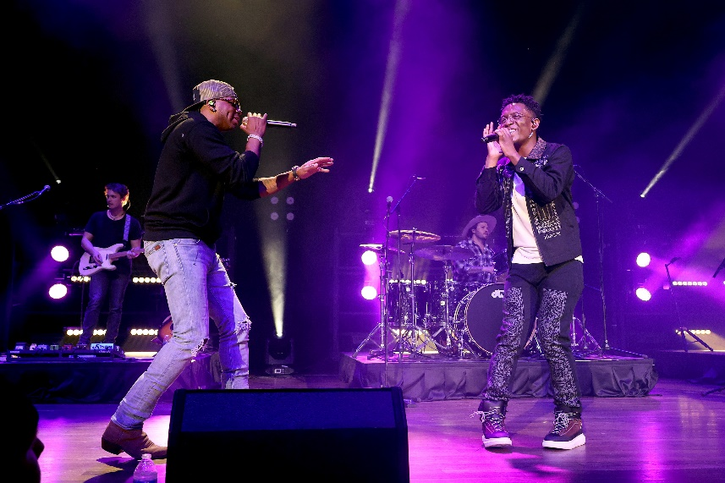
(L-R) Jimmie Allen; Breland | Photo Cred: Jason Kempin/Getty Images For “Breland & Friends”

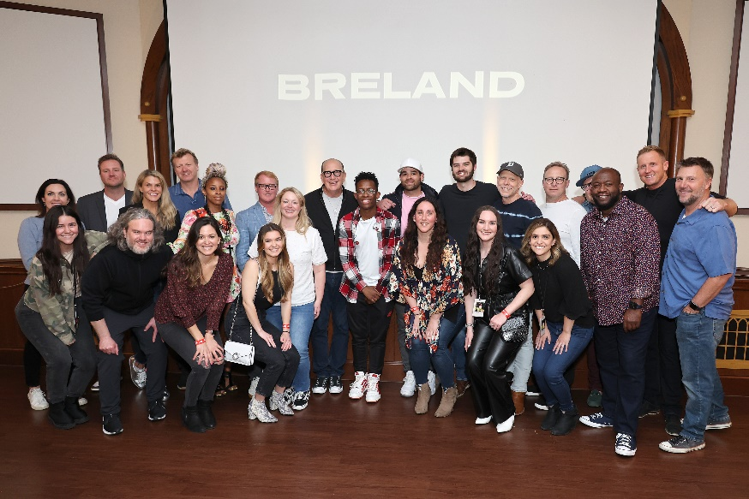
Warner Music Nashville, Atlantic Records, Why&How Teams
Breland Joined His Coast-To-Coast Label Teams, Atlantic Records And Warner Music Nashville, Management, And Industry Executives For A Pre-Show Hang Ahead Of ‘Breland & Friends’ Sold-Out Oasis Center Benefit Concert At Ryman Auditorium In Nashville, Tn On April 12. | Photo Cred: Jason Kempin/Getty Images For “Breland & Friends"

CONNECT WITH BRELAND
WEBSITE | INSTAGRAM | FACEBOOK | TWITTER | YOUTUBE | SOUNDCLOUD

FOR BRELAND
Fairley McCaskill / Fairley.McCaskill@atlanticrecords.com
Jensen Sussman / jensen@sweettalkpr.com
Mary Catherine Rebrovick / MaryCatherine@wmg.com

