FOR IMMEDIATE RELEASE
April 8, 2022

TUNE IN:

“BRELAND & FRIENDS” BENEFIT CONCERT TO STREAM LIVE VIA
THE AMAZON MUSIC TWITCH CHANNEL APRIL 12th

RAISING MONEY FOR NASHVILLE’S AT-RISK YOUTH,
STAR-STUDDED SHOW KICKS OFF AT 7:30PM CT

FOR LOVE & COUNTRY AMAZON MUSIC DOCUMENTARY OUT NOW,
2022 CMT MUSIC AWARDS WEEKEND HEATING UP

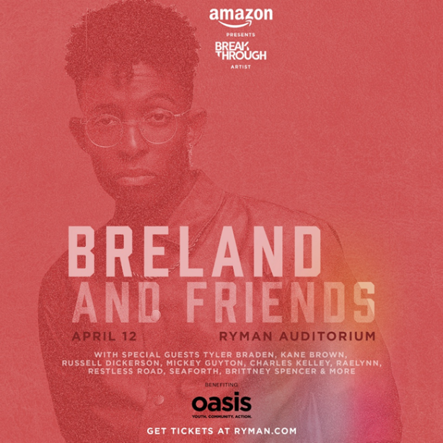
Download Asset Here

LOS ANGELES, CA. (April 8, 2022) – Bad Realm Records / Atlantic Records / Warner Music Nashville PLATINUM multi-talent BRELAND is hitting the stage to support Nashville’s youth in need, and his star-studded benefit concert will be streamed live via the Amazon Music Twitch channel April 12th.

Hosted by the Breakthrough Artist for Amazon Music, the previously announced “BRELAND & Friends” concert sponsored by Amazon Music will take place at the iconic Ryman Auditorium, featuring Dierks Bentley, Tyler Braden, Kane Brown, Russell Dickerson, Mickey Guyton, Charles Kelley, RaeLynn, Restless Road, Lily Rose, Seaforth, Brittney Spencer, and more.

With the community-focused night benefiting the Oasis Center – one of Middle Tennessee’s most comprehensive youth development agencies – tickets for the special evening are available here, and fans who can’t make it can still help the cause. “BRELAND & Friends” will be live streamed by the Amazon Music Twitch channel, with the show kicking off at 7:30 p.m. CT (4/12).

Meanwhile, the trailblazing Country newcomer has more in store as the big night arrives.

Released yesterday (4/7), BRELAND is featured in the new Amazon Music Original feature-length documentary, For Love & Country. Directed by Joshua Kissi, the film proclaims Country music has always been Black music. For Love & Country is now available to watch in the Amazon Music app and on Prime Video.

Sunday (4/10), BRELAND will deliver a special performance during “CMT Music Awards Nomination Special” – a half-hour celebration featuring CMT Music Awards nominees 8 p.m. CT – and when the 2022 CMT Music Awards take place the following night, he’ll be all over the stage.

Set for Monday (4/11) and airing live on CBS for the first time, the 2022 CMT Music Awards return to Nashville as Country’s only 100-percent fan-voted awards show at 7 p.m. CT. BRELAND is nominated three times in his first appearance on the show’s ballot and will also perform his spirit-lifting new track,
“Praise The Lord” HERE.

ABOUT BRELAND
With his PLATINUM debut “My Truck,” singer/songwriter/producer BRELAND has emerged as a bold new force on today’s music landscape. The newly named Breakthrough Artist by Amazon Music first popped off when the Hip-Hop and Country hybrid hit #1 on Spotify’s Global Viral 50 in 2019, and a remix featuring Sam Hunt landed on best-of-the-year lists from NPR to The New York Times. Debuting his brand-new song “Praise The Lord (feat. Thomas Rhett)” at the 2022 ACM Awards, the “symbol of Country music’s ongoing evolution” (Rolling Stone) will be featured on his highly anticipated debut album CROSS COUNTRY slated for release this summer. Featured on Dierks Bentley’s Top 5 and rising single with HARDY, “Beers On Me,” BRELAND also teamed up with Keith Urban for the buzzy track “Throw It Back.” Since signing to Bad Realm Records / Atlantic Records / Warner Music Nashville, he has collaborated with heavy-hitters such as Gary LeVox of Rascal Flatts, Nelly, Blanco Brown, Lauren Alaina, and Chase Rice, and scored high profile looks on The Kelly Clarkson Show, ABC’s 2021 CMA Awards, ABC’s CMA Summer Jam, CMT Crossroads, ABC’s Jimmy Kimmel Live!, ABC’s Good Morning America, CBS’ New Year’s Eve Live: Nashville’s Big Bash, YouTube’s Artist on The Rise, and a Chevy campaign that launched during NFL’s season opener. Coined “1,000 percent the whole package” (Rolling Stone), he’s nominated for three fan-voted nominations for the 2022 CMT Music Awards. He’s out on the road for Russell Dickerson’s ALL YOURS, ALL NIGHT TOUR and is recognized in the Country Music Hall of Fame® and Museum’s brand-new exhibit, American Currents: State of the Music.

CONNECT WITH BRELAND
WEBSITE | INSTAGRAM | FACEBOOK | TWITTER | YOUTUBE | SOUNDCLOUD

FOR BRELAND
Fairley McCaskill / Fairley.McCaskill@atlanticrecords.com
Jensen Sussman / jensen@sweettalkpr.com
Mary Catherine Rebrovick / MaryCatherine@wmg.com

