FOR IMMEDIATE RELEASE
MARCH 28, 2022

COUNTRY’S NEWEST TRAILBLAZER BRELAND ANNOUNCES STAR-STUDDED LINEUP FOR “BRELAND & FRIENDS” AT RYMAN AUDITORIUM

OASIS CENTER YOUTH-IN-NEED FUNDRAISER SET FOR APRIL 12
SPECIAL GUESTS KANE BROWN, MICKEY GUYTON AND MORE TO JOIN HIM ON STAGE

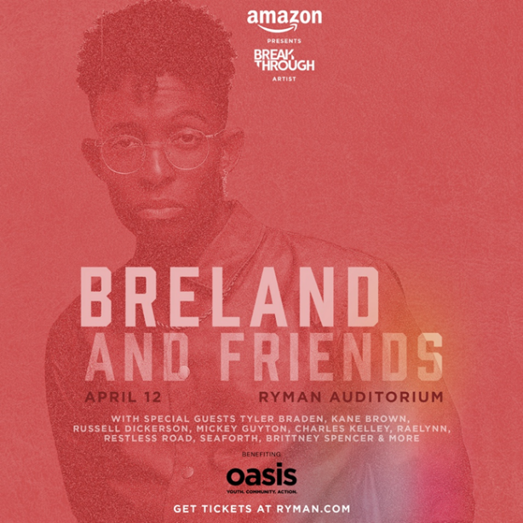
Download Asset Here

LOS ANGELES, CA. (March 28, 2022) – As Country’s newest trailblazer, PLATINUM-selling sensation and Breakthrough artist for Amazon Music, BRELAND has been making friends and admirers wherever he goes in country in country music - and now he’s putting his good will to good use.

The Bad Realm Records/ Atlantic Records / Warner Music Nashville artist will host “BRELAND & Friends” on April 12 at Nashville’s world-famous Ryman Auditorium for his star-studded concert to benefit Oasis Center, aiming to help support local youth in need. The show will kick off at 7:30 pm CT.

Sponsored by Amazon Music, the “Cross Country” game-changer’s show will feature BRELAND plus a top-shelf lineup of guests including Tyler Braden, Kane Brown, Russell Dickerson, Mickey Guyton, Charles Kelley, RaeLynn, Restless Road, Seaforth, and Brittney Spencer with proceeds going to the Oasis Center.

"Oasis Center does incredible work with youth in crisis, and their impact on the Nashville community and beyond is unmatched," BRELAND expresses. "I can’t think of a better location to celebrate and raise money for this amazing organization than the Mother Church itself. Every artist I have joining me at the Ryman represents the same altruistic ideals as the Oasis Center, and I’m so excited to share the stage with them."

One of Middle Tennessee’s most comprehensive youth development agencies, Oasis Center is at the forefront of helping young people and their families navigate the complex challenges of today. Over 20 programs and services respond to the area’s diverse needs, and BRELAND and Oasis share the belief that the greatest impact happens when we bring people together and unite for a common purpose.
Tickets for the special evening – to help youth feel connected, loved, valued and safe – are available here, and the event marks another high point for a talent who’s truly on the rise.

The night before (April 11), BRELAND will be on hand at the 2022 CMT Music Awards, where he is nominated for three fan-voted trophies. Vote here: vote.cmt.com. Also just announced, he’ll be a part of Amazon’s For Love & Country documentary, exploring the growing diversity movement in Country music, and his forthcoming album CROSS COUNTRY (pre-save/pre-add here) is set for release this summer.
Meanwhile, BRELAND made his performance debut at the 57th Annual Academy of Country Music Awards on March 7, singing his brand-new song “Praise The Lord (feat. Thomas Rhett),” (listen here) and then headed straight to London to perform for C2C: Country To Country Festival.

Up next, BRELAND will appear on high-profile stages such as Tortuga Music Festival (4/9) and Stagecoach Country Music Festival (4/29), with more dates to come.

ABOUT BRELAND
With his PLATINUM debut “My Truck,” singer/songwriter/producer BRELAND has emerged as a bold new force on today’s music landscape. The newly named Breakthrough Artist by Amazon Music first popped off when the Hip-Hop and Country hybrid hit #1 on Spotify’s Global Viral 50 in 2019, and a remix featuring Sam Hunt landed on best-of-the-year lists from NPR to The New York Times. Debuting his brand-new song “Praise The Lord (feat. Thomas Rhett)” at the 2022 ACM Awards, the “symbol of Country music’s ongoing evolution” (Rolling Stone) will be featured on his highly anticipated debut album CROSS COUNTRY slated for release this summer. Featured on Dierks Bentley’s Top 5 and rising single with HARDY, “Beers On Me,” BRELAND also teamed up with Keith Urban for the buzzy track “Throw It Back.” Since signing to Bad Realm Records / Atlantic Records / Warner Music Nashville, he has collaborated with heavy-hitters such as Gary LeVox of Rascal Flatts, Nelly, Blanco Brown, Lauren Alaina, and Chase Rice, and scored high profile looks on The Kelly Clarkson Show, ABC’s 2021 CMA Awards, ABC’s CMA Summer Jam, CMT Crossroads, ABC’s Jimmy Kimmel Live!, ABC’s Good Morning America, CBS’ New Year’s Eve Live: Nashville’s Big Bash, YouTube’s Artist on The Rise, and a Chevy campaign that launched during NFL’s season opener. Coined “1,000 percent the whole package” (Rolling Stone), he’s nominated for three fan-voted nominations for the 2022 CMT Music Awards. He’s out on the road for Russell Dickerson’s ALL YOURS, ALL NIGHT TOUR and is recognized in the Country Music Hall of Fame® and Museum’s brand-new exhibit, American Currents: State of the Music.

CONNECT WITH BRELAND
WEBSITE | INSTAGRAM | FACEBOOK | TWITTER | YOUTUBE | SOUNDCLOUD

FOR BRELAND
Fairley McCaskill / Fairley.McCaskill@atlanticrecords.com
Jensen Sussman / jensen@sweettalkpr.com
Mary Catherine Rebrovick / MaryCatherine@wmg.com

