FOR IMMEDIATE RELEASE
OCTOBER 15, 2021

RAICHE HEATS UP THE FALL WITH “BURN YOUR CLOTHES”

ACCLAIMED NEW R&B STAR UNVEILS FIERY NEW SINGLE HOT OFF THE HEELS OF A STELLAR SET AT THE AUSTIN CITY LIMITS FESTIVAL

OFFICIAL VISUALIZER STREAMING NOW

NEW PROJECT COMING SOON

“BURN YOUR CLOTHES” AVAILABLE NOW AT ALL DSPS AND STREAMING SERVICES

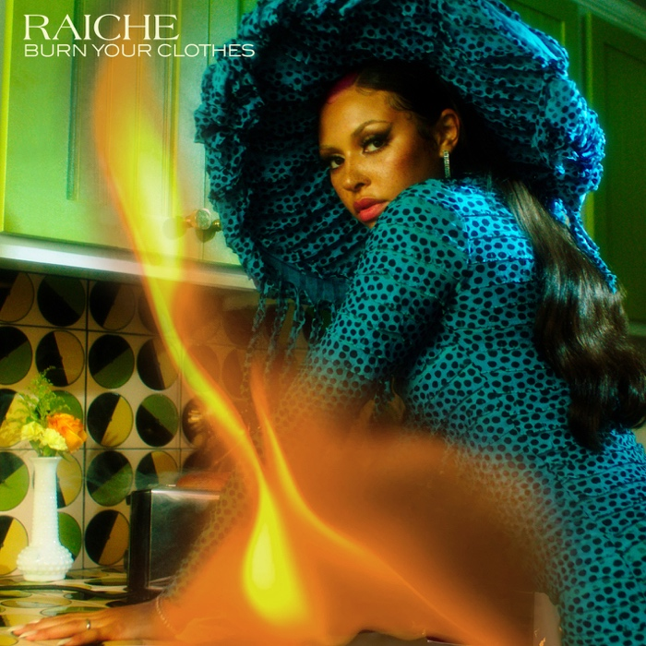

Rising R&B vocalist Raiche has announced today’s release of her sultry new single. “Burn Your Clothes” is available now via GDE/Island Prolific/Atlantic Records at all DSPs and streaming services; the sizzling track is joined by an official visualizer, streaming now at the MA-based singer’s official YouTube channel HERE.

“Burn Your Clothes” marks the first single from Raiche’s new project, LOVELAND, due later this year. The track follows her smash 2020 release, “Pick A Side,” available for streaming and download. The track – which reached #2 at R&B radio outlets nationwide while earning more than 5M worldwide streams – is joined by an official music video (streaming HERE) as well as a melodic remix featuring 2x GRAMMY® Award-nominated R&B icon Ty Dolla $ign, available now at all DSPs and streaming services HERE.

Named one of Billboard’s “15 Hip-Hop & R&B Artists to Watch in 2021” as well as an ESSENCE “Rising Star,” YouTube “Artist on the Rise,” and iHeartRadio “On The Verge Artist,” Raiche celebrated her ascent with a spectacular live performance of “Pick A Side” on NBCUniveral’s nationally syndicated Kelly Clarkson Show, streaming HERE.

With her breezy vocals and refreshingly unique singing style, Raiche – who recently lit up the Austin City Limits Music Festival with a show-stopping live set – has quickly proven to be a creative sensation and breath of fresh air in contemporary R&B. The gifted young artist fuses soulful roots with modern pop to concoct a genuinely distinctive new sound all her own, lit up with confidence, consistency and positivity. Born and raised in Pittsfield, MA, just two hours outside of Boston, Raiche devoted her energies towards music from an early age, uploading cover videos to YouTube that almost immediately earned her online applause. Her musical dreams almost came to a halt following high school graduation but some encouraging words from her beloved Nana eventually led her to Boston, where she met and began being mentored by DJ Knock Out. The local legend soon introduced Raiche to her GDE production team as well as to superstar songwriter Prince Charlez (Rihanna, Beyoncé, Usher), who promptly signed the talented vocalist to his recently launched Island Prolific imprint at Atlantic Records.

Now boasting close to 17M worldwide streams across her growing body of work, Raiche made her national debut with 2018’s “Money Pies,” streaming HERE; a colorful official video – directed by the all-female Verluxe collective – can be viewed HERE. “Complicated” followed the next year and was featured on Raiche’s acclaimed debut EP, DRIVE, available HERE. The EP was further highlighted by the title track, “Drive,” featured in Netflix’s Self Made: Inspired by the Life of Madam C.J. Walker.

CONNECT WITH RAICHE
MYNAMEISRAICHE.COM | FACEBOOK | TWITTER | YOUTUBE | INSTAGRAM | SPOTIFY | SOUNDCLOUD
FOR PRESS INQUIRIES CONTACT:
SYDNEY.MARGETSON@ATLANTICRECORDS.COM

