FOR IMMEDIATE RELEASE
MARCH 9, 2022

BRELAND’S “PRAISE THE LORD” APPLAUDED AS “ONE OF THE CATCHIEST SONGS OF THE NIGHT” (WASHINGTON POST) DURING ACM AWARDS PERFORMANCE DEBUT WITH SPECIAL GUEST THOMAS RHETT (3/7)

"PRAISE THE LORD (FEAT. THOMAS RHETT)" OUT NOW; DEBUT ALBUM CROSS COUNTRY COMING THIS SUMMER

PERFORMING AT C2C: COUNTRY TO COUNTRY FESTIVAL IN THE UK ON MARCH 11

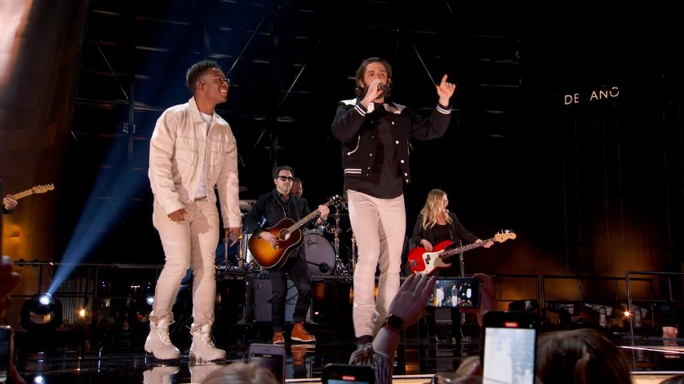
Download Press Asset Here

LOS ANGELES, CA. (March 9, 2022) – “Praise The Lord” for Bad Realm Records / Atlantic Records / Warner Music Nashville artist BRELAND’s Amazon Music Breakthrough performance at the 57th Annual Academy of Country Music Awards Monday night (3/7) live from Las Vegas, NV. Joined by collaborator Thomas Rhett, The Tennessean hailed the debut performance as “both noteworthy and poignant,” while PEOPLE claimed “BRELAND took us all to church” making their list of “The Biggest Moments from the 2022 ACM Awards.” “Praise The Lord (feat. Thomas Rhett)” is out now. Listen HERE.

“I knew when I wrote this song that Thomas Rhett had to be on it, and I wouldn’t put it out until I had him,” says BRELAND. “As I predicted, he added so much flavor and energy to the song. I’m going to be Praising the Lord for this collaboration and his friendship for a long time.”

Thomas Rhett raves, “BRELAND’s energy is so contagious - this song is such a blast! I’m so grateful to get to be a part of it. My kids can’t stop dancing to this one.”

“Praise The Lord (feat. Thomas Rhett)” will be featured on BRELAND’s just-announced debut album CROSS COUNTRY and is expected to release summer 2022. Pre-Save/Pre-Add HERE. The previously released title track was met with rave reviews from fans and critics alike, with Rolling Stone claiming the song is “a symbol of Country music’s ongoing evolution.” Taking it up a notch, BRELAND also released a duet version featuring Mickey Guyton.

Named a Breakthrough Artist for Amazon Music, “BRELAND is a streaming-music star,” affirms Rolling Stone. The New Jersey native joins the short list of artists earning this coveted all-genre nod aimed at “amplifying and championing” the best new talent. Only the second Country artist in the program’s history, previous Breakthrough Artists include Gabby Barrett, Blxst, Remi Wolf, Arlo Parks, and more.

Up next, BRELAND will take his signature sound global with a performance at C2C: Country To Country Festival at London’s The O2 Arena (3/11). He’ll return stateside for three performances in Nashville: the Grand Ole Opry (3/19) followed by two appearances at Ryman Auditorium for Russell Dickerson’s ALL YOURS, ALL NIGHT TOUR (3/25) and then BRELAND and Friends concert to benefit the Oasis Center, which supports Nashville youth in need (4/12). Continuing the momentum, he’ll take the stage at the high-profile Stagecoach Country Music Festival (4/29), with more dates to come.

ABOUT BRELAND
With his PLATINUM debut “My Truck,” singer/songwriter/producer BRELAND has emerged as a bold new force on today’s music landscape. The newly named Breakthrough Artist by Amazon Music first popped off when the Hip-Hop and Country hybrid hit #1 on Spotify’s Global Viral 50 in 2019, and a remix featuring Sam Hunt landed on best-of-the-year lists from NPR to The New York Times. Debuting his brand-new song “Praise The Lord (feat. Thomas Rhett)” at the 2022 ACM Awards, the “symbol of Country music’s ongoing evolution” (Rolling Stone) will be featured on his highly anticipated debut album CROSS COUNTRY slated for release this summer. Featured on Dierks Bentley’s Top 10 and rising single with HARDY, “Beers On Me,” BRELAND also teamed up with Keith Urban for the buzzy track “Throw It Back.” Since signing to Bad Realm Records / Atlantic Records / Warner Music Nashville, he has collaborated with heavy-hitters such as Gary LeVox of Rascal Flatts, Nelly, Blanco Brown, Lauren Alaina, and Chase Rice, and scored high profile looks on The Kelly Clarkson Show, ABC’s 2021 CMA Awards, ABC’s CMA Summer Jam, CMT Crossroads, ABC’s Jimmy Kimmel Live!, ABC’s Good Morning America, CBS’ New Year’s Eve Live: Nashville’s Big Bash, YouTube’s Artist on The Rise, and a Chevy campaign that launched during NFL’s season opener. Coined “1,000 percent the whole package” by Rolling Stone, he’s out on the road for Russell Dickerson’s ALL YOURS, ALL NIGHT TOUR and is recognized in the Country Music Hall of Fame® and Museum’s brand-new exhibit, American Currents: State of the Music.

CONNECT WITH BRELAND
WEBSITE | INSTAGRAM | FACEBOOK | TWITTER | YOUTUBE | SOUNDCLOUD

FOR BRELAND
Jensen Sussman / jensen@sweettalkpr.com
Fairley McCaskill / Fairley.McCaskill@atlanticrecords.com
Mary Catherine Rebrovick / MaryCatherine@wmg.com

FOR THOMAS RHETT
Tyne Parrish / tyne@thegreenroompr.com
Meg Scott / meg@thegreenroompr.com

