FOR IMMEDIATE RELEASE
JULY 23, 2021

CHILDISH MAJOR SHARES THANK YOU, GOD. FOR IT ALL.

GRAMMY® AWARD-NOMINATED ARTIST/PRODUCER UNVEILS LONG AWAITED NEW PROJECT

HIGHLIGHTS INCLUDE THE SMOKING HOT SUMMER SINGLE,
“F YAH JOB”

PART 1 OF EXCLUSIVE THANK YOU, GOD. FOR IT ALL. DOCUMENTARY
PREMIERES TODAY VIA YOUTUBE HERE

THANK YOU, GOD. FOR IT ALL. AVAILABLE EVERYWHERE NOW

STREAM/DOWNLOAD THANK YOU GOD, FOR IT ALL

STREAM/DOWNLOAD “F YAH JOB”
WATCH OFFICIAL MUSIC VIDEO

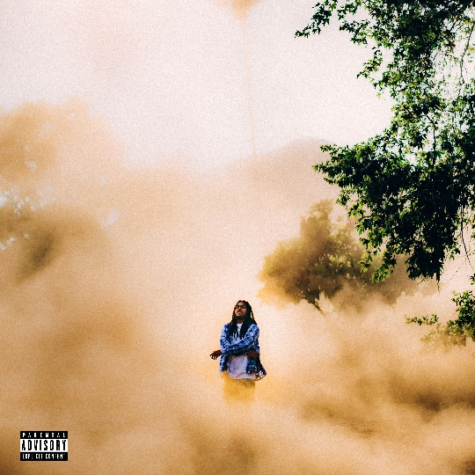
(DOWNLOAD HI-RES ARTWORK)

GRAMMY® Award-nominated artist/producer Childish Major is proud to announce today’s release of his eagerly anticipated new EP, Thank You, God. For It All., available now at all DSPs and streaming services HERE.

A powerful expression of intent, confidence, gratitude, and sincerity, THANK YOU, GOD. FOR IT ALL. sees Childish Major continuing to hone his craft with laser precision on tracks like the sizzling new single, “F Yah Job,” available now at all DSPs and streaming services HERE. Written by Childish Major and produced by Hollywood Cole, the track is joined by an official music video streaming now at YouTube HERE.

In addition, Childish Major is celebrating the 7-track project with a full-length THANK YOU, GOD. FOR IT ALL. documentary, Part 1 of which premieres today via YouTube HERE; additional chapters will debut throughout the summer.

Born Markus Randle, Childish Major is a GRAMMY® Award-nominated artist and producer based in Atlanta, Georgia. Originally from Edgefield, SC, Childish made his mark on the ATL music scene working with a wide variety of artists including Rocko, Future, SZA, J. Cole, Isaiah Rashad, Pusha T, Fall Out Boy, Young Jeezy, and 6lack.

Major unveiled his own debut project, WOO$AH, in 2017 and has kept moving forward ever since. 2019 saw the release of his second studio project, Dirt Road Diamond, while songs like “Supply Luh” (produced by J.Cole) and “Know Nothing” were featured in the hit HBO series, Insecure. More recently, “Kick It (Feat. Jace)” was included on EA’s Madden NFL 21 soundtrack. Major has also been featured in major brand campaigns including Reebok’s Alter the Icons (with Tayla Parx) and the MCM Autumn/Winter 2019 collection (alongside close friend Billie Eilish). He also appeared with legendary producer Timbaland in an IBM commercial that premiered during Super Bowl LV (streaming HERE).

For more information/the latest on Childish Major, please visit www.childishmajorofficial.com/.

THANK YOU, GOD. FOR IT ALL
CHILDISH MAJOR

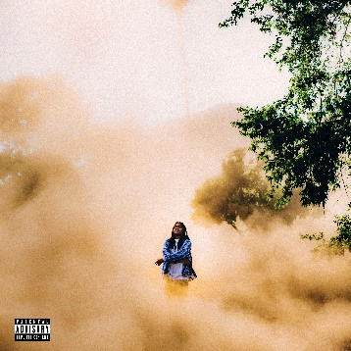

Player’s Prayer
Check
Money Power Respect
Down South
F Yah Job
Disrespectful
Thank You, God. For It All.

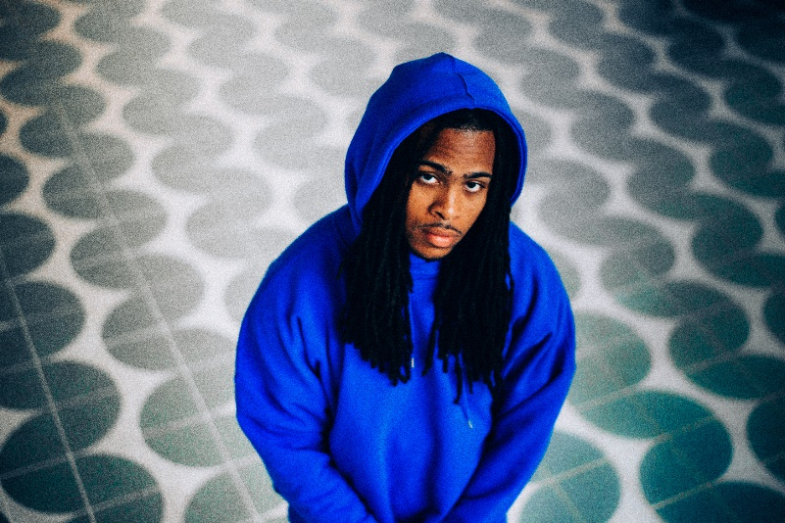
DOWNLOAD PRESS IMAGES HERE

# # #
CONNECT WITH CHILDISH MAJOR
INSTAGRAM | TWITTER | YOUTUBE | SOUNDCLOUD | WEBSITE

PRESS CONTACT
SELAM BELAY // SELAM.BELAY@ATLANTICRECORDS.COM

