CHILDISH MAJOR SHARES PART 2 OF THANK YOU, GOD. FOR IT ALL. DOCUMENTARY

STAR-FILLED EPISODE OF THE THREE-PART DOCUMENTARY FEATURES CANDID CONVERSATIONS WITH J. COLE AND KENDRICK LAMAR

TICKETS ON SALE TODAY FOR THE THANK YOU, GOD. FOR IT ALL. RELEASE SHOW

WATCH/SHARE PART 2: THANK YOU GOD FOR THE PAST
WATCH/SHARE PART 1: THANK YOU GOD FOR THE NOW
STREAM/DOWNLOAD THANK YOU GOD, FOR IT ALL

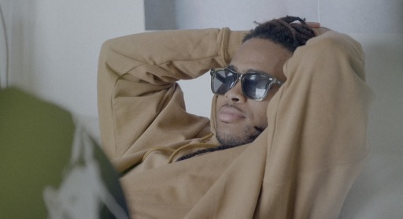

Following the release of his eagerly anticipated EP, Thank You, God. For It All., available now at all DSPs and streaming services via Humility City Records/Atlantic Records, GRAMMY-nominated artist/ producer CHILDISH MAJOR is releasing part of 2 of his documentary of the same name. This second installment of the documentary hosted by HipHopDX is appropriately titled “Thank You, God. For The Past.” as it features a heartwarming conversation between Childish and his close friend and frequent collaborator, DJ Dos Dias.

In this episode, we get an inside look into the sibling like relationship of the two and viewers are invited to watch as they unpack the development of their friendship and the creation of the “Thank you, God. For it all.” EP. Childish also goes on to share excerpts of his conversations with hip-hop heavy weights including Kendrick Lamar and J. Cole.

“Thank You, God. For It All.” is a 3-part documentary detailing Childish Major’s transformation from platinum-selling producer (U.O.E.N.O., Revenge of the Dreamers, etc.) to Grammy nominated artist featuring conversations with music executive and hip-hop icon Don Cannon, producer/DJ Dos Dias, multi-disciplinary artist Mez, superstar singer 6lack, music journalist Yoh Phillips and Childish himself. The films mesh archival footage with interview to show and tell Childish’s story in his words and contextualize the ascending star’s newest project release, “Thank you, God. For it all.

To celebrate the release of the album and documentary, Childish has announced a headlining show at Atlanta’s Vinyl in partnership with Milk and Cookies. The show will feature performances of brand-new tracks from the “Thank You, God. For It All.” EP and tickets are available for purchase today HERE.

For more information/the latest on Childish Major, please visit www.childishmajorofficial.com/.

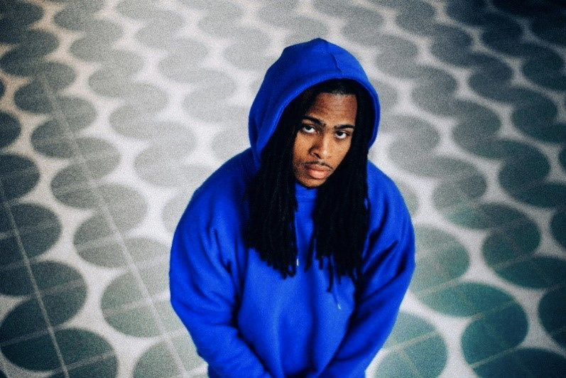

DOWNLOAD PRESS IMAGES HERE

CHILDISH MAJOR

Thank You God, For It All marks Childish Major’s third studio project and follows his debut release, WOO$AH,in 2017 and his second project, Dirt Road Diamond, in 2019.

The Grammy-nominated artist and producer celebrates early career milestones and his journey thus far with an abundance of gratitude in this new project. In the four years since his debut project, Childish Major has had his songs “Supply Luh” and “Know Nothing” featured in the hit HBO series, Insecure. His single “Kick It” featuring Jace is on the Madden NFL 21 soundtrack and he appeared in an IBM Super Bowl LV commercial alongside Timbaland. He also has been featured in Reebok (alongside Tayla Parx) and MCM (alongside close friend Billie Eillish) fashion campaigns.

Offering energetic anthems and soulful bops, this third project from Childish Major is full of intention and sincerity. Tracks such as the recently released “Disrespectful” sets the tone for the confidence and introspection weaved throughout the entire project. Fellow artists ScHoolboy Q and Yung Baby Tate are featured on the seven-song project. Thank You God, For It All opens with “Player’s Prayer,” a song and title that grounds you in the direct praise Childish is giving to God throughout the entire project. Childish Major eloquently raps about the fantastic truths of his evolving career in juxtaposition to the realities of his purpose. From start to finish this project is a grand display of Childish Major’s musical range and devotion to the craft.

# # #
CONNECT WITH CHILDISH MAJOR
INSTAGRAM | TWITTER | YOUTUBE | SOUNDCLOUD | WEBSITE

PRESS CONTACT
SELAM BELAY // SELAM.BELAY@ATLANTICRECORDS.COM

