FOR IMMEDIATE RELEASE
JUNE 17, 2022

CKAY TEAMS UP WITH AFRICA’S SUPERSTARS FOR NEW SINGLE “WATAWI (FEAT. DAVIDO, FOCALISTIC, AND ABIDOZA)

FOLLOW UP TO “EMILIANA” STREAMING HERE

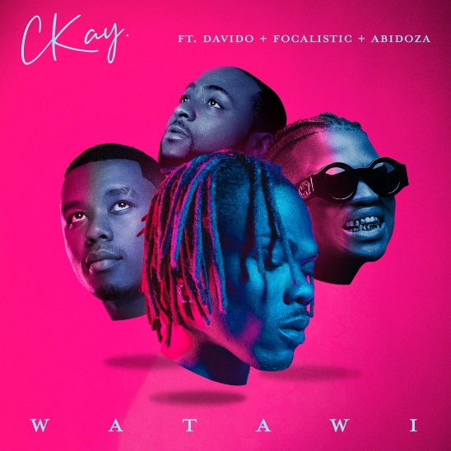

Listen to WATAWI (feat. Davido, Focalistic & Abidoza)

Fresh off the success of Emiliana, love nwantiti and his performances abroad, CKay returns with yet another smash single, WATAWI, this time calling on fellow Nigerian superstar Davido and South Africa’s Amapiano new school cool kids, Focalistic and Abidoza.

CKay has surpassed 3 billion career streams and recently sold out his first two shows in the United States. With love nwantiti breaking several records, including being the most streamed song globally on Spotify, and Emiliana once garnering over 700 thousand streams in a single day on Spotify, WATAWI is another opportunity for CKay to capture the ears and hearts of his fans around the world.

Nigeria’s Afrobeats heavyweight, Davido, and South Africa’s Amapiano chief lyricist and artist, Focalistic, are both multi-platinum artists featured on this new hit with Abidoza on production. Abidoza adds his Midas touch with the beat, while Davido tunes in with his effortless flow. Focalistic spares 18 bars of Sipotori rap (a language which blends various languages, popular in the townships of Pretoria). CKay’s vocals and signature layered harmonies drive the song on a catchy sing along, which compliments the soulful Amapiano production. Lyrically, the song covers a common topic in modern relationships - WATAWI / what are we? CKay, Davido, and Focalistic narrate the situation through the smoothest of melodies, as they make it clear to their respective ladies that no labels are required for what they are.

“A lot of people have been in tricky situations when their “situationship” attempts to push things further than it needs to be,” comments CKay on the story behind WATAWI. “Sometimes it’s best to let things be and just vibe without the pressure of defining the nature of the relationship.”

###

About CKay
Chukwuka Ekweani, known publicly as CKay, is the rising star in the ever-burgeoning Afrobeats scene. A multi-talented artist, whether behind the boards as a producer or in front of the mic performing his self-penned songs, it is CKay’s single-minded vision that shines through. The self-defined Emo-Afrobeat star has and continues to soar up charts across the globe thanks to his first globally recognized single “love nwantiti.”

The Nigerian singer, songwriter and producer originally released love nwantiti (ah ah ah) back in 2019 as part of his debut EP, CKay The First. In 2021, CKay became the most streamed artist of the year and became the first African artist with two tracks on the Global Spotify Top 30 simultaneously. love nwantiti has been certified platinum/multi-platinum in five countries, including the United States and India, The viral hit has also been certified gold in the UK, Australia, South Africa, Italy, and New Zealand. CKay became the first African artist in 50 years to hold a top 5 position on the UK Singles Chart for 4 straight weeks with love nwantiti.

CKay has continued to create a global presence with accomplishments such as the “most Shazam-ed song in the world”. His most recent globally recognized single, Emiliana, has followed suit and racked in global chart positions and currently has just under 100 million streams. Emiliana peaked at #1 on the UK Afrobeats Chart, #2 on Shazam Top 200 (Afrobeats), and #1 in six countries on Apple Music.

With new music on the way in 2022, CKay is bound to continue creating amazing music that will catch the attention of fans, both old and new, on a global scale.

###

CONNECT WITH CKAY:
TWITTER | FACEBOOK | INSTAGRAM

PRESS CONTACT:
ARIANA.WHITE@ATLANTICRECORDS.COM

