FOR IMMEDIATE RELEASE
JUNE 13, 2021

CORDAE RELEASES TED TALK DEBUT WATCH NOW

2X GRAMMY® NOMINATED RAPPER DISCUSSES “THE HI LEVEL MINDSET” ABOUT THE POWER OF DISCIPLINE TO ACHIEVE ONE’S DREAMS

ON WORLD TOUR NOW WITH HEADLINE DATES AND FESTIVAL PERFORMANCES INCLUDING LOLLAPALOOZA, OSHEAGA, FIREFLY MUSIC FESTIVAL,
& MORE

FROM A BIRDS EYE VIEW AVAILABLE NOW VIA ART@WAR/ATLANTIC HERE

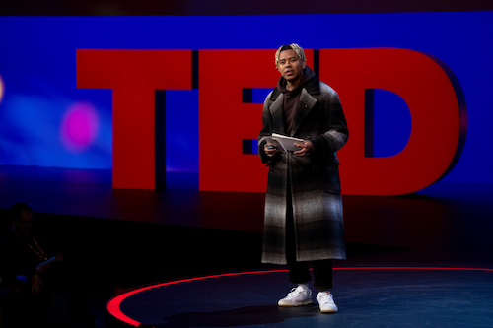
DOWNLOAD HI-RES IMAGES

2x GRAMMY® Award-nominated rapper Cordae makes his TED Talk debut today with “The Hi Level Mindset.” The talk is available now exclusively at go.ted.com/cordae.

An informative talk mixed with humor about the journey of a high school kid who would grow to achieve his dream of becoming a music star by learning the power of discipline, “The Hi Level Mindset” sees Cordae making the case for doing everything that you put your hands on at the highest level possible, having an extreme work ethic and seriousness in everything you do, no matter how insignificant it may seem. For more information, please visit www.ted.com/speakers/cordae.

Today’s TED Talk premiere follows the release earlier this year of Cordae’s acclaimed sophomore album. From A Birds Eye View, available now via ART@WAR/Atlantic Records HERE. Deeply inspired by a life-changing trip to Africa, enduring the loss of a friend gone too soon, and evolving as an artist and a man, the 14-track album sees Cordae telling these stories and more through technicolor imagery, nimble rhymes, and fast evolving wisdom. Featuring collaborations with the likes of Stevie Wonder, Lil Wayne, Freddie Gibbs, Eminem, H.E.R., Lil Durk, Gunna, Ant Clemons and Roddy Ricch, the album has been celebrated with both a performance and interview on NBC’s The Tonight Show Starring Jimmy Fallon, an NPR Tiny Desk Concert and wide-spread acclaim. All official music videos are streaming now via YouTube HERE.

Cordae will be traveling the globe on a massive world tour that includes headline dates and highly anticipated festival performances at Hot 97 Summer Jam (June 12), Greenwood Village, CO’s KS 105.7 SummerJam (June 18), Milwaukee’s Summerfest (July 8), Chicago, IL’s Lollapalooza (July 28-31), Montreal, QC’s Osheaga Festival Musique et Arts (July 29-31), Bonner Springs, KS’s Breakaway Music Festival (August 5-6), Dover, DE’s Firefly Music Festival (September 22-25) followed by UK/ European Tour ( September 27 – October 19). For complete details, please see www.cordaemusic.com/tour.

​​About TED
TED is a nonprofit organization devoted to Ideas Worth Spreading, often in the form of short talks delivered by leading thinkers and doers. Many of these talks are given at TED conferences, intimate TED Salons and thousands of independently organized TEDx events around the world. Videos of these talks are made available, free, on TED.com and other platforms. Audio versions of TED Talks are published to TED Talks Daily, available on all podcast platforms.

TED's open and free initiatives for spreading ideas include TED.com, where new TED Talk videos are posted daily; TEDx, which licenses thousands of individuals and groups to host local, self-organized TED-style events around the world; the TED Fellows program, which selects innovators from around the globe to amplify the impact of their remarkable projects and activities; The Audacious Project, which surfaces and funds critical ideas that have the potential to impact millions of lives; TED Translators, which crowdsources the subtitling of TED Talks so that big ideas can spread across languages and borders; and the educational initiative TED-Ed. TED also offers TED@Work, a program that reimagines TED Talks for workplace learning. TED also has a growing library of original podcasts, including The TED Interview with Steven Johnson, WorkLife with Adam Grant, Am I Normal? with Mona Chalabi and How to Be a Better Human.

Follow TED on Twitter, Facebook, Instagram, TikTok and LinkedIn.

# # #
CONNECT WITH CORDAE
WEBSITE | FACEBOOK | INSTAGRAM |TWITTER | YOUTUBE

FOR MORE INFORMATION ON CORDAE
SYDNEY.MARGETSON@ATLANTICRECORDS.COM

FOR MORE INFORMATION ON RANGE MEDIA PARTNERS
JACLYNU@GRANDSTANDHQ.COM + KATEJ@GRANDSTANDHQ.COM

