COLDPLAY JOINED ON STAGE BY H.E.R.
FOR FINAL SHOW OF SOLD OUT U.S. LEG OF
MUSIC OF THE SPHERES WORLD TOUR

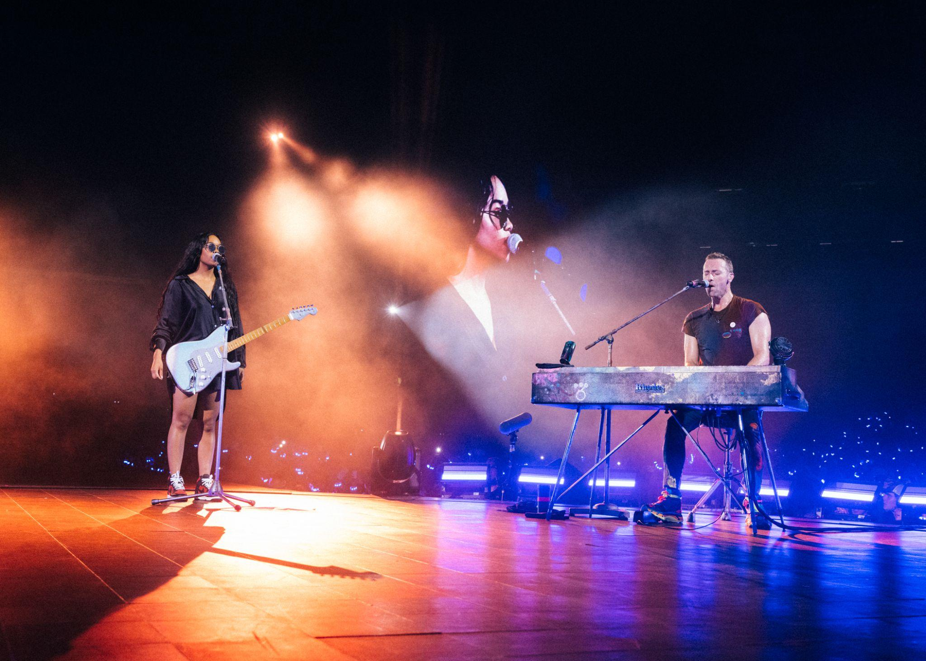
Photograph: Stevie Rae Gibbs

“Pure joy” – HOUSTON CHRONICLE
“Crank the joy meter past 11” – BILLBOARD
“A post-pandemic triumph” – SAN FRANCISCO GATE
“One of the best live music performances that I've ever experienced” – HOUSTON PRESS

Last night, Coldplay played the final show of the hugely successful U.S. leg of their record-breaking Music Of The Spheres World Tour to 55,000 fans at Tampa’s Raymond James Stadium.

They were joined on stage by Grammy-winning artist H.E.R., who duetted with the band on their recent single, Let Somebody Go (singing Selena Gomez’s parts from the studio version). H.E.R. has been the main support on the Latin American and U.S. legs of the tour, and will play further shows with Coldplay in Europe this summer.

<< Click here for free-to-use hi-res images >>

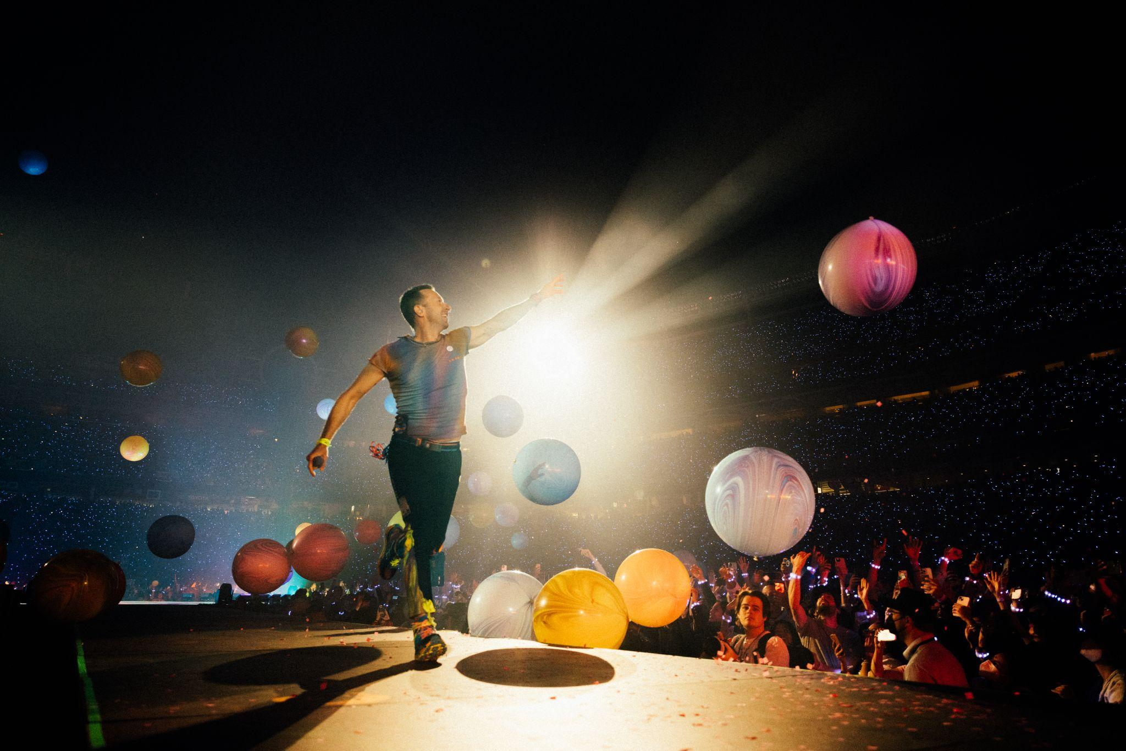
Photograph: Stevie Rae Gibbs

The twelve U.S. stadium dates saw the band play to a combined audience of 600,000 in Dallas, Houston, Phoenix, Santa Clara, Chicago, Washington DC, East Rutherford, Atlanta and Tampa.

Celebrating the release of the band’s current album Music Of The Spheres, the show featured their recent hits My Universe, Higher Power and Let Somebody Go alongside classics including Yellow, Clocks, Fix You, Viva La Vida and Adventure Of A Lifetime.

Along the way, the band also welcomed a host of surprise special guest performers to share the stage with them, including Bruce Springsteen, Kelly Rowland, Kylie Minogue and Lupe Fiasco.

More than 3.8 million tickets have now been sold for the tour, which reaches Europe on July 2, when the band will play the first of three sold out shows at Frankfurt’s Deutsche Bank Park stadium. They will then perform in Poland, France, Belgium and the UK, with a run of dates including four sold out nights at both Paris’s Stade de France and Brussels’ King Baudouin Stadium, and six sold out nights at London’s iconic Wembley Stadium.

Coldplay will then head to Latin America in the autumn for the tour’s second leg in the region, following shows in March / April 2022. For the upcoming concerts, the band have smashed several records, including most dates by a single artist at Estadio Nacional, Santiago (4 shows); Allianz Parque, São Paulo (6 shows); and River Plate, Buenos Aires (an incredible 10 shows).

The tour is accompanied by a comprehensive set of sustainability initiatives which includes the following commitments:

A show powered by 100% renewable energy in almost all locations
Power bikes and kinetic dancefloors allowing fans to help power the show
Solar panels at every show
Pledge to cut tour emissions by 50%
One tree planted for every ticket sold
Incentives to encourage fans to travel to shows by green transport

The band also secured discounts on public transport in several of the U.S. cities to host the recent shows. Last week, Coldplay’s Chris Martin spoke to NBC’s TODAY about the sustainability initiatives: watch here. Full details of the band’s initiatives can be seen at coldplay.com/sustainability.

The full list of the band’s upcoming shows, including support acts, is below. Further dates are expected to be announced soon.

JULY
2: Frankfurt, DE - Deutsche Bank Park (Support: H.E.R. + Alli Neumann) SOLD OUT
3: Frankfurt, DE - Deutsche Bank Park (Support: H.E.R. + Alli Neumann) SOLD OUT
5: Frankfurt, DE - Deutsche Bank Park (Support: London Grammar + Alli Neumann) SOLD OUT
8: Warsaw, PL - PGE Narodowy (Support: H.E.R. + Mery Spolsky) SOLD OUT
10: Berlin, DE - Olympiastadion Berlin (Support: London Grammar + Zoe Wees) SOLD OUT
12: Berlin, DE - Olympiastadion Berlin (Support: H.E.R. + Zoe Wees) SOLD OUT
13: Berlin, DE - Olympiastadion Berlin (Support: H.E.R. + Alli Neumann) SOLD OUT
16: Paris, FR - Stade de France (Support: H.E.R. + GAUMAR) SOLD OUT
17: Paris, FR - Stade de France (Support: H.E.R. + GAUMAR) SOLD OUT
19: Paris, FR - Stade de France (Support: London Grammar + Lous and the Yakuza) SOLD OUT
20: Paris, FR - Stade de France (Support: London Grammar + Lous and the Yakuza) SOLD OUT

AUGUST
5: Brussels, BE - King Baudouin Stadium (Support: H.E.R. + Lous and the Yakuza) SOLD OUT
6: Brussels, BE - King Baudouin Stadium (Support: H.E.R. + Lous and the Yakuza) SOLD OUT
8: Brussels, BE - King Baudouin Stadium (Support: London Grammar + Lous and the Yakuza) SOLD OUT
9: Brussels, BE - King Baudouin Stadium (Support: London Grammar + Lous and the Yakuza) SOLD OUT
12: London, UK - Wembley Stadium (Support: H.E.R. + Griff) SOLD OUT
13: London, UK - Wembley Stadium (Support: H.E.R. + Griff) SOLD OUT
16: London, UK - Wembley Stadium (Support: London Grammar + Ibibio Sound Machine) SOLD OUT
17: London, UK - Wembley Stadium (Support: H.E.R. + Ibibio Sound Machine) SOLD OUT
19: London, UK - Wembley Stadium (Support: London Grammar + Laura Mvula) SOLD OUT
20: London, UK - Wembley Stadium (Support: London Grammar + Laura Mvula) SOLD OUT
23: Glasgow, UK - Hampden Park Stadium (Support: H.E.R. + Nina Nesbitt) SOLD OUT
24: Glasgow, UK - Hampden Park Stadium (Support: London Grammar + Nina Nesbitt) SOLD OUT

SEPTEMBER
10: Rio De Janeiro, BR - Rock in Rio Festival SOLD OUT
13: Lima, PE - Estadio Nacional (Support: Camila Cabello) SOLD OUT
14: Lima, PE - Estadio Nacional (Support: Camila Cabello) SOLD OUT
16: Bogotá, CO - Estadio El Campín (Support: Camila Cabello) SOLD OUT
17: Bogotá, CO - Estadio El Campín (Support: Camila Cabello) SOLD OUT
20: Santiago, CL - Estadio Nacional (Support: Camila Cabello) SOLD OUT
21: Santiago, CL - Estadio Nacional (Support: Camila Cabello) SOLD OUT
23: Santiago, CL - Estadio Nacional (Support: Camila Cabello) SOLD OUT
24: Santiago, CL - Estadio Nacional (Support: Camila Cabello) SOLD OUT

OCTOBER
11: Rio De Janeiro, BR - Estadio Nilton Santos Engenhao (Support: H.E.R.) SOLD OUT
12: Rio De Janeiro, BR - Estadio Nilton Santos Engenhao (Support: H.E.R.) SOLD OUT
15: São Paulo, BR - Allianz Parque (Support: H.E.R.) SOLD OUT
16: São Paulo, BR - Allianz Parque (Support: H.E.R.) SOLD OUT
18: São Paulo, BR - Allianz Parque (Support: H.E.R.) SOLD OUT
19: São Paulo, BR - Allianz Parque (Support: H.E.R.) SOLD OUT
21: São Paulo, BR - Allianz Parque (Support: H.E.R.) SOLD OUT
22: São Paulo, BR - Allianz Parque (Support: H.E.R.) SOLD OUT
25: Buenos Aires, AR - Estadio River Plate (Support: H.E.R.) SOLD OUT
26: Buenos Aires, AR - Estadio River Plate (Support: H.E.R.) SOLD OUT
28: Buenos Aires, AR - Estadio River Plate (Support: H.E.R.) SOLD OUT
29: Buenos Aires, AR - Estadio River Plate (Support: H.E.R.) SOLD OUT

NOVEMBER
1: Buenos Aires, AR - Estadio River Plate (Support: H.E.R.)
2: Buenos Aires, AR - Estadio River Plate (Support: H.E.R.)
4: Buenos Aires, AR - Estadio River Plate (Support: H.E.R.)
5: Buenos Aires, AR - Estadio River Plate (Support: H.E.R.)
7: Buenos Aires, AR - Estadio River Plate (Support: H.E.R.)
8: Buenos Aires, AR - Estadio River Plate (Support: H.E.R.)

For more information please visit Coldplay.com or contact:
Sheila Richman | sheila.richman@atlanticrecords.com
Ted Sullivan | ted.sullivan@atlanticrecords.com
Gabrielle Reese (Tour) | gabrielle.reese@atlanticrecords.com

