DEATH CAB FOR CUTIE ANNOUNCES SUMMER 2022 HEADLINE RUN

8x GRAMMY-NOMINATED ROCK BAND UNVEILS RUN OF SELECT US DATES
SET TO KICK OFF JULY 7 IN CINCINNATI

TICKETS ON-SALE THIS FRIDAY, MARCH 11 AT 10AM (LOCAL)

BAND SET TO APPEAR AT MARQUEE FESTIVALS THIS SPRING INCLUDING NEW ORLEANS JAZZ & HERITAGE FESTIVAL, BEALE STREET MUSIC FESTIVAL, SHAKY KNEES & CORONA CAPITAL

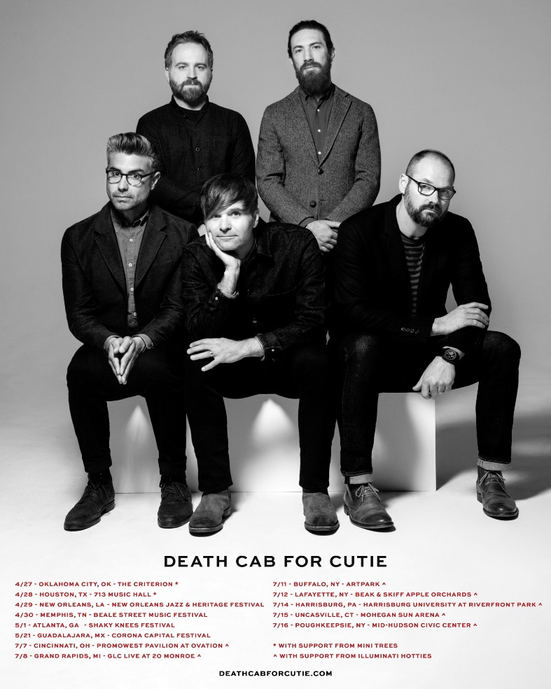

8x GRAMMY-nominated rock band Death Cab for Cutie have today announced a series of summer headline tour dates, set to kick off July 7 in Cincinnati, OH. Featuring support from LA-based indie rock band illuminati hotties, the run finds the Seattle-based quintet making stops in Michigan, New York, Pennsylvania, and Connecticut [full routing enclosed below].

Pre-sale for the summer tour kicks off Wednesday, March 9 at 10am (local), with general on-sale beginning Friday, March 11 at 10am (local). Signup for early access to tickets for the newly announced dates here.

Also being announced today is that LA-based artist Mini Trees will serve as support for two previously announced dates in April (Oklahoma City on Apr 27 + Houston on Apr 28).

Death Cab for Cutie will also appear at a number of marquee festivals throughout April and May, including: New Orleans Jazz & Heritage Festival, Beale Street Music Festival, Shaky Knees Festival, and Corona Capital Festival in Mexico.

For tour updates and additional information, please visit https://www.deathcabforcutie.com/.

###

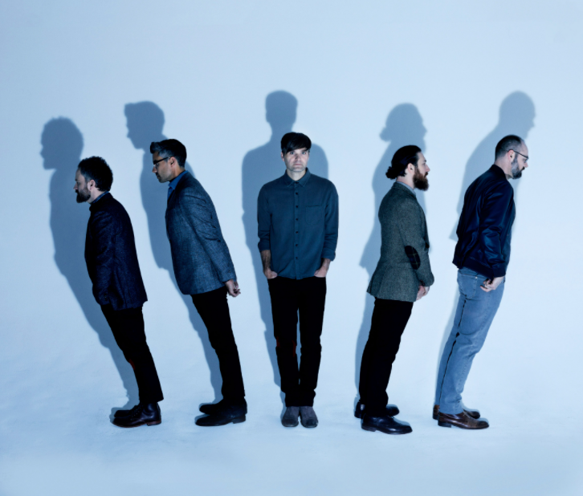
photo credit: Eliot Lee Hazel; download hi-res here

ABOUT DEATH CAB FOR CUTIE:
8x GRAMMY-nominated rock band Death Cab for Cutie formed in Bellingham, WA in 1998. Their 2005 studio release, PLANS, proved the band’s popular breakthrough, earning RIAA platinum certification as well as spawning the chart-topping singles, “Soul Meets Body” and “I Will Follow You Into The Dark,” the latter of which was honored with a GRAMMY nomination for Best Pop Performance By Duo Or Group With Vocals, with PLANS also receiving a nod for Best Alternative Album. Their following albums, Narrow Stairs (2008), The Open Door (2009), Codes and Keys (2011), and Kintsugi (2015) also all received various GRAMMY nominations, yielding their fourth straight nomination for Best Alternative Music Album and bringing their nominations to eight overall.

Death Cab for Cutie’s most recent full-length release Thank You for Today (2018) is the sound of a band both expanding and refining; twenty years into its evolution, still uncovering new curves in its signatures, new sonic corners to explore. The Seattle group’s ninth studio album was heralded by lead single “Gold Rush,” which reached #1 on Billboard’s Adult Alternative Songs chart.

In December 2020, ahead of the run-off elections in Georgia, the band released The Georgia E.P., featuring covers of iconic artists from the state. Originally released as a 24-hour Bandcamp exclusive, the EP raised over $100K for Fair Fight Action, Stacey Abrams’ voting rights organization promoting fair elections around the country through voter education, election reform, and combating voter suppression.

Throughout the duration of the COVID-19 pandemic, lead vocalist and guitarist Benjamin Gibbard helped raise over $250K in donations and supplies for various Seattle-area relief organizations via his series of at-home livestream performances.

Most recently in February 2022, Gibbard conceived, curated, and executive produced Ocean Child: Songs of Yoko Ono – a tribute to the acclaimed singer, songwriter, multimedia artist, and activist. Death Cab for Cutie themselves contributed a cover of “Waiting For The Sunrise,” with other artists on the compilation including David Byrne, Japanese Breakfast, The Flaming Lips, and Sharon Van Etten.

UPCOMING LIVE DATES:
April 27 (Wed) Oklahoma City, OK The Criterion *
April 28 (Thu) Houston, TX 713 Music Hall *
April 29 (Fri) New Orleans, LA New Orleans Jazz & Heritage Festival ^
April 30 (Sat) Memphis, TN Beale Street Music Festival ^
May 1 (Sun) Atlanta, GA Shaky Knees Festival ^
May 21 (Sat) Guadalajara, MX Corona Capital Festival ^
July 7 (Thu) Cincinnati, OH PromoWest Pavilion at Ovation #
July 8 (Fri) Grand Rapids, MI GLC Live at 20 Monroe #
July 11 (Mon) Buffalo, NY ARTPARK #
July 12 (Tue) LaFayette, NY Beak & Skiff Apple Orchards #
July 14 (Thu) Harrisburg, PA Harrisburg University at Riverfront Park #
July 15 (Fri) Uncasville, CT Mohegan Sun Arena #
July 16 (Sat) Poughkeepsie, NY Mid-Hudson Civic Center #

*support from Mini Trees
^ festival date
# support from illuminati hotties

Press Contact:
Libby Kober
Director, Publicity | Atlantic Records
Libby.Kober@atlanticrecords.com

