DEATH CAB FOR CUTIE RELEASES THE GEORGIA E.P. TO DSP’s

ORIGINALLY RELEASED FOR 24 HOURS ON BANDCAMP, COVERS EP RAISED $100K+ TO BENEFIT FAIR FIGHT ACTION AHEAD OF THE GEORGIA RUNOFF ELECTIONS

BAND ALSO ANNOUNCES PRE-ORDER FOR LIMITED-EDITION PEACH-COLORED VINYL

BUY/STREAM HERE
PRE-ORDER VINYL HERE

“Fair Fight is grateful for the support of Death Cab for Cutie in our fight for free and fair elections in Georgia and nationwide. ‘The Georgia E.P.’ helps tell the story of Georgia just as their contributions have helped us write the next chapter.” – Stacey Abrams, Fair Fight founder

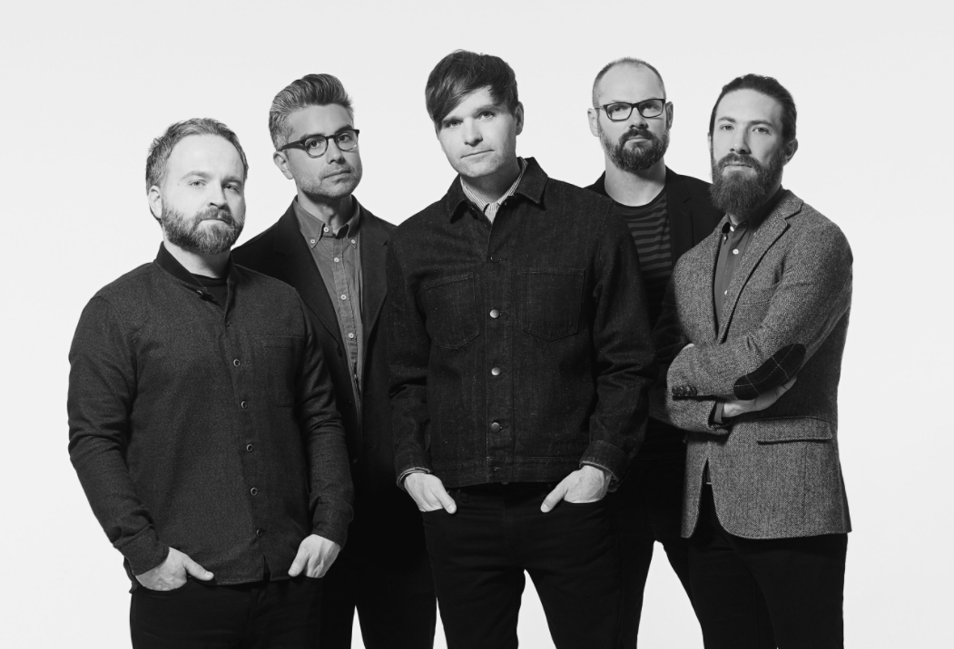
download hi-res press image here

8x GRAMMY Award nominees Death Cab for Cutie have announced today’s release of The Georgia E.P. to all DSP’s; buy/stream HERE. Originally released in December as a 24-hour Bandcamp exclusive, the project – featuring covers of iconic artists from the state of Georgia – raised over $100K for Fair Fight Action, Stacey Abrams’ voting rights organization promoting fair elections around the country through voter education, election reform, and combating voter suppression. With last week’s runoff elections flipping the state blue and securing Democrats control of the Senate, the band chose to celebrate by making the EP available today for fans across all platforms.

Of the release, Fair Fight founder Stacey Abrams shared:

“Fair Fight is grateful for the support of Death Cab for Cutie in our fight for free and fair elections in Georgia and nationwide. ‘The Georgia E.P.’ helps tell the story of Georgia just as their contributions have helped us write the next chapter.”

The project – recorded remotely over just four days in the band members’ home studios – will also be made available as a limited-edition peach-colored vinyl – pre-order here.

In a video message released this morning, the band explained:

Because we are so happy with the results of the recent Georgia runoff elections, we have decided to release our EP ‘The Georgia E.P.’ - originally released on Bandcamp for 24 hours in early December - today on all streaming services, so that everybody can take a listen to it. It will also be available soon on peach vinyl, which we’re all very excited about.

It’s an EP of covers of acts from Georgia including Neutral Milk Hotel, Vic Chesnutt, R.E.M., TLC, and Cat Power, and we had a blast making it.

We raised over $100K for voting rights organization Fair Fight, which we’ve always been big supporters of; we’re really stoked. So, we hope you enjoy it and we hope to see you guys in person very soon!

The band previously supported Fair Fight Action via their participation in the multi-artist compilation Good Music to Avert the Collapse of American Democracy – another Bandcamp Friday initiative whose net proceeds benefitted the organization. A recording of “The New Year” live from Seattle’s The Showbox and a demo of “Only Love Will Save This Place” (a collaboration between Ben Gibbard and Tycho) were featured alongside previously unreleased recordings from artists including My Morning Jacket, Hayley Williams, Phoebe Bridgers, The National’s Matt Berninger, Fleet Foxes’ Robin Pecknold, Rostam, Best Coast, and many more.

In December, Gibbard participated in ‘Rock the Runoff’ – a virtual concert curated by Fair Fight featuring local and national artists, with net proceeds going towards the non-profit’s voter mobilization efforts leading up to the upcoming runoff elections. Other performers included John Legend, Common, Ant Clemons and Justin Timberlake, Monica, Indigo Girls, Earthgang and more.

In August, Death Cab for Cutie held a fundraising auction We Have The Facts And We’re Voting 2020 – raising over $50K to help support voter rights and combat voter suppression ahead of the general election. Donations benefitted both Fair Fight Action as well as the organization Future Now. Auction items ranged from exclusive merch, signed test pressings, one-on-one music lessons, and even a grand prize of a private acoustic concert with the band.

Throughout the duration of the COVID-19 pandemic, Gibbard has helped raise over $250K in donations and supplies for various Seattle-area relief organizations via his series of at-home livestreams. A highlight of the early days of quarantine for so many, the shows included songs from throughout his career with Death Cab for Cutie, The Postal Service and his solo material, along with covers and other surprises. They have been viewed over 4.5 million times, and were featured by outlets such as The New York Times, The New Yorker, Rolling Stone, Newsweek, Variety, NPR, and more, and prompted Stereogum to ask, “Is Ben Gibbard going to single-handedly get us all through quarantine?”

Gibbard has also released two new singles during this time: “Promixa B” and “Life in Quarantine,” with the former debuted in April during the Smithsonian’s National Air & Space Museum virtual concert Space Songs: Through the Distance and the latter composed for Seattle alt-weekly The Stranger’s A Message to the City series in late March. Net proceeds from the release of “Life in Quarantine” benefitted the homelessness-support services nonprofit Aurora Commons, a welcoming space for unhoused Seattle residents to rest, prepare a meal, connect to resources, and collectively create a healthy and vibrant community. Gibbard performed the song live on both The Late Show with Stephen Colbert and MSNBC’s Morning Joe.

***
DEATH CAB FOR CUTIE
The Georgia E.P. TRACKLISTING

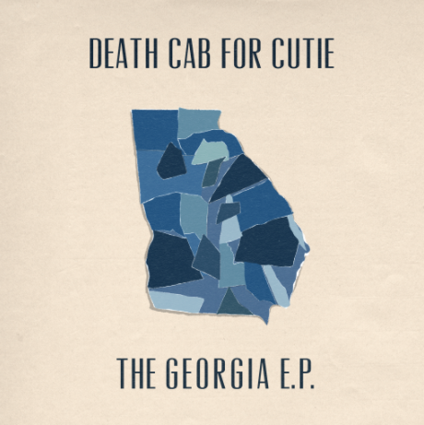
download hi-res artwork here | (cover art by Zack Bolotin)

1. Waterfalls (TLC cover)
2. The King of Carrot Flowers, Pt. 1 (Neutral Milk Hotel cover)
3. Fall On Me (R.E.M. cover)
4. Flirted With You All My Life (Vic Chesnutt cover)
5. Metal Heart (Cat Power cover)

***

