FOR IMMEDIATE RELEASE
MARCH 11, 2022

FENIX FLEXIN ARRIVES WITH NEW SINGLE + VISUAL “DEAD HOMIES”
WATCH HERE
STREAM HERE

"FENIX FLEXIN VOL. 2" DUE TO RELEASE APRIL 19th

DOWNLOAD THUMBNAIL HERE

Fenix Flexin returns with his latest single, “Dead Homies,” with visuals directed by Ordinary Visions. The boastful visual captivates Fenix’s flashy ways and bold lifestyle with a yellow Lamborghini to back him up while he continues to claim his spot in the star-studded L.A. hip-hop scene. This marks the second single off his upcoming project Fenix Flexin Vol. 2 slated to release April 19th.
Fenix continues to mark his style and sound with West Coast/g-funk flow. Setting the tone for what fans can expect from Fenix Flexin Vol. 2, Fenix dropped the first single "Fenix Flexin Vol. 2 Intro" in November delivering the lively and braggadocios music that his die-hard fanbase simply cannot get enough of. "Lyrically, this latest single seems to effectively capture his current headspace," said HotNewHipHop.

Fenix solidified the start of his solo career with the release of his mixtape, Fenix Flexin, Vol. 1, last July marking solo success for the respected platinum-selling artist. Featuring the late Drakeo The Ruler, D-Block Europe, Rob Vicious, Cypress Moreno, Bravo the Bagchaser, Peso Peso, and SaysoTheMac, the 15-track Atlantic Records release charted on Spotify’s Top 10 in the USA as well as Apple Music. Thanks in part to his stand-out singles "10 Toes," the Ron Ron and Menace produced "For Me," and "NDS", the mixtape has 32.4 million streams. His song “Risky”, the intro for Fenix Flexin, Vol. 1 became a fan-favorite—the song streamed over 100,000 times every week after its initial release. He followed the success of his mixtape with his first solo multi-city tour, Fenix Flexin, Vol. 1 Tour, which wrapped up in late-September. In 2021, Fenix launched, Burnt Co, his own lifestyle and skateboard apparel company with a team of pro skaters including Kevin Viernes, Blazzy, Kevin Scott, and others. Fenix is still gathering serious accolades from his time in Shoreline Mafia, including Shoreline Mafia’s iconic debut album Shorelinedothatshit RIAA Certified Gold. Also, his records like “Musty”, “Bands”, and “Nun Major” certified Platinum, as well as songs like “Whuss The Deal” & “Bottle Service” certified Gold.

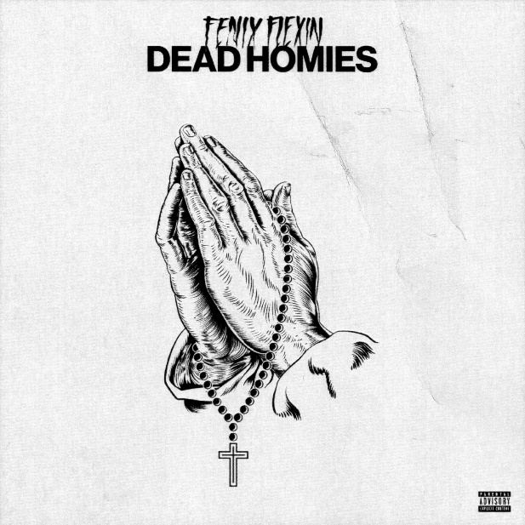
DOWNLOAD HIGH-RES ARTWORK HERE

ABOUT FENIX FLEXIN:
Being on his own is something that is not new to Fenix Rypinski. “We were dirt poor; my parents were all over the place,” he says of childhood. While the rapper’s mother and father battled addiction, he bounced around between his grandmother and siblings’ houses, staying in West LA, East Hollywood, Downey, and Huntington Park. During Fenix’s adolescence, his father sobered up and secured a stable job. However, the teen remembers regularly ditching school for skateparks, where he remained from morning to late night. “I was always raising myself,” the artist of Black, Mexican, and Polish heritage recalls. Along with skating and graffiti, rap became a creative outlet that allowed the kid on the move to make fast friends. As a soloist, Fenix remembers epic freestyles. It was through recording with classmate OhGeesy's equipment that led to a bond igniting a highly successful group. True to their name, waves begin at the Shoreline, and the quartet of LA upstarts cemented a legacy as new-era West Coast pioneers.

Fenix Flexin was instrumental in propelling Shoreline Mafia to becoming a critically acclaimed group that headlined arena tours. After three platinum singles ("Bands," "Nun Major," "Musty"), two gold records (“Whuss Da Deal,” “Bottle Service”), and over a billion streams, Fenix is carrying that momentum into a solo career. His pivot has been met with an overwhelmingly positive response on Mafia Bidness songs, including "Hoe Sh*t" and "How We Do It" (featuring Wiz Khalifa), as well as "Fell In Love" off 2019's Party Pack Vol. 2. "The group had a bunch of respect, a huge following, and a whole lot of people behind us," Fenix asserts. "Now, I'm claiming all of those things for myself as an individual, and I'm off to a good start." Bringing his seven-figure streaming audience and viewership with him, Fenix Flexin recently shared his debut Atlantic Records mixtape, Fenix Flexin Vol. 1, and just wrapped up his multi-city solo tour.

CONNECT WITH FENIX FLEXIN:
Instagram | Twitter | Soundcloud | Spotify | Apple Music | Website | Burnt Co.

PRESS CONTACT:
Brittany Bell | Brittany.Bell@atlanticrecords.com

