FOR IMMEDIATE RELEASE
JUNE 29, 2022

JASON DERULO’S “SLIDIN’ (FT. KODAK BLACK)” OFFICIAL MUSIC VIDEO OUT EVERYWHERE NOW

JASON DERULO SLIDES INTO THE METAVERSE WITH
“SLIDIN’ (FT. KODAK BLACK)” MUSIC VIDEO PREMIERE IN DECENTRALAND

GLOBAL SUPERSTAR AND NFT ENTHUSIAST TEAMS WITH TERRAZERO FOR
IMMERSIVE 48-HOUR EXPERIENCE IN THE VIRTUAL SOCIAL PLATFORM, DECENTRALAND

TAKING PLACE IN VIRTUAL SOCIAL PLATFORM, DECENTRALAND

ENTER THE EXPERIENCE HERE

WATCH OFFICIAL VIDEO HERE | LISTEN TO “SLIDIN’ (FT. KODAK BLACK)” HERE

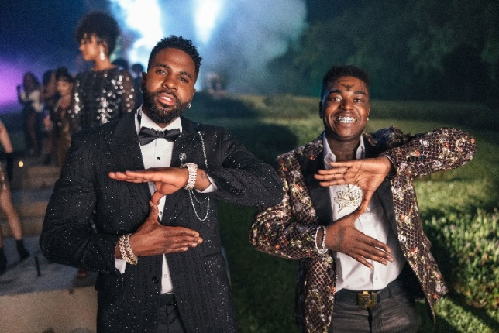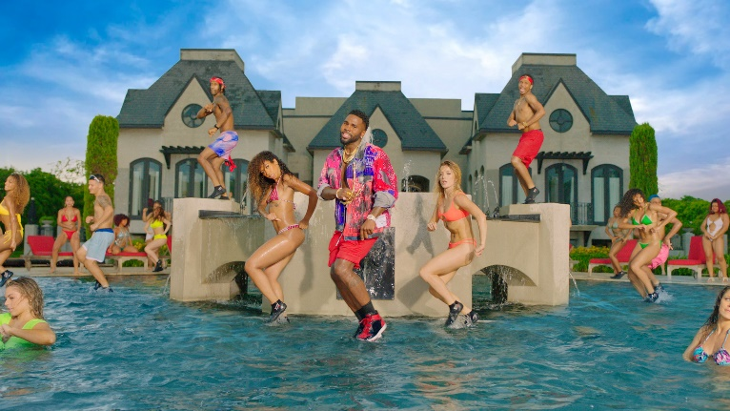
DOWNLOAD HIGH-RES ARTWORK HERE DOWNLOAD THUMBNAIL HERE

Multi-platinum global superstar Jason Derulo teams up with Atlantic Records and prominent metaverse developer TerraZero for the metaverse premiere of the official music video for his smash summer anthem, “Slidin’ (Ft. Kodak Black),” in Decentraland – one of the premiere decentralized virtual social platforms. Launching today, the 48-hour immersive experience – which sees the virtual recreation of the real-life mansion featured in the new video – allows fans to watch the video, dance and hang out with Derulo. One lucky fan will also have the chance to be given the keys to take over Jason’s Decentraland mansion, throwing their own house party. Fans can enter the email subscriber sweepstakes for a chance to win HERE. Watch “Slidin’ (Ft. Kodak Black)” official music video HERE and enter the experience HERE.

"Throughout my career, I’ve always tried to find new and creative ways to interact with my fans and technology has always been at the center of that philosophy," says Derulo. "I have been watching and investing in the web3 space for a while now and seeing the impact it’s had on fostering communities had my mind racing. That’s why I’m incredibly excited for this Decentraland experience to be able to hang out with my fans in real time and experience the music video in a new way. Shout out TerraZero for architecting the space. I’m excited for you all to experience it."
Directed by Michael Garcia, the visual is not far from Jason’s usual formula – fun, captivating and high-spirited. “When me and Jason spoke, we both knew this song needed a video big enough to match the song. Something sleek, sexy and screams summer...We are both really excited with the result!”

“Slidin’ (Ft. Kodak Black)” is available now via Atlantic Records at all DSPs and streaming services HERE. An official dance video – which sees Derulo challenge his fans with his own version of the electric slide – is streaming HERE. Produced by Jason Evigan, Jason Derulo, Lionel Crasta, Bluf & Smile High, “Slidin’” has all the energy and enthusiasm of a surefire smash, given extra heat from chart-topping rapper Kodak Black. Derulo’s knack for laying undeniably catchy melodies on top of fun, upbeat production is once again in full effect, affirming that this summer is almost certainly his for the taking.

Derulo recently celebrated the release of “Slidin’ (Ft. Kodak Black)” with a wildly extravagant Slidin’ Weekend, hosting a number of his closest friends in a secret Miami location. Coming in at a total cost of over $500K, the four luxurious days and nights were filled with cross-country flights on private jets, yachting, a lavish six-figure dinner at the swanky Komodo restaurant, partying at the opulent Fontainebleau Hotel, Club LIV, and more. Derulo was joined for his Slidin’ Weekend – which was sponsored by TREO and Dave.com – by such high profile friends and influencers as Lele Pons, Hannah Stocking, Luara Fonseca, Younes Zarou, Adam W, Jasmine Chiswell, Enola Bedard, Anwar, Jena Frumes and more. An exclusive video recapping the Slidin’ Weekend is streaming now at YouTube HERE.

Hailed by Billboard as “The Crown King of TikTok” and named atop the influential “Future 25” in its 2021 “Future of Music” issue, Derulo is among TikTok’s biggest superstars, currently the fourth most followed male on the video-sharing platform, with the 11th biggest account overall. Indeed, the multi-talented singer-songwriter, digital guru, and entrepreneur continue to see his already astronomical TikTok presence growing daily, now boasting more than 52.3M followers worldwide and over 1.2B likes, amassing more than 5M views with each and every post.

About Jason Derulo
Forward-thinking, genre-defying, and massively creative, Derulo has staked his claim as one of the most dynamic forces on the global pop landscape. Since breaking through with his 5x RIAA platinum-certified single, “Whatcha Say,” the award-winning singer-songwriter has sold more than 200M records worldwide, earned over 18.2B worldwide streams, and built an unstoppable social media following of over 117M followers across all platforms. Now at work on his highly anticipated fifth album – and full-length debut for Atlantic Records – Derulo has delivered an ongoing series of smash singles that have drawn a stunning 500M+ views, including the irresistibly buoyant “Acapulco,” the RIAA platinum-certified “Take You Dancing,” and Jawsh 685 x Jason Derulo’s 3x platinum-certified chart-topper, “Savage Love (Laxed – Siren Beat).” The latter track – and its official BTS remix – proved an unstoppable international sensation upon its 2020 arrival, peaking at #1 on Billboard’s “Hot 100” as well as atop charts in 16 additional countries around the world. A truly multi-dimensional creator, Derulo has also established himself as an actor and businessman, investing in enterprises like Catch L.A. and Rumble Boxing, becoming part-owner of Bedlam Vodka, launching an innovation-minded podcast, and developing a line of supplements and fitness products with the Najafi Group and BodyBuilding.com. What’s more, Derulo recently unveiled Jason Derulo’s UZO, an immersive new graphic novel from Z2 Comics based on a TikTok character created by the artist himself. With his TikTok regularly amassing over 5M views per post, Derulo notes that the platform has drastically reshaped his relationship with his fans. Derulo is now amongst TikTok’s biggest superstars, currently the 4th most followed male on the video-sharing platform with the 11th biggest account overall. He continues to see his already astronomical TikTok presence growing daily, now boasting more than 52.5M followers worldwide and over 1.2B likes. Reclaiming his title as the TikTok king, he released hot new summer smash single “Slidin’” with a fan-challenged TikTok video to his own rendition of the electric slide. Watch the dance video HERE. His knack for laying undeniably catchy melodies on top of fun, upbeat productions, is the formula for his Summer takeover. To celebrate the new single Derulo recently hosted a wildly extravagant “Slidin’” Weekend in Miami with some of his closest creator friends. The weekend included a private “Slidin’” jet set from LA to Miami; an insanely larger “Slidin’” mansion; and sexy “Slidin’” yacht party; hibachi, dinners, clubbing and more! Watch the “Slidin’” recap video HERE.

About Atlantic Records
Atlantic Records celebrated its 70th anniversary in 2018. Founded in New York City, the label literally grew from a one-room operation into one of the world’s preeminent music companies. Atlantic has released a string of recordings that have had a profound impact on the course of modern music, its rich history including such musical icons as Ray Charles, Aretha Franklin, John Coltrane, and Led Zeppelin. The Atlantic Records Group roster today includes many of the world’s most popular recording artists, among them Kelly Clarkson, Bruno Mars, Ed Sheeran, Cardi B, Sia, Coldplay, Charlie Puth, Janelle Monáe, Wiz Khalifa, Death Cab for Cutie, Matchbox Twenty, Lil Uzi Vert, Jason Mraz, Kevin Gates, Melanie Martinez, Rob Thomas, Skrillex, Trey Songz, and many more.

About TerraZero Technologies Inc.
TerraZero (www.terrazero.com) is a vertically integrated Metaverse development group and leading Web 3.0 technology company specializing in brand activations for the Metaverse space. The Company’s vision is to develop user experiences that will shape the future of Web 3.0. TerraZero’s clients include major Fortune 100 companies across all sectors, and legacy entertainment IP. For more information, please visit www.terrazero.com.

About Decentraland
Decentraland is a decentralized virtual social platform powered by the Ethereum blockchain. Within the Decentraland platform, users can create, experience, and monetize content and applications. Decentraland is unique in that it is owned and governed by the people who use the platform every day. Through the decentralized autonomous organization (DAO) users can submit proposals for owners of MANA (Decentraland currency) and LAND (Decentraland property) to vote on. For more information, please visit decentraland.org.
# # #

CONNECT WITH JASON DERULO
OFFICIAL | INSTAGRAM | TWITTER | FACEBOOK | YOUTUBE | TIKTOK

PRESS CONTACTS FOR JASON DERULO
FAIRLEY MCCASKILL | FAIRLEY.MCCASKILL@ATLANTICRECORDS.COM
AMANDA PENNA | AMANDA_PENNA@DKCNEWS.COM
PRISTINA ALFORD | PRISTINA_ALFORD@DKCNEWS.COM

CONNECT WITH KODAK BLACK
TWITTER | FACEBOOK | INSTAGRAM | YOUTUBE

PRESS CONTACT FOR KODAK BLACK
ASHLEY KALMANOWITZ | ASHLEY.KALMANOWITZ@ATLANTICRECORDS.COM

PRESS CONTACT FOR DECENTRALAND
JO HUNT | JO@SEROTONIN.CO

PRESS CONTACT FOR TERRAZERO
MEDIA@TERRAZERO.COM

