FOR IMMEDIATE RELEASE
April 27, 2022

JOSH LEVI DROPS HIGHLY ANTICIPATED VISUALS FOR
LATEST SINGLE “VICES” OFF FORTHCOMING EP
WATCH HERE

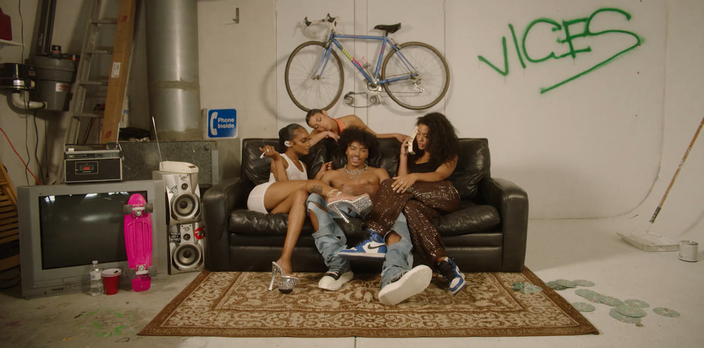
DOWNLOAD THUMBNAIL HERE

Raedio/Atlantic Records recording artist and R&B reviver, Josh Levi, has officially shared self-directed video for his most recent single, “VICES”. Levi swoons as he tries to fight off past female toxicity. Last week Levi dropped the new record immersing listeners into a luxurious R&B experience setting the tone for the upcoming release.

Levi was recently featured as the voice of Aaron Z., a member of Disney Pixar’s, 4*Town, the teenage heartthrob boyband in the film Turning Red. After Disney released the first record, “Nobody Like U,” written by Grammy®-winning singer-songwriters Billie Eilish and Finneas O’Connell, a feel-good track reminiscent of classic hits from 90s and early 2000s boybands like NSYNC and the Backstreet Boys, Levi’s streams spiked 3.3M in monthly listeners on Spotify. "Nobody Like U" peaked at #49 on the Billboard Hot 100 chart.
In August of 2021 Josh released the first single off the forthcoming EP, “NASA” The Loris Russier-directed companion visual sees Josh building out his vision. Introducing this new era of Josh Levi, he kicked off 2022 with a live performance of “NASA” beginning his performance with an intimate approach while showing off his R&B cadence and centering himself with high energy choreography.
Fans also had the chance to hear Levi’s 2021 single, “What’s The Use,” featured on the soundtrack of critically acclaimed HBO Series, Insecure: Season 5. Billboard/Tunefind’s Top TV/Movie Syncs of 2021 recognized “ What’s The Use” as the #6 top song of the year. Levi wrapped 2021 by coming in at #7 on People’s list of 25 Emerging Musical Artists You Should Add to Your Playlist This Fall.

ABOUT JOSH LEVI:
The Houston-raised and Los Angeles-based singer, songwriter, and actor immediately captivates with each inhale of experience and exhale of emotion. His teen years moved at a whirlwind pace. Mom recognized his dreams and agreed to move the family to Los Angeles where Josh broke into film and television. Along the way, he appeared as a regular on series such as Friday Night Lights. He further developed his fan base through a series of viral covers on YouTube and consistent touring. During 2020, he made a statement with his proper debut EP, DISC ONE, impacting the culture in the process. Among many highlights, “IF THE WORLD” posted up 1.3 million Spotify streams and counting. V Magazine crowned him “your classic triple threat,” and Earmilk hailed the EP as “an all-encompassing showcase of how much of an anomaly he is.” Billboard crowned his song “Don’t They” as a pop song you need to get you through the week. Meanwhile, he graced the cover of Wonderland. Along the way, he caught the attention of Raedio, Issa Rae's label imprint, and Atlantic Records, scoring a deal in 2021.

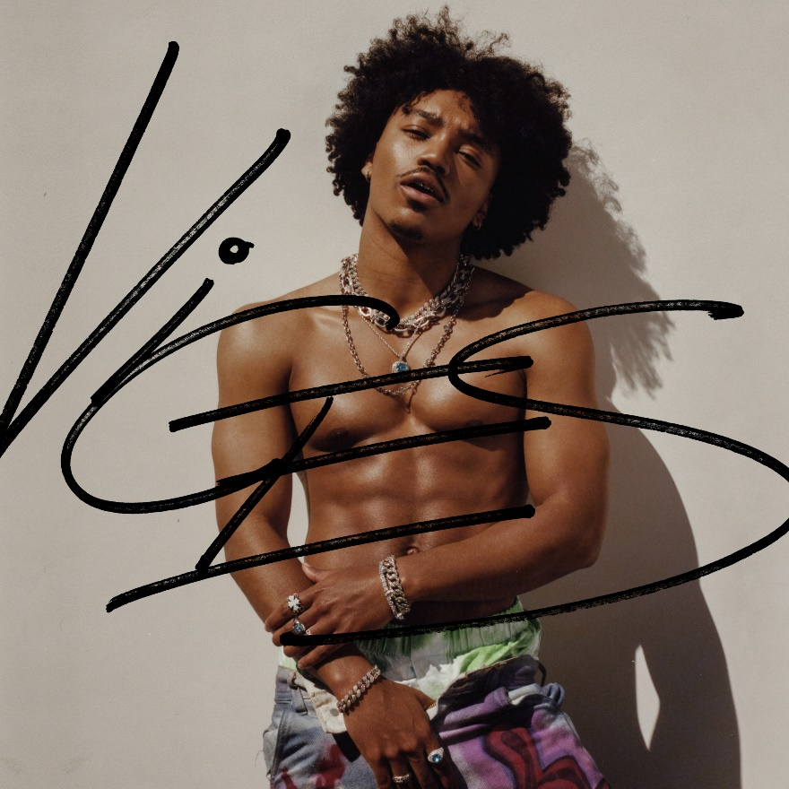
HIGH-RES ARTWORK | PRESS PHOTOS, CRED: Blair Caldwell

CONNECT WITH JOSH LEVI:
TWITTER | INSTAGRAM | YOUTUBE

PRESS CONTACT:
Brittany Bell | Brittany.Bell@atlanticrecords.com

